UK Emissions of Air Pollutants 1970 to 2002
C J Dore
J D Watterson
J W L Goodwin
T P Murrells
N R Passant
M M Hobson
S L Baggott
G Thistlethwaite
P J Coleman
K R King
M Adams
P R Cumine
October 2004

UK Emissions of Air Pollutants 1970 to 2002
October 2004

Executive Summary
- This is the 16th annual report from the UK National Atmospheric Emissions Inventory (NAEI), and is produced by the National Environmental Technology Centre.
- UK air pollutants - This report presents the latest estimates of emissions to the atmosphere from the UK for the period 1970 to 2002. 44 pollutant species are included in the 2002 annual inventory including 10 pollutant groups (NMVOC, Particulate Matter, PCDD/F, PAH, PCB, HFC, PFC, SCCP, PCN and PBDE). Size fractionation is available for particulate matter and speciation is available for: 500 NMVOCs, oxidation states of Hg, Ni and Cr, 11 PAHs and 209 PCBs. The pollutants considered in this report are:

Greenhouse Gases | Air Quality Strategy Pollutants
- carbon dioxide, CO₂ | - particulate matter, PM₁₀ *
- methane, CH₄ | - black smoke
- nitrous oxide, N₂O | - carbon monoxide, CO
- hydrofluorocarbons (HFC) | - benzene
- perfluorocarbons (PFC) | - 1,3-butadiene
- sulphur hexafluoride (SF₆) | - PAH * †
Acidifying Pollutants & Ozone Precursors | Base Cations
- nitrogen oxides, NO_{x} | - calcium, Ca
- sulphur dioxide, SO₂ | - magnesium, Mg
- non-methane volatile organic compounds (NMVOC) * | - sodium, Na
- ammonia, NH₃ | - potassium, K
- hydrogen chloride, HCl
- hydrogen fluoride, HF
Persistent Organic Pollutants | Heavy Metals
- polycyclic aromatic hydrocarbons (PAH) * † | - arsenic, As | - mercury, Hg *
- dioxins and furans (PCDD/F) | - beryllium, Be | - nickel, Ni *
- polychlorinated biphenyls (PCB) * | - cadmium, Cd | - tin, Sn
- pesticides: | - chromium, Cr * | - selenium, Se
- lindane, hexachlorobenzene, pentachlorophenol | - copper, Cu | - vanadium, V
- short-chain chlorinated paraffins (SCCPs) | - lead, Pb | - zinc, Zn
- polychlorinated napthalenes (PCNs) | - manganese, Mn
- polybrominated diphenyl ethers

* Pollutant emissions are given as a total emission and speciated emissions. Particulate matter emissions are given as PM₁₀ , PM_{2.5} , PM_{1.0} and PM_{0.1} .

† Benzo[a]pyrene is included in the Air Quality Strategy, but appears in this report in the chapter on Persistent Organic Pollutants, as it is a PAH.

The change in emissions for these pollutants, is summarised in the following plot. The change is given as the difference between the 1990 and 2002 emissions, expressed as a
percentage of the 1990 values.

The greenhouse gas SF₆ is the only pollutant showing an increase across this period. SF₆ emissions arise from a relatively small number of sources (magnesium production, high voltage switchgear, electronics and manufacture of trainers), with most of these giving increased emissions since 1990.

However, these emissions of SF₆ should be placed in context by considering the other greenhouse pollutants. Comparison of the 1990 and 2002 emissions of a basket of six greenhouse gases indicates a 10% decrease in the contribution to global warming. Therefore the impact of the increased SF₆ emissions is more than counteracted by the decreased emissions of other greenhouse gases (see Figure 2.1).

- CO₂ – Emission estimates for CO₂ from the UK show a decrease of 8% between 1990 and 2002, giving an emission of 146.3 Mt of carbon in 2002. The most significant reductions arise from the public power and industrial combustion sectors. 2002 road transport emissions account for 22% of the total emission and indicate a reasonably constant absolute emission since 1997.
- CH₄ - Estimates of methane emissions show a decrease of 44% from 1990 to 2002, giving emissions of 2.1 Mt in 2002. The largest sources are landfills, agriculture, natural gas distribution and coal mining. Reduction is largely due to the decline in the coal mining industry and increased levels of methane recovery on landfill sites.
- N₂O - UK emissions of nitrous oxide were 0.132 Mt in 2002, corresponding to a decrease of 40% between 1990 and 2002. Emissions of nitrous oxide are dominated by agricultural emissions and the production of nylon and nitric acid. Reductions have primarily resulted from these production processes through abatement. Emission estimates of N₂O are highly uncertain (see Section 2.6).
- HFC, PFC and SF₆- The UK emissions in 2002 were HFCs: 2.8 Mt of carbon equivalent, PFCs: 0.10 Mt of carbon equivalent and sulphur hexafluoride: 0.4 Mt of carbon equivalent. These correspond to reductions of 8% and 72% for HFC and PFC respectively. The increase in SF₆ has been discussed above in point 2.
- PM – The UK emissions of PM₁₀ declined by 48% between 1990 and 2002, giving an emission of 0.16 Mt in 2002. This reflects a trend away from coal use particularly by domestic users. Coal combustion and road transport together contribute 50% of UK emissions of PM₁₀ in 2002. PM₁₀ emissions from road transport have shown a steady decline across recent years. Other PM size fractions are also included in this report. PM_{2.5} emissions have also fallen, but by a smaller amount, the largest source sector being road transport, accounting for 34% of the 2002 total emission.
- BS - Black smoke emissions in the UK have significantly declined (by some 78% between 1970 and 2002). Emissions in 2002 were estimated to be 259 kt. These estimates are based on old measurement data and are very uncertain. They are included here for completeness only.
- CO - Emissions in 2002 (3.2 Mt) represent a 56% reduction on the emission in 1990. UK emissions of CO are dominated by those from road transport (59% of UK emissions in 2002). The change in emissions between 1990 and 2002 is dominated by the reduction in emissions from the road transport sector, caused by the increased use of catalytic converters in cars.
- Benzene –Benzene emissions have decreased by 75% between 1990 and 2002, giving an emission of 13.5 kt in 2002. Fuel combustion in the road transport sector is the most significant source of benzene, accounting for some 32% of the 2002 UK emission. The use of benzene in the chemical industry gives rise to stack and fugitive emissions, however these emissions sum to contribute only 4% to the UK total emission.
- 1,3-Butadiene – Emissions in 2002 were estimated to be 3.7 kt, representing a decrease of 73% between 1990 and 2002. Emissions of 1,3-butadiene are dominated by fuel combustion in the road transport sector, which account for some 75% of the 2002 UK emission. There have been significant reductions in the emissions from this sector due to the increase in the number of cars equipped with catalytic convertors.
- NO_{x} - UK emissions of NO_{x} were 2.8 Mt in 1990. Emissions have fallen significantly to 1.6 Mt in 2002, representing a 43% reduction on the 1990 emissions estimate. This is primarily a consequence of: abatement measures in road transport, abatement measures in coal fired power stations and the increased use of other fuels for power generation. Road transport and coal combustion combine to account for 65% of UK emissions in 2002.
- SO₂ - UK emissions of sulphur dioxide have fallen from 3.72 Mt in 1990 to 1.0 Mt in 2002, representing a decrease of 73%. This is a result of reduced emissions from the industrial and public power sectors arising from the decreasing use of coal and increasing use of abatement equipment. However, coal combustion still accounts for 75% of the 2002 UK SO₂ emissions.
- HCl - UK emissions of hydrogen chloride have decreased by 79% between 1990 and 2002, giving an emission of 58 kt in 2002. This reduction is largely as a result of declining coal use.
- NMVOC - UK emissions of NMVOC are estimated as 2.6 Mt for 1990 and 1.4 Mt for 2002, a decrease of 46%. The observed decrease arises primarily from the road transport and industrial sectors.
- NH₃ - The total UK emission of ammonia for 2002 is estimated at 0.29 Mt, compared to the 1990 estimate of 0.35 Mt, giving a 17% reduction. The agricultural sector dominates the ammonia emissions, and emissions have decreased substantially since 1999. There have been increases in the emissions from the road transport sector (caused by increased use of catalytic convertors), but these have been more than offset by the impact of decreased agricultural livestock numbers.
- HF – The total HF emissions for 2002 are estimated to be 5.4 kt, representing a 50% reduction on the 1990 emission estimates. As with HCl the dominant source is coal combustion for public power contributing 66% of emissions.
- POPs – The 2002 UK emissions of persistent organic compounds may be summarised as follows: 2039 t PAH (USEPA 16), 316 gTEQ PCDD/F (grammes of “toxic equivalent” of dioxins & furans) and 1.45 t PCB. Emissions from all three of these pollutant groups have greatly decreased. Emissions in 2002 equate to decreases of 76%, 74% and 80% on the 1990 emission, for PAHs, PCDD/Fs and PCBs respectively.
- Pb - UK Emissions of lead have declined sharply following reductions in the lead content of leaded petrol, and the increased use of unleaded and lead replacement petrol. Emissions in 2002 are estimated to be 0.16 kt, a decrease of 94% on the 1990 estimates. Road transport now contributes only 1% to UK emissions total in 2002.
- The 2002 emission inventory indicates that the dominant sources of many of the air pollutants are from road transport and the use of coal (see table below).
Road Transport and Coal Combustion Contribution to Emissions of Selected Pollutants (2002)
Pollutant | Total Coal Combustion | Road Transport | Total Contribution
HCl | 97% | 0% | 97%
Sn | 94% | 1% | 95%
Mn | 91% | 0% | 91%
HF | 87% | 0% | 87%
Be | 40% | 36% | 76%
1,3-Butadiene | 0% | 75% | 75%
SO₂ | 77% | 0% | 77%
16 PAHs | 21% | 52% | 73%
Se | 48% | 0% | 48%
CO | 16% | 59% | 75%
NO_{x} | 21% | 45% | 66%
Mg | 43% | 0% | 43%
As | 46% | 0% | 46%
Na | 38% | 0% | 38%
Cu | 36% | 0% | 36%
K | 16% | 0% | 16%
PM₁₀ | 23% | 19% | 42%
Carbon | 22% | 22% | 44%
Benzene | 18% | 32% | 50%
Benzo[a]pyrene | 32% | 5% | 37%

It is therefore likely that future trends in emissions will be substantially determined by market demand and UK Government/devolved administration policies associated with these areas.

- A copy of this report may be found at the NAEI web site (http://www.naei.org.uk) along with a facility for local interrogation of the data and links to data on emissions in other countries.

Contents
1. Introduction 1
1.1 An Introduction to Emission Inventories 1
1.2 The UK National Atmospheric Emissions Inventory 2
1.2.1 International Commitments 3
1.2.2 National Information 4
1.2.3 Information Dissemination 6
1.2.4 Continuous Improvement and Basic Methodology 7
1.2.5 Mapping Emissions 9
1.3 UK Pollution InventorIES 12
1.3.1 The Environment Agency of England & Wales - Pollution Inventory 12
1.3.2 The Scottish Environmental Protection Agency – EPER Inventory 12
1.3.3 The Northern Ireland Department of Environment – ISR Inventory 12
2. Greenhouse Gas Emissions 14
2.1 Introduction 14
2.2 CO₂ Emission Estimates 16
2.2.1 Total CO₂ Emissions 16
2.2.2 Electricity Supply Industry 20
2.2.3 Domestic 22
2.2.4 Industrial 22
2.2.5 Transport 22
2.2.6 Agriculture/Forests/Land Use Change 23
2.3 CH₄ Emission Estimates 23
2.3.1 Total CH₄ Emissions 23
2.3.2 Landfill 24
2.3.3 Agriculture 24
2.3.4 Coal mining 25
2.3.5 Leakage from the Gas Distribution System 25
2.3.6 Offshore Oil and Gas 25
2.3.7 Sewage Disposal 26
2.4 N₂O Emission Estimates 26
2.4.1 Agriculture 27
2.4.2 Production Processes 27
2.4.3 Power Generation 27
2.4.4 Road Transport 27
2.5 HFCs, PFCs and SF₆ Emission Estimates 28
2.5.1 Hydrofluorocarbons 28
2.5.2 Perfluorocarbons 29
2.5.3 Sulphur Hexafluoride 30
2.6 ACCURACY of Emission Estimates OF Greenhouse Gases 31
3. Stratospheric Ozone Depletors 32
4. Air Quality Strategy Pollutants 33
4.1 Introduction 33
4.2 Particulate Matter 34
4.2.1 Introduction 34
4.2.2 PM₁₀ 36
4.2.2.1 Sources of emissions 36
4.2.2.2 PM₁₀ Emission estimates 37
4.2.3 Finer Particulates: PM_{2.5}, PM_{1.0} and PM_{0.1} 40
4.2.4 Air Quality Expert Group (AQEG) review 43
4.2.4.1 A Recent Review of Particulate Matter Emission Factors for Industrial Processes and Combustion 43
4.2.4.2 Review of Industry Processes 43
4.2.4.3 Review of Emissions from the Combustion of Natural Gas 44
4.2.4.4 Review of Emissions from Mining, Quarrying and Construction 45
4.2.4.5 Review of Emissions from Bonfires, Bonfire Night and Accidental & Malicious Fires 45
4.2.5 Black Smoke 46
4.3 Carbon Monoxide Emission Estimates 46
4.3.1 Transport 50
4.3.2 Other Sources 50
4.4 Benzene 50
4.5 1,3-Butadiene 54
4.6 Accuracy of Emission Estimates of Air Quality Strategy Pollutants 57
4.6.1 Carbon Monoxide Estimates 57
4.6.2 Benzene and 1,3-Butadiene Estimates 57
4.6.3 Particulate Matter Estimates 57
4.6.4 Black Smoke Estimates 58
5. Acidifying Gases and Tropospheric Ozone Precursors 59
5.1 Introduction 59
5.2 NO_{x} Emission Estimates 62
5.2.1 Transport 65
5.2.2 Power Generation 67
5.2.3 Industry 67
5.3 SO₂ Emission EStimates 68
5.3.1 Power Generation 71
5.3.2 Industry 71
5.3.3 Transport 71
5.3.4 Other 71
5.4 Hydrogen Chloride Emission Estimates 71
5.5 non-methane volatile organic compounds 74
5.5.1 Solvent Use and Production Processes 77
5.5.2 Transport 77
5.5.3 Other Sectors 77
5.5.4 Speciation of NMVOCs 78
5.5.5 Photochemical Ozone Creation Potential 80
5.6 Ammonia Emission Estimates 82
5.6.1 Agricultural Sources 83
5.6.2 Other Sources 83
5.7 Hydrogen Fluoride Emission Estimates 86
5.8 Accuracy of Emission Estimates of Acidifying Gases and Tropospheric Ozone Precursors 87
6. HAZARDOUS AIR POLLUTANTS 89
6.1 Introduction 89
6.1.1 UN/ECE Heavy Metals and POPops Protocols 89
6.1.1.1 Persistent Organic Pollutants (POP)s 89
6.1.1.2 Heavy Metals 90
6.2 Persisent Organic Pollutants 92
6.2.1 Polycyclic Aromatic Hydrocarbons (PAHs) 92
6.2.2 Dioxins And Furans (PCDD/F) 98
6.2.3 Polychlorinated Biphenyls (PCBs) 102
6.2.4 Pesticide Emissions 104
6.2.4.1 Lindane (γ HCH) 104
6.2.4.2 Pentachlorophenol (PCP) 106
6.2.4.3 Hexachlorobenzene (HCB) 107
6.2.5 Short Chained Chlorinated Paraffins (SCCP) 109
6.2.5.1 Introduction 109
6.2.5.2 Production and Emission to Air 109
6.2.5.3 Emission Estimates 109
6.2.6 Polychlorinated Napthalenes (PCN) 109
6.2.6.1 Introduction 109
6.2.6.2 Prodction and Consumption 109
6.2.6.3 Emission Estimates 110
6.2.7 Polybrominated Diphenyl Ethers (PBDEs) 110
6.2.7.1 Introduction 110
6.2.7.2 Production and Release to Air 110
6.2.7.3 Emission Estimates 111
6.3 Accuracy of Emission Estimates of POPs 111
6.4 Heavy Metal Emission Estimates 112
6.4.1 Introduction 112
6.4.2 Emissions of Arsenic 113
6.4.3 Emissions of Cadmium 114
6.4.4 Emissions of Chromium 116
6.4.4.1 Speciation of Chromium 118
6.4.5 Emissions of Copper 118
6.4.6 Emissions of Lead 120
6.4.7 Emissions of Mercury 121
6.4.7.1 Speciation of Mercury Emissions 123
6.4.8 Emissions of Nickel 123
6.4.8.1 Speciation of Nickel Emissions 125
6.4.9 Emissions of Selenium 125
6.4.10 Emissions of Vanadium 127
6.4.11 Emissions of Zinc 128
6.4.12 Emissions of Beryllium 130
6.4.13 Emissions of Manganese 130
6.4.14 Emissions of Tin 130
6.4.15 Spatial Disaggregation of Heavy Metals 132
6.5 Accuracy of Emission Estimates of Pops and Heavy Metals 137
7. BASE CATIONS 138
7.1 Introduction 138
7.2 Background 138
7.3 Stationary Combustion of Fossil Fuels 139
7.4 Mineral Extraction Processes 139
7.5 Processes in The Mineral Products Industry 140
7.6 Industrial Processes Using Limestone, Dolomite and Soda Ash 140
7.7 Soil Liming and Cultivation in Agriculture 140
7.8 Construction Activities 140
7.9 Mobile Sources 140
7.10 Calcium 141
7.11 Magnesium 142
7.12 Sodium 143
7.13 Potassium 143

7.14 Accuracy of Emission Estimates of Base Cations 145
8. REGIONAL EMISSION ESTIMATES 146
8.1 Introduction 146
8.1.1 Unallocated Emissions and Inclusion of Sources 146
8.2 Regional CO₂ Emissions 146
8.3 Regional Emissions of AQS Pollutants 147
8.4 Regional Emissions of Acidifying Pollutants and Ozone Precursors 148
8.5 Regional Emissions of Persistent Organic Pollutants 150
8.6 Regional Emissions of Heavy Metals 151

9. REFERENCES 1

ANNEX 1 DEFINITIONS OF UN/ECE SOURCE SECTORS

The Appendices associated with this report are now no longer included in the hard copy, but are still available. They may be accessed through the NAEI website: http://www.naei.org.uk/
where they are listed with the electronic version of this report.
The Appendices at this website include tabulated data, and a detailed methodology of the NAEI.

Introduction

An Introduction to Emission Inventories
Emission inventories play an important role in assessing the effects of anthropogenic (man-made) activity on atmospheric pollution. The principal demands for energy, transportation, materials and food may be regarded as the “drivers” for the production of air pollutants. In order for an economy to continue to develop in a sustainable way these sources of pollution must be managed. To do this we must understand the “impacts”- i.e. what types of pollution affect which parts of the environment or human health, and to what extent. To decide whether action is necessary we also need to know the “state” of the environment- i.e. to evaluate whether the levels in the environment exceed those which will cause environmental harm.

In taking appropriate action we must be able to respond in a focused way to control and reduce pollution while avoiding larger-scale damage to economic development. Emission inventories provide policy makers and the public with an understanding of the key polluting sources or the “pressures”, how these sources have developed with economic growth and how they are likely to contribute to pollution in the future. This understanding is essential for a focused “response” to the problems associated with air pollution and to meet the demands of sustainable development.

Figure 1.1 shows how our understanding of the pressures (through emission inventories) interact with other areas of environmental knowledge such as impact assessment and monitoring (state). Figure 1.1 also clearly shows the relationship between: emission inventories, economic activity and effective environmental policy.

Figure 1.1 “DPSIR” Relational Diagram

The UK National Atmospheric Emissions Inventory
The UK National Atmospheric Emission Inventory (NAEI) is compiled by the National Environmental Technology Centre on behalf of the Department for Environment, Food and Rural Affairs (Defra) Air and Environment Quality (AEQ) Division and the devolved administrations. Related work on greenhouse gas emissions is also conducted for the Global Atmosphere Division of the Department. The NAEI is the standard reference air emissions inventory for the UK and includes emission estimates for a wide range of important pollutants. These include: greenhouse gases, regional pollutants leading to acid deposition and photochemical pollution, persistent organic pollutants and other toxic pollutants such as heavy metals. The full range of pollutants is summarised in Table 1.1. Where possible, estimates are presented for 1970-2002. However, for some pollutants, e.g. ammonia, there is insufficient information to produce a 1970-2002 time series and estimates are presented from 1990-2002.

Emission inventories serve several important functions, as explained in Section 1.1. The following highlight several of the more important uses of the UK NAEI:

- Provision of Public Information- The data from the NAEI is made available to the public in various forms (see Section 1.2.3). The aim is to make information available in an easily understandable format, informing the public of emissions in their area as well as making national emissions data available. The NAEI is paid for by tax payers money, through the Government, and consequently it is important to maintain a high public profile and accessibility to the work. A copy of this report is available on the internet at http://www.naei.org.uk. Further information can be found in Section 1.2.3.

- Development of policy- The data from the NAEI is used to inform development of policies to tackle emissions of air pollutants and greenhouse gases.
- Identification of Primary Sources- The NAEI compiles emissions from all possible anthropogenic and natural sources (where information allows). Consequently it is simple to determine which source sectors are the major emitters of individual pollutants.

- Temporal and Spatial Trend Assessment- The NAEI provides information to allow temporal trend analysis as it is compiled annually (from 1970 for most pollutants). UK maps are also generated for several of the pollutants, allowing spatial trends to be assessed.

- Inventory Comparisons- Mapped emission inventories exist for a number of cities across the UK. In some cases the techniques used to compile these emission inventories differ from the NAEI. As a result comparison with the NAEI highlights the potential strengths and weaknesses of the different techniques.

- National Modelling Studies- The NAEI is used in a variety of modelling studies investigating spatial and temporal trends in deposition and concentration of pollutants. Furthermore, it is possible to use the NAEI alone to investigate the impact on emissions of particular future policy scenarios.

- Local Support- Data from the NAEI is frequently used by Local Authorities to support air quality assessments, and aid the generation of local policy.

- National and International Reporting- The NAEI provides the official air emissions estimates for the UK. National and International reporting requirements are given in more detail in the following Sections.

- Progress on Complying with National and International Commitments- The annual inventory provides an important assessment tool for policy makers. The inventory is used to monitor progress towards emission limits and ceilings at both the national and international level, and is therefore an important tool in assessing the effectiveness of existing policy measures.

International Commitments
The NAEI provides the UK air emission data for submission to United Nations Economic Commission for Europe (UN/ECE) and the United Nations Framework Convention on Climate Change (UNFCCC). Under the UNFCCC, the UK is committed to developing, publishing and regularly updating national emission inventories of greenhouse gases using reporting guidelines from the Intergovernmental Panel on Climate Change (IPCC). The inventories for both direct greenhouse gases (carbon dioxide, methane, nitrous oxide, hydrofluorocarbons, perfluorocarbons and sulphur hexafluoride) and indirect greenhouse gases (nitrogen oxides, carbon monoxide and non-methane volatile organic compounds) are drawn from the UK NAEI emissions data included in this report. Likewise, NAEI estimates of emissions of nitrogen oxides, carbon monoxide, ammonia, sulphur dioxide, NMVOC, persistent organic pollutants and heavy metals are submitted to UN/ECE under the Convention on Long-Range Transboundary Air Pollution (CLRTAP). NAEI data are also provided to international emission inventory activities such as the EC’s CORINAIR and EUROSTAT inventories. The UK inventory team play an important role in the development of international guidelines by the European Environment Agency and the UN/ECE which aims to achieve a consistent set of good quality inventories for all European countries. More information may be found at the EMEP and UNFCCC websites at:

http://www.emep.int and http://www.unfccc.de

Not all international reporting of emissions are drawn from the UK NAEI. One exception is the EC’s forthcoming EPER (European Pollutant Emissions Register) which arises from the IPPC Directive. The Environment Agency’s Pollution Inventory (PI) will provide data for the EPER for England and Wales. Scotland are in the process of constructing their own PI equivalent, and Northern Ireland will also need to consider compiling these data.

National Information
The NAEI is a key database used to provide air emissions data to the public, UK Government, the devolved administrations, Local Authorities and private sector organisations. Many of the specific policy uses have been outlined above, but there are a number of other ways in which the data is used. Several are given below:

- A significant amount of time is spent providing detailed emission estimates, output from scenario analysis and supporting information to Defra and the devolved administrations. This information is required for a wide variety of uses- from long-term policy support to specific short-term issues.

- A great deal of information is made available to other organisations working on Defra projects, or projects for the devolved administrations. This ensures a high level of consistency and efficiency.

- Mapped emission inventories for the UK are generated on a 1x1km scale. These are frequently used as a starting point for many local emission inventories, which may then be used to assess current and future air quality.

- Emission estimates for point sources and emissions arising from the surrounding area are used in modelling studies as part of Environmental Impact Assessments by developers and their consultants.

- There is a two way exchange of data with Trade Associations. This ensures that the NAEI and the Trade Associations can arrive at emission estimates that are truly representative.

- Emission factor data is fed into the UK’s Emission Factor Database for access by Local Authorities.

Table 1.1 Pollutants Covered by the Inventories
Pollutant |  | Range of Estimates¹ | Type of Pollutant²
Carbon Dioxide | CO₂ | 1970-2002 | G
Methane | CH₄ | 1970-2002 | G
Nitrous Oxide | N₂O | 1990-2002 | G
Hydrofluorocarbons | HFC | 1990-2002 | G
Perfluorocarbons | PFC | 1990-2002 | G
Sulphur Hexafluoride | SF₆ | 1990-2002 | G
Nitrogen Oxides | NO_{x} (NO₂ + NO) | 1970-2002 | NAQS, AC, IG, O
Sulphur Dioxide | SO₂ | 1970-2002 | NAQS, AC, IG
Carbon Monoxide | CO | 1970-2002 | NAQS, O
Non-Methane Volatile Organic Compounds | NMVOC | 1970-2002 | NAQS, O, IG
Black Smoke | BS | 1970-2002 | NAQS
Particulates < 10 μm | PM₁₀ | 1970-2002 | NAQS
Ammonia | NH₃ | 1990-2002 | AC
Hydrogen Chloride | HCl | 1970-2002 | AC
Hydrogen Fluoride | HF | 1970-2002 | AC
Lead | Pb | 1970-2002 | NAQS, TP
Cadmium | Cd | 1970-2002 | TP
Mercury | Hg | 1970-2002 | TP
Copper | Cu | 1970-2002 | TP
Zinc | Zn | 1970-2002 | TP
Nickel | Ni | 1970-2002 | TP
Chromium | Cr | 1970-2002 | TP
Arsenic | As | 1970-2002 | TP
Selenium | Se | 1970-2002 | TP
Vanadium | V | 1970-2002 | TP
Beryllium | Be | 2000-2002 | TP
Manganese | Mn | 2000-2002 | TP
Tin | Sn | 2000-2002 | TP
Polycyclic Aromatic Hydrocarbons | PAH | 1990-2002 | TP
Dioxins and Furans | PCDD/F | 1990-2002 | TP
Polychlorinated Biphenyls | PCB | 1990-2002 | TP
Lindane (gamma-HCH) | HCH | 1990-2002 | TP
Pentachlorophenol | PCP | 1990-2002 | TP
Hexachlorobenzene | HCB | 1990-2002 | TP
Short-chain chlorinated paraffins | SCCP | 1990-2002 | TP
Polychlorinated Napthalenes | PCN | NE | TP
Polybrominated diphenyl ethers | PBDE | SE | TP
Sodium | Na | 1990-2002 | BC
Potassium | K | 1990-2002 | BC
Calcium | Ca | 1990-2002 | BC
Magnesium | Mg | 1990-2002 | BC

1 An explanation of the codes used for time series:
SE A “Single Emission” estimate not attributed to a specific year
NE “Not Estimated” due to lack of information currently available

2 An explanation of the codes used for pollutant types:
G Greenhouse gas IG Indirect greenhouse gas
O Ozone precursor AC Acid gas
NAQS National Air Quality Standard/Local Air Quality Management pollutant
TP Heavy metals and POPs are generally referred to as “Toxic Pollutants” (although other pollutants also have toxic properties)
BC Base cation

The NAEI is compiled on an annual basis, each year the latest set of data are added to the inventory and the full time series are updated to take account of improved data and any advances in the methodology used to estimate the emissions. Updating the full time series is an important process as it ensures that the entire dataset uses the methodology that is the most current, and hence considered to give the most accurate results and the most accurate indication of temporal trends. The new data are then reported to UN/ECE, UNFCCC and other international fora. This annual cycle of activity is represented schematically in Figure 1.2.

Figure 1.2 The Annual NAEI Cycle

This report presents the definitive 2002 data from the NAEI and is the latest in a series of annual reports published by the NAEI (Eggleston, 1988; Eggleston and Munday, 1989; Munday, 1990; Leech, 1991; Gillham et al 1992; Gillham et al 1994; Salway et al 1996, 1996a, 1997, Salway 2000, Salway et al 1999, Goodwin et al 2000, Goodwin et al 2001, Goodwin et al 2002, Dore et al 2003, Baggott et al 2004).

This report discusses trends in pollutant emissions, the accuracy of the emission estimates and in many cases the pattern of their spatial disaggregation within the UK. A detailed description of the methodology used in the compilation of the data is given in Appendix 1 and recent methodological improvements to the inventory, and planned developments are both included in Appendix 2. Mapping methodologies, NMVOC speciation and a full listing of pollutant emissions at a high detail level are also included in the Appendices. The appendices are now not included with this hard copy of the report, but can be accessed from the NAEI webpage (http://www.naei.org.uk).

Information Dissemination
Data from the NAEI is made available to national and international bodies in a number of different formats- as explained in Sections 1.2.1 and 1.2.2. An annual report is produced, giving the most recent emissions data and other information such as: temporal trends, new pollutants and methodology changes. The NAEI team also hold seminars with representatives from industry, trade associations, UK Government and the devolved administrations.

In addition there is a continuous drive to make information available and accessible to the public. A large amount of information is made available on the internet. The NAEI web pages may be found at:
http://www.naei.org.uk

These web pages are arranged into a number of different categories which fall under the following headings:

- Annual Report:- The most recent NAEI annual report is made available in electronic format.

- Methodology:- The methods used for the compilation of the NAEI are given.

- Datasets:- Various datasets are made available, the most comprehensive being a queriable database of the NAEI emission estimates.

- Emissions Maps:- Emissions of pollutants are given in the form of UK maps. These maps give emissions of various pollutants on a 1 x 1 km resolution. It is possible to zoom in to access the source data for the maps.

- Post Code Search:- This search facility enables visitors to the site to enter their post code, and obtain emissions data concerning the major sources in the vicinity.

The web site is constructed so that the air emissions are placed in context. In addition there are numerous links to locations explaining technical terms, pages giving airborne pollutant concentrations and why there is an interest in particular pollutants. In particular there are links to the various Defra pages containing comprehensive measurement data on ambient concentrations of various pollutants. The Defra air quality sites can be found at:

http://www.defra.gov.uk/environment/airquality/index.htm

and

http://www.defra.gov.uk/environment/climatechange/index.htm

Continuous Improvement and Basic Methodology
Throughout the compilation of the inventory, considerable effort has been made to ensure both consistency with other national statistics and that all available data sources are considered. Hence, the source data are drawn from a wide range of sources. One source is the provision by the Environment Agency of emissions data, since 1988, on SO₂ and NO_{x} emissions from large combustion plant, and more recently the emissions data for Part A Processes in the Pollution Inventory. Where specific point source emission data are unavailable, emissions are estimated from other activity data such as fuel consumption, distance travelled, production or some other statistical data that is directly related to the emissions. Emission estimates are calculated by applying an emission factor to an appropriate activity statistic.

That is:

Emission = Factor × Activity

Emission factors are generally derived from measurements on a number of sources assumed to be representative of a particular source sector. The resulting emission factor may then be applied to similar sources within the sector. However, as mentioned above, some sectors are particularly well characterised and individual point sources within the sector may report a specific emission, which is regarded as being more reliable. This is often the case with sectors incorporating large point sources (an example being the Power Station sector). The inventories presented here are generated using a combination of reported point source emissions, and emissions calculated using emission factors. Methodology improvements are applied to all years (where appropriate).

For many of the pollutants, the major source of emission is fossil fuel combustion. As a result fuel consumption statistics feature prominently in the calculation of these emission estimates. It is important to consider the difference between consumption and deliveries when making use of fuel statistics. Most readily available statistics refer to deliveries which for many source categories relate closely to actual consumption of fuel. However, where fuel can be stockpiled, deliveries and consumption may differ significantly. This is just one example of having to ensure that the available data is correctly interpreted, and used in the most appropriate way to arrive at representative emission estimates.

Emissions from sources such as industrial processes, farm animals and motor fuel evaporation require different statistics; in these cases data on process output, population and motor fuel sales are appropriate.

In other cases, where emissions are more complex, further refinements or an alternative methodology is required. For example, consider the emissions from road vehicles. An obvious activity indicator would be distance travelled, but emissions per unit distance travelled will depend on: vehicle type, vehicle age, engine size, average speed and several other parameters. Clearly the methodology rapidly becomes complicated. A separate road transport model is used for calculating the emissions given in the NAEI.

For the 1970-2002 emissions dataset, particular emphasis has been placed on improving several areas of the emission inventory. In particular, emissions of PM₁₀ and heavy metals have been improved. In addition, a considerable amount of work has been conducted on generating emission projections. The emissions estimates for base cations were reported for the first time in 2000, and substantially revised in 2001 in order to give the time series reported here.

Under several international protocols, emissions from UK dependent territories (and some other locations) are allotted to the UK. Consequently it has been necessary to estimate the emissions from a number of new geographical locations. Emission estimates for: Gibraltar, Jersey, Guernsey, the Isle of Man have been made, and were included for the first time in the 2000 report. Preliminary emission estimates have been made for the two Sovereign base areas of Cyprus. There is on-going work to revise and extend the work being conducted for these Overseas Dependencies, Crown Dependencies and Sovereign Bases.

At a more general level there is also a continued drive to use data which most accurately represents the source. Emission factors and activity data are assessed each year to identify whether more appropriate information has become available. The methodology used for compiling the inventory is given in Appendix 1, and the most significant changes from the 2001 inventory methodology are given in Appendix 2. The current methodology used for generating emission maps is also included in this report as Appendix 3. It should be noted that this methodology is for mapping only, and does not generate total emission estimates- merely spatially disaggregates them in the most appropriate way. These appendices are no longer included with this hard copy of the report, and can be found on the NAEI website (http://www.naei.org.uk).

Chapters 1 to 7 present the NAEI emission estimates for the UK. They have been divided into five groups, reflecting the national and international activity relating to atmospheric pollution, namely greenhouse gases, National Air Quality Strategy pollutants, stratospheric ozone depletors, acidifying gases and tropospheric ozone and other hazardous air pollutants. Each of these chapters include a discussion of the importance of the pollutants concerned, present time series emission data, and discuss the data trends and the accuracy of the emission estimates. Chapter 8 contains emissions estimates for the UK, divided into the Country Regions. This allows comparisons to be made on the different industrial profiles in the Regions and the resulting emissions per capita to be considered. The emissions data summarised in this report is available to differing detail levels by accessing the NAEI website (see http://www.naei.org.uk).

Mapping Emissions
The sources contributing to the UK emissions can be represented as one of three categories: points, lines or areas. Sectors such as power stations, refineries and large industrial plant can be represented by points. Their locations are known and data to estimate emission contributions are available. Major roads and railways are sectors that can be represented by lines if data are available. Other diverse and numerous source sectors such as agriculture, domestic and commercial are represented by areas.

The method used to map emissions in the UK is shaped by the data that are available. The technique employs a combination of reported emissions (for emission sources at regulated sites) and surrogate geographical statistics to distribute emissions from line and area sources.

The emission maps combine a number of different source sectors represented by the point, line and area sources. In order to map this combination, the UK is divided into a grid of 1km squares. Emissions are then represented in terms of tonnes per 1km grid square. Maps of emissions for various pollutants have been included in the main body of this report. These maps show emissions from all sources including some offshore sources. The offshore component is made up of shipping and fishing related emissions within a 12km coastal zone and also offshore oil and gas extraction further afield. The onshore and offshore components of the maps are shown separately for NO_{x} below in Figure 1.3.

It is difficult to identify an offshore total for many of the pollutants as the emissions occur from a number of different sectors under reporting formats. For example, CH₄ emissions from offshore platforms will arise from a number of activities. Emissions may be included under “Extraction and Distribution of Fossil Fuels”, however other emissions may fall within the “Waste Treatment and Disposal” category (e.g. venting of the CH₄). Emissions from fuel combustion in shipping fall into the “Other Mobile Sources and Machinery” sector. Annex 1 gives an explanation of the UN/ECE reporting framework and indicates which source category the emissions are reported under.
These maps meet the needs of a wide range of users. For example, they are used to provide input into air quality modelling, which allows Local Authorities to generate action plans as part of their air quality management role. The maps are also used in research projects investigating pollutant transport and atmospheric chemistry, and by the general public who are interested in understanding the air quality climate in their area.
Figure 1.3 NO_{x} Emissions Maps- Onshore, Offshore and Total Emissions (illustrative purposes)
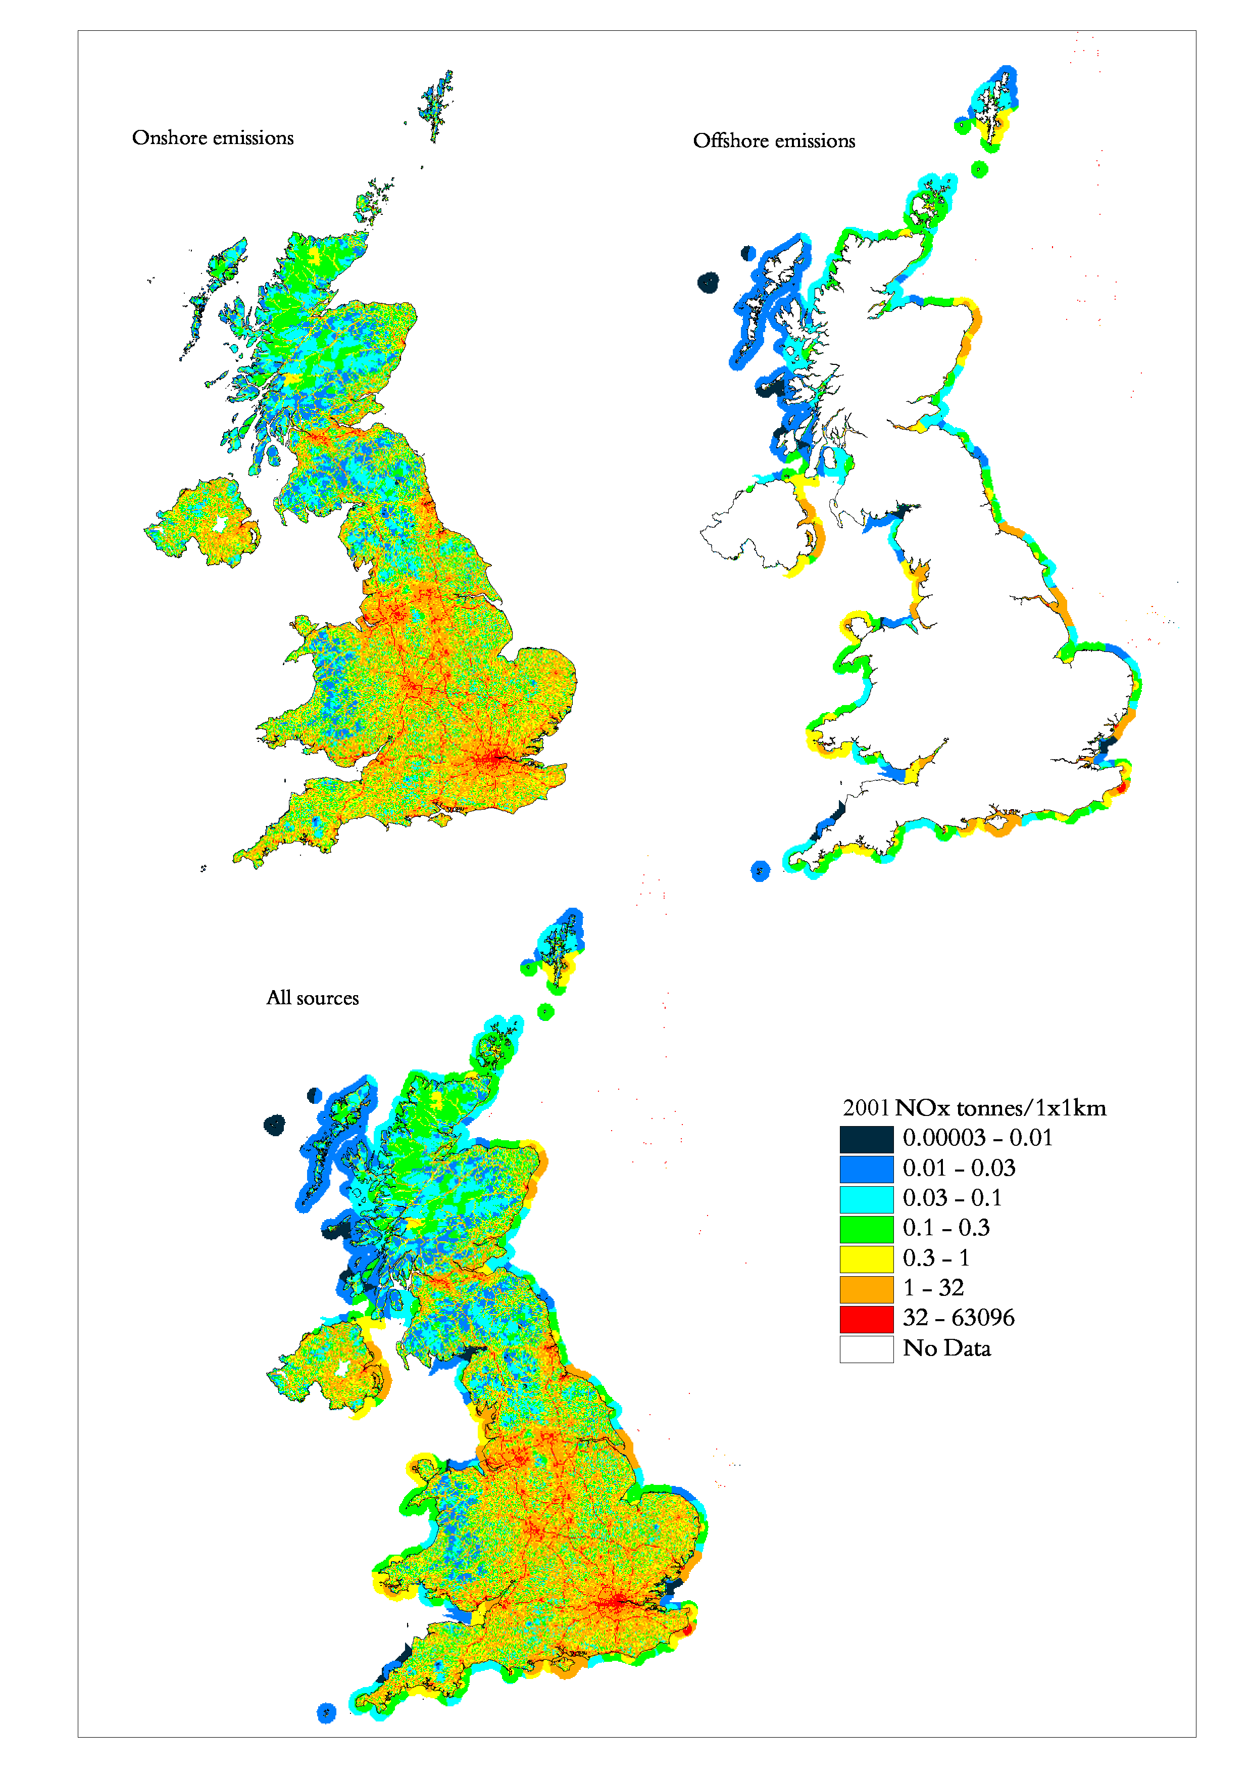

UK Pollution InventorIES
The environmental regulatory authorities in the UK each manage pollution inventories for industrial emissions to air, land and water. Operators of industrial processes that are authorised under IPC (Part A) and PPC (Part A) are required to submit annual estimations of emissions of target substances, and this data is verified by the regulators and then made publicly available.

The Environment Agency of England & Wales - Pollution Inventory

The Environment Agency of England & Wales (EA) compiles a Pollution Inventory (PI) of emissions from around 2,000 major point sources in England and Wales. This requires the extensive compilation of data from a large number of different source sectors. This valuable source of information is incorporated into the NAEI wherever possible, either as emissions data, or surrogate data for particular source sectors. The information held in the PI is also extensively used in the generation of the NAEI maps, as the locations of individual point sources are known. The NAEI and the EA work closely to maximise the exchange of useful information. The PI allows access to air emissions through post code interrogation, and may be found at:-

http://www.environment-agency.gov.uk/business/444255/446867/255244/

The Scottish Environmental Protection Agency – EPER Inventory

The Scottish Environmental Protection Agency (SEPA) compiles an emissions inventory for emissions reporting under the Integrated Pollution Prevention and Control (IPPC) Directive and the European Pollutant Emission Register (EPER). The reporting of emissions is required for all activities listed in Annex I of the IPPC Directive, and under EPER requirements, emissions reporting is required for the years 2002, 2004 and 2007. Historically, the Scottish emissions inventory was managed by three regional offices, but in recent years progress has been made to allow a centralised emissions inventory for Scotland to be developed. As with the data from the EA Pollution Inventory, the point source emissions data provided via the SEPA inventory is used within the NAEI in the generation of emissions totals, factors and mapping data. The SEPA inventory can be found at:-

http://www.sepa.org.uk/data/eper/mainpage.htm

The Northern Ireland Department of Environment – ISR Inventory

The Environment & Heritage Service of the Northern Ireland Department of Environment compiles an inventory of industrial emissions for the purposes of EPER and this point source data, although not as yet available via the web, is readily available to the public via the Department itself. The NAEI utilises this valuable point source emissions data for the development of emissions totals, factors and mapping data.

http://www.ehsni.gov.uk/environment/industrialPollution/ipollution_intro.shtml

Greenhouse Gas Emissions

Introduction
Increasing atmospheric concentrations of greenhouse gases (GHGs) originating from anthropogenic activities are leading to enhanced warming of the atmosphere and global climate change. The major greenhouse gases are carbon dioxide (CO₂), methane (CH₄) and nitrous oxide (N₂O) all of which have both natural and anthropogenic sources. In contrast, the three industrial gases: hydrofluorocarbons (HFC), perfluorocarbons (PFC) and sulphur hexafluoride (SF₆), are potent greenhouse gases but do not occur in nature, and hence only originate from anthropogenic sources.

These six greenhouse gases comprise the ‘basket of emissions’ against which reduction targets were agreed at the Third Conference of the Parties of the United Nations Framework Convention on Climate Change (UNFCCC) in Kyoto, Japan in December 1997. The target for the UK is to achieve a reduction of the global warming potential of the six greenhouse gases of 12.5% by 2008-2012 (based on 1990 emissions estimates). Consequently the UK is required to compile annual emission inventories of these greenhouse gases and report the emissions to international bodies, such as the UNFCCC to demonstrate progress against its target under the Kyoto Protocol. The UK Greenhouse Gas Inventory is submitted to UNFCCC in the Common Reporting Format (CRF). The Common Reporting Format gives net carbon emissions, that is emissions minus removals. The data in this report is presented here in a UN/ECE reporting format (see Annex 1) and quotes land use change and forestry emissions and removals separately. More detailed information may be found in the annual report on UK GHG emissions produced by the NAEI (Baggott et al, 2004).

The 2002 emissions for each of these six greenhouse gases are summarised in Table 2.1, and their inventories are discussed in the following sections. Inventories for the three indirect greenhouse gases (carbon monoxide, nitrogen oxides and non-methane volatile organic compounds) are included in subsequent chapters (Chapters 4, 5 and 5 respectively).

The total global warming potential of UK greenhouse gas emissions has been calculated using their global warming potentials (GWPs), which measures their effectiveness in global warming relative to CO₂, agreed by IPCC for a 100 year time horizon (IPCC, 1996).

Table 2.1 GWP for UK Emissions of Greenhouse Gases in 2002
Direct GHG | Emissions (ktonnes)  in 2002 | GWP  (100 years) | Global Warming Equivalence  (equivalent kt of CO2)
CO₂ (as carbon)¹ | 146,187 | 3.7 | 540,892
CH₄ | 2,097 | 21 | 44,037
N₂O | 132 | 310 | 40,920
HFCs | 5.26 | 140-11,700² | 10,418
PFCs | 0.05 | 6,500-9,200² | 384
SF₆ | 0.07 | 23,900 | 1594
1 The emissions given here are on a UNECE basis and hence do not include land-use change emissions.
2 A number of GWPs are used as this refers to a group of compounds.

During the period 1990-2002 there has been a decrease in UK emissions of CO₂, CH₄, N₂O, HFC and PFC but considerable increases in SF₆ emissions. The overall effect has been a decrease in global warming potential from UK emissions. Figure 2.1 shows greenhouse gas emissions (comprising CO₂ , CH₄ , N₂O , HFCs, PFCs and SF₆) as CO₂ equivalent for 1990 to 2002. Reliable emission estimates of HFCs, PFCs, SF₆ and N₂O (from adipic acid production) are not available prior to 1990.

Figure 2.1 Total UK GHG Emissions, 1990-2002, CO₂ equivalent

CO₂ is the major contributor to greenhouse gas emissions in the UK and arises predominately from the combustion of fossil fuels. Non-fossil fuel sources are more difficult to assess and include the emission and uptake of CO₂ from the global carbon cycle. Following internationally agreed conventions, the NAEI excludes emissions of CO₂ originating from recently photosynthesised carbon as these will be part of the carbon cycle. Hence emissions from biomass combustion, non fossil-fuel derived components of waste incineration, landfill and sewage treatment are not included in the total. Emissions of other pollutants from biomass combustion are included in the appropriate inventories. The NAEI also currently excludes CO₂ emissions from the effect of changing land use although these emissions are estimated in the UK Greenhouse Gas Inventory (Baggott et al, 2004) and are discussed below.

Methane, like carbon dioxide, is naturally occurring and is part of the global carbon cycle. However, the magnitudes of sinks and sources of methane are not well known. Methane in the atmosphere is eventually oxidised to CO₂ and the most recent IPCC estimate of its lifetime in the atmosphere is 12±3 years (IPCC, 1996). Methane has a much greater warming effect on the climate than carbon dioxide (Table 2.1). The major anthropogenic sources of methane are waste disposal, agriculture, coal mining and leakage from the gas distribution system. Due to the nature of these sources the estimation of methane emissions is very uncertain although the methodologies are continuously being improved. Early estimates of methane emissions by sector were based on the findings of the Watt Committee on Energy (Williams, 1994), however many have now been revised to take into account new information and to ensure consistency with the methodologies recommended by the IPCC Revised Guidelines (IPCC, 1997).

The third direct greenhouse gas, nitrous oxide (N₂O), is emitted from natural and anthropogenic sources (agriculture, biomass burning, coal combustion and some industrial processes). As N₂O has a GWP of 310, it is a powerful greenhouse gas. However, emissions from the UK are low, so the overall contribution to global warming is relatively small. A full set of detailed emission factors for man-made sources, e.g. combustion, are not yet available. However, emissions are estimated using the default values given in the guidelines and more detailed data on coal combustion based on UK literature.

The three industrial greenhouse gases included in the ‘basket of emissions’ agreed at Kyoto, namely hydrofluorocarbons (HFCs), perfluorocarbons (PFCs) and sulphur hexafluoride (SF₆), have very high GWPs but the quantities emitted to the atmosphere are far smaller than the emissions of CO₂. Hence the contribution of these gases to global warming was equivalent to just 3% of the total contribution from CO₂ emissions in 1995 (Haydock et al, 2004). These are gases with particular industrial applications; HFCs and PFCs are substitutes for chlorofluorocarbons (CFC) and hydrochlorofluorocarbons (HCFC) which are being phased out under the Montreal Protocol due to their role in the depletion of ozone in the stratosphere. A more detailed description of the usage, emissions and methodology for calculating emissions of these gases is given by Haydock et al (2004).

The following sections present the inventories for each of the six greenhouse gases. To date, most international attention has focused on carbon dioxide and methane. Hence estimates of these pollutants were included in the UK inventory a number of years before the other four pollutants. This is reflected in the longer time series of data available for carbon dioxide and methane. The overall accuracy of the inventories is also discussed. Full details of the methodology used to compile the inventory and the changes which have been made since the publication of the inventory for 1999 are included in Appendices 1 and 2 respectively which can be accessed from the methodology section of the NAEI website (http://www.naei.org.uk)

CO₂ Emission Estimates

Total CO₂ Emissions
Carbon dioxide emissions in 2002 have reduced by 21% since 1970, as shown in Figure 2.2. However, this decline has not been steady, and peaks were observed in 1973 and 1979 which were due to the state of the economy, high oil prices and severe winters in these years. Emissions fell again during the early eighties reflecting the recession during this period and the coal miners strike of 1984. Since the mid-1980s the emissions profile has been much smoother showing an overall reduction in emissions. There are small increases in several sectors. The elevated emission from the domestic sector in 1996 is considered to be due to the colder than average winter (indicated by lower than average mean air temperatures).

The major emissions of carbon dioxide arise from the combustion of fossil fuels in power generation, and the transport, domestic and industrial sectors (Figure 2.2, Table 2.2). The level of emissions depends on the fuel mix and the fuel consumption data. Details of UK fuel consumption are given annually in the Department of Trade and Industry's Digest of United Kingdom Energy Statistics (DTI, 2003). The fuel consumption data used to calculate the pollutant emission totals in the NAEI are given in Table 2.3; fuels which are used as feedstocks are omitted (principally natural gas used for the production of ammonia, methanol and acetic acid and some use of LPG and OPG in petrochemical plants).

Figure 2.3 gives the CO₂ emissions mapped across the UK on a 1km x 1km grid. Fuel combustion sources are clearly dominant and occur in urban centres and across the road network. The mapping concept, and methodology, is outlined in Section 1.2.5.

Table 2.2 UK Emissions of CO₂ as Carbon by UN/ECE¹ Source Category and Fuel (Mtonnes)
 | 1970 | 1980 | 1990 | 1996 | 1997 | 1998 | 1999 | 2000 | 2001 | 2002 | 2002%
BY UN/ECE CATEGORY²
Combustion in Energy Prod
Public Power | 57.0 | 58.3 | 54.1 | 43.5 | 39.6 | 40.6 | 38.8 | 41.9 | 44.3 | 43.0 | 29%
Petroleum Refining Plants | 5.6 | 5.5 | 4.8 | 5.6 | 5.5 | 5.5 | 5.1 | 4.4 | 4.5 | 4.4 | 3%
Other Combustion & Trans. | 8.2 | 2.9 | 3.8 | 5.3 | 5.4 | 5.8 | 5.9 | 5.8 | 6.0 | 6.0 | 4%
Combustion in Comm/Res
Residential Plant | 26.5 | 23.2 | 21.5 | 24.7 | 22.7 | 23.2 | 23.1 | 23.4 | 24.3 | 23.8 | 16%
Comm/Agricul Combustion | 12.3 | 9.9 | 8.5 | 9.3 | 8.6 | 8.5 | 8.5 | 8.3 | 8.2 | 7.2 | 5%
Combustion in Industry
Iron & Steel Combustion | 1.5 | 0.4 | 0.7 | 2.0 | 2.0 | 1.9 | 1.9 | 1.8 | 1.6 | 1.4 | 1%
Other Ind. Combustion | 46.8 | 29.7 | 23.8 | 22.2 | 22.4 | 21.9 | 21.6 | 21.1 | 21.8 | 20.4 | 14%
Production Processes | 4.8 | 4.0 | 4.0 | 3.8 | 3.6 | 3.5 | 3.7 | 3.7 | 3.3 | 2.9 | 2%
Extr./Distrib. of Fossil Fuels | 0.1 | 0.1 | 0.4 | 0.2 | 0.2 | 0.2 | 0.2 | 0.2 | 0.2 | 0.3 | 0%
Road Transport | 16.3 | 21.2 | 29.7 | 31.3 | 31.7 | 31.5 | 31.8 | 31.7 | 31.8 | 31.9 | 22%
Other Trans/Machinery
Off-Road Sources | 3.1 | 3.0 | 3.2 | 2.8 | 2.6 | 2.4 | 2.3 | 2.2 | 2.0 | 1.9 | 1%
Other³ | 2.3 | 2.0 | 1.7 | 1.7 | 1.7 | 1.7 | 1.6 | 1.6 | 1.5 | 1.5 | 1%
Waste | 0.4 | 3.5 | 2.4 | 2.1 | 1.7 | 1.7 | 1.5 | 1.4 | 1.5 | 1.4 | 1%
Agriculture & Land Use Change | 0.5 | 0.4 | 0.4 | 0.4 | 0.4 | 0.3 | 0.2 | 0.2 | 0.2 | 0.2 | 0%
By FUEL TYPE
Solid | 90.2 | 70.5 | 61.4 | 39.6 | 34.4 | 34.3 | 30.5 | 31.9 | 35.7 | 32.7 | 22%
Petroleum | 67.7 | 54.5 | 52.9 | 51.5 | 49.4 | 48.2 | 47.0 | 45.9 | 46.7 | 46.1 | 32%
Gas | 22.7 | 32.2 | 38.8 | 57.8 | 58.7 | 60.7 | 63.7 | 65.0 | 64.1 | 62.8 | 43%
Non-Fuel | 4.7 | 7.1 | 6.3 | 5.8 | 5.6 | 5.5 | 5.2 | 4.9 | 4.8 | 4.7 | 3%
TOTAL | 185.3 | 164.3 | 159.3 | 154.8 | 148.1 | 148.7 | 146.4 | 147.7 | 151.3 | 146.3 | 100%
1 UK emissions reported in IPCC format (Baggott et al, 2004) differ slightly due to the different source categories used.
2 See Annex 1 for definition of UN/ECE Categories
3 Railways, civil aircraft, shipping, naval vessels and military aircraft.

Figure 2.2 Time Series of CO₂ Emissions from Key Sectors (Mtonnes)
Figure 2.3 Spatially Disaggregated UK Emissions of CO₂
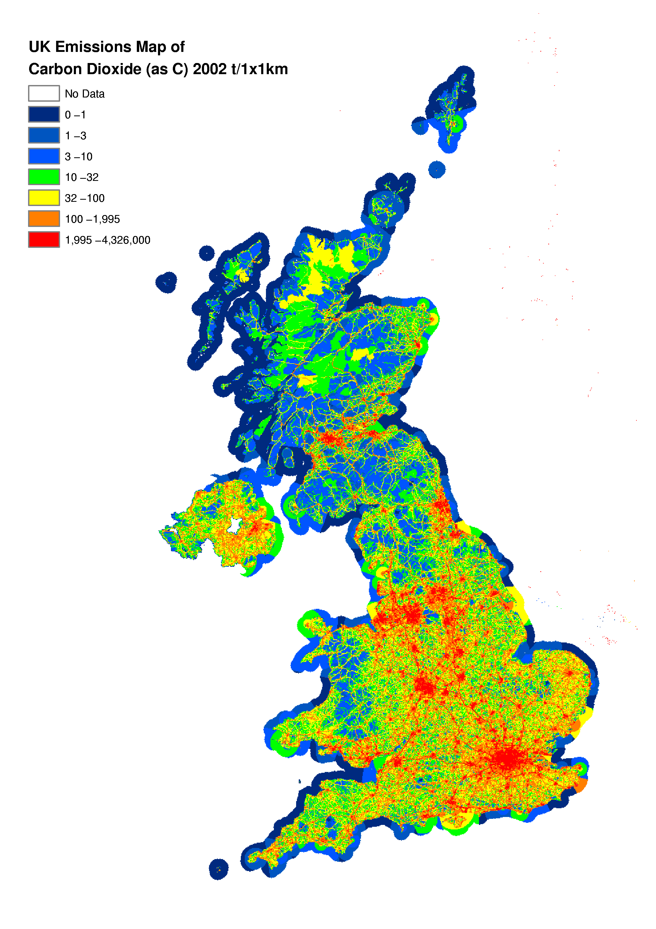

Electricity Supply Industry
The electricity supply industry is the major consumer of fossil fuels, and hence the major source of carbon dioxide emissions in the UK (Tables 2.2 and 2.3). There have been significant changes in the generating mix between 1980 and 2002, as shown in Figure 2.4. The level of CO₂ emissions is determined by both the fuel mix and the generating technology used. During the 1970s the electricity supply industry was dominated by coal and fuel oil fired thermal power stations, and coal and oil consumption increased to meet the rising demand for electricity. The use of coal for power generation peaked in 1980 at 89.6 Mt and has subsequently declined. The fall has not been steady, showing minima in 1982 and 1984 due to recession in the early 1980s and the miners strike of 1984. During the late 1980s and early 1990s, the closure of inefficient plants led to an overall increase in the thermal efficiency of the conventional thermal power plants, and the contribution of nuclear power generation increased with the greater utilisation of existing nuclear plants and the commissioning of Sizewell B in 1995. The use of oil generation peaked in 1972 and apart from increased consumption during the miners strike of 1984 has been in decline ever since. Two oil-fired stations were converted to burn Orimulsion® (an emulsion of bitumen and water) although this practice has been discontinued, largely on environmental grounds. More recently, the privatisation of the power industry has resulted in a move away from coal and oil generation towards combined cycle gas turbines (CCGT). Since 1970 the use of gas in power generation has increased by 99%, and further increases may be expected as and when more CCGT stations come on line.

Table 2.3 UK Fuel Consumption, 1970-2002
Fuel | Consumer |  | 1970 | 1980 | 1990 | 1995 | 1996 | 1997 | 1998 | 1999 | 2000 | 2001 | 2002
Coal | Major Power Prod | Mtonnes | 77 | 90 | 83 | 58 | 53 | 45 | 47 | 40 | 45 | 49 | 46
Coal | Industry | Mtonnes | 22 | 9 | 8 | 6 | 5 | 5 | 4 | 4 | 3 | 4 | 4
Coal | Domestic | Mtonnes | 20 | 9 | 4 | 3 | 3 | 3 | 2 | 3 | 2 | 3 | 2
Coal | Others | Mtonnes | 38 | 16 | 14 | 10 | 10 | 10 | 10 | 9 | 10 | 9 | 7
Other Solid Fuels | All Consumers | Mtonnes | 26 | 10 | 10 | 10 | 10 | 10 | 9 | 9 | 9 | 8 | 7
Motor Spirit | Road Transport | Mtonnes | 14 | 19 | 24 | 22 | 22 | 22 | 22 | 22 | 22 | 21 | 20
Gas Oil | Road Transport | Mtonnes | 5 | 6 | 11 | 14 | 14 | 15 | 15 | 16 | 16 | 16 | 18
Gas Oil | Industry | Mtonnes | 5 | 5 | 3 | 3 | 3 | 3 | 3 | 3 | 3 | 4 | 4
Gas Oil | Others | Mtonnes | 7 | 8 | 6 | 5 | 5 | 5 | 5 | 4 | 4 | 3 | 4
Fuel Oil | Major Power Prod | Mtonnes | 12 | 6 | 6 | 2 | 2 | 1 | 1 | 1 | 1 | 1 | 1
Fuel Oil | Refineries | Mtonnes | 4 | 4 | 2 | 2 | 2 | 2 | 2 | 2 | 1 | 2 | 2
Fuel Oil | Industry | Mtonnes | 21 | 10 | 4 | 3 | 3 | 2 | 2 | 1 | 1 | 1 | 1
Fuel Oil | Others | Mtonnes | 5 | 2 | 1 | 1 | 1 | 1 | 1 | 1 | 0 | 0 | 1
Orimulsion | Major Power Prod | Mtonnes | 0 | 0 | 0 | 1 | 1 | 0 | 0 | 0 | 0 | 0 | 0
Burning Oil | Domestic | Mtonnes | 2 | 2 | 2 | 2 | 3 | 3 | 3 | 2 | 2 | 3 | 3
Burning Oil | Others | Mtonnes | 4 | 0 | 0 | 1 | 1 | 1 | 1 | 1 | 1 | 2 | 1
Aviation Turb. Fuel | Air Transport | Mtonnes | 1 | 1 | 7 | 8 | 8 | 9 | 10 | 10 | 11 | 11 | 10
Other Pet. Products | All Consumers | Mtonnes | 1 | 1 | 1 | 2 | 2 | 2 | 2 | 2 | 2 | 1 | 1
Petroleum Gases | Refineries | Mtherms | 1011 | 987 | 1303 | 1382 | 1460 | 1378 | 1318 | 1279 | 1308 | 1194 | 1098
Petroleum Gases | Others | Mtherms | 700 | 717 | 680 | 858 | 858 | 760 | 742 | 728 | 687 | 755 | 625
Natural Gas | Major Power Prod | Mtherms | 60 | 55 | 3 | 4540 | 6029 | 7633 | 8063 | 9622 | 9683 | 9454 | 9939
Natural Gas | Industry | Mtherms | 710 | 6616 | 7016 | 7967 | 8783 | 9152 | 9698 | 10185 | 10717 | 10726 | 10375
Natural Gas | Domestic | Mtherms | 627 | 8420 | 10250 | 11124 | 12824 | 11790 | 12144 | 12218 | 12622 | 12938 | 12841
Natural Gas | Others | Mtherms | 2206 | 2188 | 3021 | 3945 | 4375 | 4172 | 4382 | 4570 | 4659 | 4747 | 4222
Other Gases | All Consumers | Mtherms | 7009 | 1126 | 1371 | 1268 | 1339 | 1394 | 1397 | 1409 | 1433 | 1310 | 1219

Figure 2.4 Generating Mix (1980-2002) Million Tonnes Oil Equivalent (Mtoe).

The effect of these changes in the power sector are clearly reflected in the carbon dioxide emissions. Since 1970 electricity generation has substantially increased but emissions have decreased by around 25%. This is due specifically to:
- The greater efficiency of the CCGT stations compared with conventional coal fired stations - around 47% as opposed to 36%.
- The calorific value of natural gas (per unit mass carbon) being higher than that of coal and oil (the inventory takes account of unrefined gas or sour gas used by some plant).
- and to a lesser extent, the proportion of nuclear generated electricity increasing to 25%.

The overall effect of the fuel and technology changes are also clearly illustrated in Figure 2.5 which shows that the average CO₂ emission (from power generation) per kWh electricity generated decreases from 245 tonnes/GWh in 1970 to 121 tonnes/GWh in 2002. This trend is likely to continue into the future through the use of more advanced technology and abatement equipment. However, the extent to which nuclear power is used in the future is expected to have a large impact on air emissions.

Figure 2.5 Average Carbon Emission per unit of Electricity Generated (ktonne/GWh)

Domestic
The domestic use of coal (including anthracite) shows an overall decline between 1970 and 2002, falling by 91%. Domestic use of smokeless solid fuels (including coke) has also fallen significantly. This reflects a trend away from solid fuels towards alternatives such as electricity and gas in the domestic sector. Over the same period the domestic use of natural gas has increased by over 95%.

Industrial
The 2002 industrial emissions show a decrease of 55% since 1970. The peaks in 1973, 1979, and 1988 were due in part to the cold winters in these years but in general the trend of industrial emissions are closely related to economic activity. The reduction in industrial energy consumption since 1970 reflects the decline in a number of energy intensive industries in the UK and improvements in energy efficiency of combustion plants. The shift from coal and oil use to more energy efficient fuels, predominately natural gas, is evident in the industrial sector between 1970-2002.

Transport
Total emissions from the transport sector have steadily increased since 1970. Of these, road transport emissions have risen by 96% and currently account for 92% of the total transport/mobile machinery emissions in 2002. This also equates to 22% of the total UK carbon dioxide emissions. Emissions fell a little during 1974-75 reflecting the increase in motor fuel prices after the oil crisis. The steady increase in fuel use by most forms of transport reflects the increased demand for transport in the UK between 1970 and 2002. The increased use of private motor vehicles has resulted in a 43% increase in the consumption of petrol from 1970 to 2002. However, petrol consumption has declined by 17% since 1990, which is a result of the increase in popularity of diesel cars, and the increased fuel efficiency of petrol driven cars. Increased use of goods vehicles is reflected in the increase in DERV consumption by 72% since 1970.

Agriculture/Forests/Land Use Change
The effect of changing land-use can result in either net emission or net absorption of CO₂ , particularly on a global scale. For example, forest clearing for agricultural use could be a net source of CO₂. Recently the Intergovernmental Panel on Climate Change agreed new guidelines for preparing national inventories (IPCC, 1997). Land use change and forestry estimates are included in the UK Greenhouse Gas Inventory (Baggott et al, 2004) for the years 1990-2002. The estimates have yet to be included in the NAEI which covers the longer period 1970-2002 (the entry under "Agriculture & Land Use Change" in Table 2.2 corresponds to the CO₂ emissions arising from the application of lime to soils). For comparative purposes the land use change estimates of carbon emissions and removals are summarised in Table 2.4 (Milne, 2003). The new guidelines for Land Use Change and Forestry include emissions from liming of soils under ‘Source D: CO₂ Emissions and Removals from Soils’. These are already included in the NAEI under Agricultural Soils.

Table 2.4 Emissions & Removals of CO₂¹ (as CO₂) from Land Use Change & Forestry (2002)
Sources |  |  | Emissions (ktonnes) | Removals (ktonnes)
A. Changes in Forest and Other Woody Biomass Stocks ¹ |  |  | - | 10,582
B. Forest and Grassland conversion |  |  | - | -
C. Abandonment of Managed Lands |  |  | - | -
D. CO₂ Emissions and Removals from Soil ² |  |  | 11,685 | 1,747
E. Other ³ |  |  | 3389 | 1,100
Total |  |  | 15,074 | 13,429
¹ Removals include removals to forest and soil litter, and to forest products.
² Emissions include removals to soil due to set aside of arable land
³ Emissions include emissions from soil due to upland drainage, lowland drainage and peat extraction. Removals are increases in crop biomass.

CH₄ Emission Estimates

Total CH₄ Emissions
Since 1970, the total methane emission in the UK has declined by 44%, although this has not been a steady decrease with emissions actually increasing throughout the seventies, reaching a peak in 1983 (Figure 2.6). There was a temporary fall in emissions in 1984 as a result of the miners strike reducing emissions from coal mines. The major sources of methane are landfill sites, livestock in the agricultural sector, leakage during the transmission and distribution of natural gas and coal mines (Table 2.5). The patterns of emissions from each of these sectors are discussed in the following sections.
Figure 2.6 Time Series of CH₄ Emissions (Mtonnes)

Landfill
Landfills are estimated to account for 20% of the UK’s methane emissions in 2002. However, the estimation model is relatively complex as it needs to take account of the wide range of different types of landfill sites in the UK and the variation in methane emissions during the lifetime of a landfill site. Methane emissions are derived from estimates of the amount of putrescible waste disposed of to landfill. Based on a model of the kinetics of anaerobic digestion of waste material, the rate of methane production from landfills is estimated. Corrections are then applied for methane recovery, utilisation, flaring and oxidation by capping soil on different landfill sites.

The trend in methane emissions from landfill shows a gradual increase to a peak in the mid 1980’s followed by a decline because of the implementation of methane recovery systems. This trend is likely to continue since all new landfill sites after 1994 must collect and utilise (or flare) the methane emissions. Similarly, since 1994 the combustion of landfill gas has been required at all existing sites in the UK which have significant remaining capacity and where significant gas production is likely. The uncertainties associated with the estimation of methane from landfills are large and it is likely that these estimates will be further refined in the future as more information becomes available.

Agriculture
The largest source of methane emissions in the UK is the agricultural sector where the emissions arise primarily from enteric fermentation in the guts of ruminant animals and from animal wastes. Emissions increased in the early seventies and have declined slowly since 1974. The methane emission is dependent on the numbers and types of farm animals, with dairy cattle being the most significant source. The recent decline results from the reduction in dairy cattle numbers in line with the 1992 Common Agricultural Policy reforms and due to gradual increases in animal productivity. It is anticipated that there will be further reductions in animal numbers leading to a continued reduction in the emission of methane from this sector.

Table 2.5 UK Emissions of Methane by UN/ECE¹ Source Category and Fuel (ktonnes)
 | 1970 | 1980 | 1990 | 1996 | 1997 | 1998 | 1999 | 2000 | 2001 | 2002 | 2002%
BY UN/ECE CATEGORY²
Combustion in Energy Prod
Public Power | 2 | 2 | 6 | 14 | 16 | 19 | 24 | 28 | 31 | 33 | 2%
Petroleum Refining Plants | 1 | 1 | 1 | 1 | 1 | 1 | 1 | 1 | 1 | 1 | 0%
Other Combustion & Trans. | 1 | 1 | 1 | 3 | 4 | 3 | 8 | 7 | 8 | 9 | 0%
Combustion in Comm/Res
Residential Plant | 326 | 139 | 65 | 37 | 34 | 36 | 39 | 29 | 32 | 28 | 1%
Comm/Agricul Combustion | 2 | 2 | 4 | 5 | 4 | 4 | 4 | 4 | 4 | 4 | 0%
Combustion in Industry | 25 | 13 | 13 | 14 | 14 | 14 | 13 | 12 | 11 | 10 | 0%
Production Processes | 9 | 8 | 8 | 8 | 7 | 5 | 4 | 4 | 3 | 3 | 0%
Extr./Distrib. of Fossil Fuels
Coal Mines | 1540 | 1269 | 818 | 473 | 445 | 378 | 310 | 264 | 243 | 244 | 12%
Gas Leakage | 88 | 354 | 398 | 368 | 352 | 349 | 349 | 336 | 343 | 339 | 16%
Offshore Oil & Gas | 13 | 42 | 92 | 66 | 66 | 60 | 43 | 39 | 42 | 33 | 2%
Gasoline Distribution | 0 | 1 | 1 | 0 | 0 | 2 | 1 | 1 | 1 | 1 | 0%
Road Transport | 22 | 25 | 29 | 22 | 20 | 18 | 17 | 15 | 13 | 12 | 1%
Other Trans/Machinery ³ | 3 | 2 | 2 | 2 | 2 | 2 | 2 | 2 | 2 | 2 | 0%
Waste
Landfill | 764 | 889 | 1131 | 892 | 806 | 729 | 626 | 552 | 487 | 420 | 20%
Non Landfill Waste | 32 | 66 | 55 | 65 | 59 | 60 | 56 | 58 | 56 | 54 | 3%
Agriculture & Land Use Change
Animal Wastes | 107 | 113 | 111 | 111 | 111 | 112 | 110 | 105 | 101 | 99 | 5%
Enteric Fermentation | 782 | 872 | 911 | 907 | 895 | 895 | 895 | 865 | 813 | 806 | 38%
Non Livestock Agriculture | 14 | 21 | 13 | 0 | 0 | 0 | 0 | 0 | 0 | 0 | 0%
By FUEL TYPE
Solid | 332 | 140 | 67 | 37 | 34 | 35 | 38 | 28 | 31 | 27 | 1%
Petroleum | 30 | 31 | 33 | 26 | 24 | 22 | 20 | 18 | 17 | 15 | 1%
Gas | 18 | 11 | 21 | 34 | 37 | 39 | 49 | 52 | 54 | 56 | 3%
Non-Fuel | 3351 | 3636 | 3540 | 2892 | 2741 | 2590 | 2396 | 2226 | 2091 | 2000 | 95%
TOTAL | 3730 | 3819 | 3662 | 2988 | 2837 | 2686 | 2504 | 2323 | 2192 | 2098 | 100%
1 UK emissions reported in IPCC format (Baggott et al, 2004) differ slightly due to the different source categories used.
2 See Annex 1 for definition of UN/ECE Categories
3 Railways, civil aircraft, shipping, naval vessels, military aircraft and off-road sources.

Coal mining
Methane emissions from coal mining have reduced significantly during the past 20 years reflecting the reduction in UK coal production. In 1970 the emission accounted for 41% of total UK emissions but by 2002 this had reduced to just 12%. The strong correlation between coal production and methane emission is clearly illustrated in Figure 2.6 by the large fall in emissions during the 1984 miners strike. The reduction in mining emissions is the most important contributor to the overall fall in methane emissions.

Leakage from the Gas Distribution System
Methane leakage from the gas distribution system increased substantially between 1970 and 1990 reflecting the growth in gas sales for domestic use, and currently accounts for 16% of UK methane emissions. Emissions are estimated based on the throughput of gas and hence are rather uncertain. However, since 1990, emission estimates are based on a sophisticated gas leakage model from TRANSCO. This model accounts for the fact that old mains are being replaced by pipeline.

Offshore Oil and Gas
Methane emissions from offshore activities only account for 2% of total UK emissions but have declined in recent years, despite the increase in the number of installations. Emissions are estimated on the basis of data provided by the operating companies to the UK Offshore Operators Association. Methane emissions from cold venting, natural gas use, well testing, fugitive emissions and flaring from offshore platforms are now all estimated separately. Of these, venting is the main source of methane. Other sources are fuel oil and gas combustion and emissions from tanker loading and unloading.

Sewage Disposal
Methane emissions from sewage disposal are fairly uncertain but are likely to be quite small. They depend on the mode of disposal: sea dumping; land spreading or incineration. The proportion disposed of in landfills is allocated to the landfill estimate. Emissions are likely to rise as a result of the EC Urban Waste Water Treatment Directive but the rate of increase will depend on the disposal routes adopted. The UK stopped dumping sewage at sea in 1998.

N₂O Emission Estimates
The major source of nitrous oxide emissions in the UK are from agricultural activities. Less significant sources include industrial processes, combustion processes in the power generation sector and road transport (Table 2.6 and Figure 2.7).

Table 2.6 UK Emissions of Nitrous Oxide (N₂O) by UN/ECE¹ Category and Fuel (ktonnes)
 | 1990 | 1995 | 1996 | 1997 | 1998 | 1999 | 2000 | 2001 | 2002 | 2002%
BY UN/ECE CATEGORY²
Combustion in Energy Prod
Public Power | 6.2 | 5.7 | 5.8 | 5.8 | 6.2 | 6.3 | 6.7 | 7.0 | 7.0 | 5%
Petroleum Refining Plants | 0.4 | 0.4 | 0.4 | 0.4 | 0.4 | 0.4 | 0.3 | 0.2 | 0.3 | 0%
Other Combustion & Trans. | 0.8 | 1.0 | 1.1 | 1.2 | 1.3 | 1.3 | 1.4 | 1.4 | 1.6 | 1%
Combustion in Comm/Res | 1.2 | 0.9 | 0.9 | 0.8 | 0.8 | 0.8 | 0.7 | 0.7 | 0.6 | 0%
Combustion in Industry | 2.0 | 2.0 | 1.9 | 1.8 | 1.7 | 1.7 | 1.5 | 1.6 | 1.5 | 1%
Production Processes | 94.5 | 61.3 | 65.5 | 67.0 | 59.5 | 18.2 | 20.2 | 17.4 | 9.9 | 7%
Extract/Distrib Fossil Fuels | 0.1 | 0.0 | 0.0 | 0.0 | 0.0 | 0.0 | 0.0 | 0.0 | 0.0 | 0%
Road Transport | 3.3 | 7.0 | 8.3 | 9.5 | 10.7 | 11.9 | 12.8 | 13.8 | 14.8 | 11%
Other Trans/Machinery³ | 3.7 | 3.5 | 3.6 | 3.4 | 3.4 | 3.2 | 3.1 | 3.0 | 2.8 | 2%
Waste | 3.7 | 3.7 | 3.8 | 4.1 | 4.1 | 4.2 | 4.1 | 4.3 | 4.2 | 3%
Land Use Change
Animal Wastes | 4.9 | 4.8 | 4.9 | 4.9 | 4.9 | 4.9 | 4.6 | 4.4 | 4.3 | 3%
Non Livestock Agriculture | 98.2 | 93.6 | 94.2 | 97.1 | 94.3 | 92.4 | 88.9 | 83.2 | 85.2 | 64%
By FUEL TYPE
Solid | 8.6 | 6.1 | 5.6 | 4.9 | 4.8 | 4.3 | 4.3 | 4.9 | 4.5 | 3%
Petroleum | 7.8 | 11.4 | 12.8 | 13.8 | 14.9 | 15.8 | 16.6 | 17.3 | 18.2 | 14%
Gas | 1.2 | 2.9 | 3.6 | 4.3 | 4.7 | 5.3 | 5.6 | 5.4 | 5.8 | 4%
Non-Fuel | 201.3 | 163.5 | 168.4 | 173.2 | 162.9 | 119.8 | 118.0 | 109.5 | 103.7 | 78%
TOTAL | 218.9 | 183.9 | 190.4 | 196.1 | 187.3 | 145.2 | 144.5 | 137.2 | 132.3 | 100%
1 UK emissions reported in IPCC format (Baggott et al, 2004) differ slightly due to the different source categories used.
2 See Annex 1 for definition of UN/ECE Categories
3 Including railways, shipping, naval vessels, military aircraft and off-road sources
Figure 2.7 Time Series of N₂O Emissions (ktonnes)

Agriculture
The calculation of emissions from agricultural soils and animal wastes have been considerably extended in recent years. In particular, the publication of the Revised IPCC Guidelines (IPCC, 1997) has enabled a greater number of sources to be considered.

The emissions from agricultural soils currently account for around 64% of total UK emissions. The most significant sources are fertiliser application and emissions indirectly from leaching.

Production Processes
The production processes sector is comprised of emissions from adipic acid manufacture (a feedstock for nylon) and nitric acid manufacture. This sector accounts for 7% of the total nitrous oxide emissions in 2002. The extent of the emission depends on the production of these acids, hence the time series reflects production levels. However, the UK manufacturer of adipic acid commissioned an abatement unit in 1998 which has significantly reduced the UK total emission.

Power Generation
The contribution from public power generation has been relatively constant between 1990 and 2002 in spite of the trend away from coal towards natural gas combustion.

Road Transport
Emissions from the road transport sector have increased significantly since 1992. This is a direct result of the introduction of three-way catalytic converters which produce significantly more nitrous oxide than cars not equipped with abatement technology. Between 1990 and 2002 the proportion of vehicle kilometres traveled by cars equipped with catalytic converters has increased from <1% to 72% (Figure 2.8) and emissions of N₂O have increased by 78%. The contribution of road transport to the total N₂O emission is small, but is one of the few sources expected to consistently increase in the future. Conversely, emissions of N₂O from the other significant sectors are expected to continue to decrease.

Figure 2.8 The Growth in the Number of Car Kilometres from Cars with Catalytic Converters
*Includes cars with failed catalysts

HFCs, PFCs and SF₆ Emission Estimates

Hydrofluorocarbons
The UK emissions of HFCs are shown in Table 2.7. The emissions are reported in terms of kilotonnes of carbon equivalent to account for their global warming potential (GWP). The HFC emissions comprise many species each with its own GWP, hence it is more helpful to express emissions in terms of GWP as Carbon equivalent. It is not currently possible to give emission estimates for individual HFCs because some of these are considered commercially sensitive data within the industries involved.

HFCs had limited usage primarily as refrigerants blended with CFCs. However, CFCs and HCFCs are being phased out under the Montreal protocol, and hence HFCs are now being used increasingly as:

- substitutes for CFCs and HCFCs in domestic, commercial and industrial refrigeration and air conditioning
- substitutes for CFCs in plastic foam blowing
- substitutes for CFCs for some medical aerosols
- substitutes for CFCs for industrial and specialist aerosols
- fire fighting fluids

Baggott et al (2004) reports the emissions, estimation methodology and ongoing improvements in some detail. The UK reports both actual and potential emissions of HFCs, although here only the actual emissions are presented.

Refrigeration is the largest source and contributed 46% of the total in 2002. Emissions arise due to leakage from refrigeration and air conditioning equipment during its life time, from losses during manufacture, and from the recovery of the refrigerants on decommissioning.

There has been a large decrease in emissions from “Halocarbon production” from 1998 to 2002, primarily due to the installation of abatement systems fitted to a plant producing HCFCs.

In the case of closed foams (where the fluid is retained within the foam) there will be some leakage of HFC from the foam during its lifetime and on disposal but with open foams all losses occur during manufacture. Since 1990, the use of HFCs in aerosols has greatly increased, and this source sector now accounts for 24% of the total emission.

The total UK emission of HFC has decreased by 8% over 1990-2002 and is characterised by the increasing use of HFCs offset by the large reduction in emissions from halocarbon production between 1998 and 2002.

Table 2.7 UK Emissions of HFCs (ktonnes C equivalent)
 | 1990 | 1995 | 1996 | 1997 | 1998 | 1999 | 2000 | 2001 | 2002 | 2002%
Halocarbon production | 3102 | 3813 | 3906 | 4261 | 3370 | 1468 | 730 | 669 | 625 | 22%
Foams & Firefighting | 0 | 46 | 66 | 61 | 54 | 49 | 59 | 98 | 216 | 8%
Refrigeration | 0 | 254 | 389 | 559 | 739 | 927 | 1101 | 1238 | 1310 | 46%
Aerosols¹ | 0 | 111 | 200 | 351 | 546 | 510 | 586 | 647 | 687 | 24%
Solvents | 0 | 0 | 0 | 0 | 0 | 0 | 1 | 2 | 2 | 0%
Total | 3102 | 4225 | 4560 | 5231 | 4709 | 2954 | 2477 | 2653 | 2841 | 100%
¹ Includes metered dose inhalers.

Perfluorocarbons
Table 2.8 shows the UK emissions of PFCs reported as kilotonnes of Carbon equivalent. It is not currently possible to give emission estimates for individual PFCs because some of these are considered commercially sensitive data within the industries involved. PFCs had limited usage prior to the phase out of CFCs in the electronics and electrical industry. PFCs are now used in:

- etching processes in the semiconductor industry
- chemical vapour deposition in the electronics industry
- soldering processes
- leak testing of electrical components
- cooling electrical component , for example in supercomputers and radar systems.

Other uses include
- refrigerant blended with HFC
- fire fighting in specialist applications
- cushioning in the soles of training shoes

Other minor uses of CFCs, which now use PFCs, include cosmetics and tracer gas.

The largest source of PFCs for 2002, representing 72% of the total, is from the aluminium production sector. The emissions are caused by the anode effect which occurs when alumina concentrations become too low in the smelter. This can cause very high electrical current and decomposition of the salt - fluorine bath. The fluorine released reacts with the carbon anode, creating PFC compounds CF₄ and C₂F₆ . Total emissions from aluminium production have declined by 79% since 1990, reflecting steps taken by the industry to reduce emissions. PFCs are also produced by the electronics sector, where emissions arise from the manufacture of semiconductors. Emissions from this sector account for 28% of the UK total in 2002.

Table 2.8 UK Emissions of PFCs (ktonnes C equivalent)
 | 1990 | 1995 | 1996 | 1997 | 1998 | 1999 | 2000 | 2001 | 2002 | 2002%
Fire-fighting | 0 | 0 | 0 | 1 | 1 | 1 | 1 | 1 | 0 | 0%
Aluminium Production | 364 | 94 | 99 | 80 | 76 | 70 | 88 | 79 | 75 | 72%
Refrigeration | 0 | 2 | 4 | 5 | 7 | 8 | 9 | 9 | 0 | 0%
Electronics & Training Shoes | 16 | 28 | 33 | 37 | 37 | 42 | 49 | 30 | 29 | 28%
Total | 380 | 125 | 135 | 123 | 120 | 122 | 148 | 119 | 105 | 100%

Sulphur Hexafluoride
SF₆ is used in the following applications:

- insulation medium in high voltage applications such as switchgear and circuit breakers
- cover gas in magnesium foundries to protect the molten magnesium from re-oxidising when it is cast
- degasser in aluminium casting applications, though its use in the UK is rather limited
- insulating gas in double glazing applications, replacing vacuum as an insulation technique
- plasma etching of polysilicon and nitrite surfaces
- atmospheric tracer for scientific studies
- cushioning in soles of training shoes

Table 2.9 shows the UK emissions of SF₆. The largest source is from magnesium manufacture, where SF₆ is used as a cover gas. It is not possible to recover the SF₆, and hence the total consumption of SF₆ is released to atmosphere. Emissions from this sector account for 58% of the UK total in 2002. Emissions in 2002 are higher than those in 1990 because SF₆ has been increasingly used in place of SO₂.

The other main sources are from the manufacture of trainers and electrical/electronic equipment. The use of SF₆ as a cushioning in trainers will be phased out in the near future. Emissions from the electrical insulation arise during the manufacture and filling of electrical switchgear and from leakage and maintenance during the equipment’s lifetime. This application has only been in use for the last 20 to 30 years and little of the equipment has been decommissioned. It is expected that users will take great care over future fluid recovery so that emissions will be minimised. SF₆ emissions have increased by 47% since 1990.

Table 2.9 UK Emissions of Sulphur Hexafluoride (ktonnes C equivalent)
 | 1990 | 1995 | 1996 | 1997 | 1998 | 1999 | 2000 | 2001 | 2002 | 2002%
SF₆ Cover Gas | 130 | 130 | 130 | 130 | 142 | 200 | 313 | 215 | 254 | 58%
Electrical Insulation | 163 | 219 | 226 | 213 | 199 | 180 | 170 | 163 | 153 | 35%
Electronics & Trainers | 0 | 0 | 0 | 0 | 12 | 16 | 16 | 16 | 24 | 5%
Electrical equipment | 2 | 3 | 4 | 4 | 5 | 5 | 6 | 4 | 4 | 1%
Total | 295 | 352 | 360 | 348 | 358 | 402 | 505 | 398 | 435 | 100%

ACCURACY of Emission Estimates OF Greenhouse Gases
Quantitative estimates of the uncertainties in the greenhouse gas emissions were calculated using direct simulation, a technique similar to Monte Carlo Simulation. This corresponds to the IPCC Tier 2 approach. This work is described in detail by Eggleston et al (1998) though the estimates reported here have been revised to reflect changes in the 2002 Inventory.

Table 2.10 Uncertainty of the Emission Inventories
Pollutant | Estimated Uncertainty %
Carbon Dioxide | +/- 2.1
Methane | +/- 13
Nitrous Oxide | +/- 230
HFCs | +/- 25
PFCs | +/- 19
SF₆ | +/- 13

It should be noted that these uncertainties primarily arise from emission factor uncertainties. Activity data is considered to be more reliable and better characterised. As a result it can be assumed that the trends identified from time series plots are considerably more reliable than an absolute emission total.

Stratospheric Ozone Depletors
Ozone, ozone depletors and ozone forming compounds (ozone precursors) are all important atmospheric pollutants for differing reasons. Ozone itself is a gas which has an irritant effect on the surface tissues of the body, such as eyes, nose and lungs. Consequently at tropospheric levels (i.e. near the surface) ozone and ozone precursors are important pollutants. Ozone emissions are not estimated by the NAEI as the direct emissions are not significant compared with photochemical formation of ozone from ozone precursors. Estimating ozone concentrations in the troposphere requires modelling, and the input of information on ozone precursors. Consequently there is a need for emission estimates of ozone precursors, and these are given in this report (for location see Table 3.1 below).

Ozone naturally occurs in the stratosphere (higher layers of the earth's atmosphere) formed by the action of ultraviolet light from the sun on oxygen molecules. At this level, ozone is beneficial to health, filtering out harmful ultraviolet rays that can cause skin cancers. Chemicals which cause stratospheric ozone depletion must therefore be estimated.

Table 3.1 Location of Ozone Depletors and Precursors in this Report
Nitrous Oxide (N₂O) | Ozone Precursor | Chapter 5:Tropospheric Ozone
NMVOCs | Ozone Precursor | Chapter 5:Tropospheric Ozone
HFCs | Stratospheric Ozone Depletor | Chapter 2: Greenhouse Gases
PFCs | Stratospheric Ozone Depletor | Chapter 2: Greenhouse Gases

Evidence suggests that stratospheric ozone depletion is being caused by anthropogenic emissions of chlorine and bromine-containing substances (halocarbons) such as: CFCs, halons, and HCFCs. HCFCs are similar to CFCs but have a lower potential for depleting ozone and in some cases are being used as transitional replacements (for example in refrigeration equipment). Emissions of methyl chloroform, carbon tetrachloride and methyl bromide also contribute to the effect.

International agreement to limit the production and consumption (and hence emission) of ozone depleting substances and phase out use of these substances was reached in 1987 through the Montreal Protocol on Substances that Deplete the Ozone Layer. This has subsequently been strengthened by a number of Amendments. In addition, the EU introduced EC Regulation 3093/94 which in some cases adopted a faster timescale for the reductions. Overall this has led to substantial reductions in the production and consumption of these substances over the last 15 years.

The NAEI does not contain emissions inventories for all of these substances individually, although some of them, such as HCFCs, are included within the emissions for non-methane volatile organic compounds (see Section 5.5 and Appendix 6).

Air Quality Strategy Pollutants

Introduction
The original National Air Quality Strategy (NAQS) published in 1997 (DOE 1997) set out a framework of standards and objectives for the air pollutants of most concern (SO2, PM₁₀, NOx, CO, lead, benzene, 1,3-butadiene and tropospheric ozone). The aim of the strategy was to reduce the air pollutant impact on human health by reducing airborne concentrations. Different pollutants have differing timescales associated with human health impacts. Therefore concentrations during episodes (both Winter and Summer) are important for some pollutants, but less so for others.

The NAQS identified air quality standards for 8 priority pollutants based on the recommendations of the Expert Panel on Air Quality Standards (EPAQS) or WHO guidance where no EPAQS recommendation existed. EPAQS was set up by the Secretary of State for the Environment in 1991, and is a panel created to “advise, as required, on the establishment and application of air quality standards in the UK… taking account of the best available evidence of the effects of air pollution on human health…”. The NAQS has been subject to periodic review, with consultation documents being published in 1998 and 2001 (DETR 1998a, Defra 2001).

The NAQS then evolved into the Air Quality Strategy for England, Scotland, Wales and Northern Ireland (AQS for ESWNI), with the same goals. A second edition of the strategy was published in 2000 (DETR 2000), identifying further revisions and focused on the incorporation of air quality limit values in European Directives, and the impacts of devolution.

In 2002, following consultation, new objectives were announced for particles, benzene, carbon monoxide and polycyclic aromatic hydrocarbons (Defra, 2003). More details can be found at the Defra website (Defra news release 323/02 on www.defra.gov.uk). The situation for Scotland differs slightly - the Air Quality (Scotland) Amendment Regulations came into force on 12 June 2002. More detailed information can be found on the Scottish Executive website (Scottish Executive News Release SEen057/2002 on www.scotland.gov.uk). For Wales, similar information is available from the Welsh assembly web pages (http://www.wales.gov.uk).
In addition to the above, Local Authorities in the UK have a duty, under the 1995 Environment Act: Part IV, to review and assess air quality in their areas. The Air Quality Regulations 2000 define a staged process of review and assessment on the basis of guidance provided by Defra and the Devolved Administrations. The first stage primarily involves the collection of existing data on air quality measurements and emission sources for the 8 pollutants of interest in the AQS for ESWNI. These data are then used to define whether there is likely to be an air quality problem in a specific future year (depending on pollutant). The second and third stages require the use of increasingly sophisticated monitoring and modelling tools to identify hotspots of pollution and to determine whether or not the relevant air quality objectives will be met in each area.

The NAEI is being used as an important source of data for the compilation of appropriate local inventories. Table 4.1 summarises the total 2002 emissions of the 9 priority pollutants covered by the AQS for ESWNI.

Table 4.1 Total UK Emissions of AQS Pollutants
Pollutant | Total 2002 emission (ktonnes)
PM₁₀ | 161
Carbon Monoxide | 3238
Benzene | 13.5
1,3 Butadiene | 3.7
Nitrogen oxides | 1582
Sulphur dioxide | 1002
Tropospheric Ozone | NS¹
Lead | 0.16
PAH² | 2
¹ No significant ozone emissions from anthropogenic sources
² Benzo[a]pyrene is used as an indicator for PAH, but the emission total given here corresponds to the USEPA 16 (see Section 6.2).

The following sections provide a discussion of the UK emissions for particulate matter, carbon monoxide, benzene and 1,3-butadiene whilst a full discussion of the other pollutants is included in other chapters of this report as indicated in Table 4.2.

Table 4.2 Location of Emissions and Discussion of AQS Pollutants
Pollutant | Location
PM₁₀ | Chapter 4: AQS Pollutants
Carbon Monoxide | Chapter 4: AQS Pollutants
Benzene | Chapter 4: AQS Pollutants
1,3 Butadiene | Chapter 4: AQS Pollutants
Nitrogen oxides | Chapter 5: Acidifying Gases & Ozone Precursors
Sulphur dioxide | Chapter 5: Acidifying Gases & Ozone Precursors
Tropospheric Ozone | Chapter 5: Acidifying Gases & Ozone Precursors
Lead | Section 6.3: Heavy Metals
PAH | Section 6.2: Persistent Organic Pollutants

Particulate Matter

Introduction
Historically, interest in particulate matter focused mainly on smoke which can cause health problems especially in combination with other pollutants. The classic example was emissions of smoke and sulphur dioxide leading to the London smogs in the 1950s and early 1960s when several thousand excess deaths were recorded. Smoke emissions have fallen significantly as a result of the Clean Air Act eliminating domestic coal combustion in many urban areas. However, there is increasing interest in the measurement of fine particles, such as those arising from the combustion of diesel fuel in the transport sector, and aerosol concentrations in the atmosphere from other sources which may have harmful effects. Recent epidemiological evidence is linking concentrations of particles in the atmosphere with human health effects. Indeed, current ambient mass concentrations are thought to be sufficient to lead to increased mortality and morbidity (EPAQS, 1995).

Particles can vary widely in size and composition. Particles larger than about 30 μm (a μm is a "micrometre", or one thousandth of a millimetre) fall rapidly under gravity and those larger than about 100 μm fall out of the atmosphere so rapidly they are not usually considered. At the other end of the size scale are particles less than a tenth of a μm which are so small they do not fall under gravity appreciably, but coagulate to form larger particles that are then removed from the atmosphere.

The US PM₁₀ standard was a monitoring standard designed to measure the mass of particles less than 10 μm in size (more strictly, particles that pass through a size selective inlet with a 50% efficiency cut-off at 10 μm aerodynamic diameter). This corresponds to the International Standards Organisation thoracic convention for classifying those particles likely to be inhaled into the thoracic region of the respiratory tract. The epidemiological evidence of the effects of particulates shows good correlation in the UK between PM₁₀ concentrations and mortality or morbidity (EPAQS 1995, 2001). Therefore PM₁₀ has become the generally accepted measure of particulate material in the atmosphere in the UK and in Europe. There is also an increasing interest in the correlation between PM_{2.5} and health indicators. PM₁₀ measurements have been made in the UK for a number of years (see http://www.airquality.co.uk/archive/index.php) and their emissions have been included in the NAEI since 1995.

For many years the monitoring of particulate levels was based on the measurement of “Black Smoke”. Levels were estimated using a simple non-gravimetric reflectance method in which air is sampled through a filter and the resulting blackening measured. The method was calibrated for domestic coal smoke. When most of the emissions come from coal combustion the blackening should be approximately proportional to the mass concentrations. In the 50s and 60s, domestic coal combustion was the dominant source of black smoke and hence this method gave an indication of the concentration. The NAEI estimates of black smoke emissions were extended in 1988 to include emissions from all fuel combustion. Prior to 1988 only emissions from coal combustion had been estimated and published in the Digest of Environmental Statistics.

Smoke from different sources has a different blackening effect and so there is no simple relationship between black smoke and the mass of particulate emissions. For example, typically diesel emissions have a blackening effect three times greater, mass for mass, than coal emissions, while petrol emissions are effectively an order of magnitude less. Black smoke is a poor indicator of the concentrations of particulates in the atmosphere. Current interest and the AQS is focused on PM₁₀ (particulate matter less than 10μm i.e. 10 millionths of a metre) and smaller size fractions (EPAQS, 1995). However, black smoke has been shown to have relationships with health effects and is still used as an indicator.

For completeness the following sections present emission estimates and discussion for PM₁₀ , PM_{2.5} , PM_{1.0} , PM_{0.1} . Black Smoke is included in a summarised format.

PM₁₀

Sources of emissions
PM₁₀ in the atmosphere arises from two sources. The first is the direct emission of particulate matter into the atmosphere from a wide range of sources such as fuel combustion, surface erosion and wind blown dusts and mechanical break-up in, for example, quarrying and construction sites. These are called ‘primary’ particulates. The second source is the formation of particulate matter in the atmosphere through the reactions of other pollutants such as sulphur dioxide, nitrogen oxides and ammonia to form solid sulphates and nitrates, as well as organic aerosols formed from the oxidation of NMVOCs. These are called ‘secondary’ particulates. This inventory only considers primary sources. For further information on secondary particulate see the third Quality of Urban Air Review Group report (QUARG, 1996) and the report from the Airborne Particles Expert Group (APEG, 1999)- see http://www.airquality.co.uk/archive/index.php and http://www.defra.gov.uk/environment/airquality/airbornepm/index.htm respectively.

There is currently a programme sponsored by Defra and the Society of Motor Manufacturers and Traders (SMMT) to measure PM₁₀ emissions from road transport. This programme has developed measurement techniques and aims to produce improved PM₁₀ emission factors, particulate characterisation and particle size distribution.

The main sources of primary PM₁₀ are briefly described below:
- Road Transport. All road transport emits PM₁₀. However diesel vehicles emit a greater mass of particulate per vehicle kilometre than petrol-engined vehicles. Emissions also arise from brake and tyre wear and from the re-entrainment of dust on the road surface. Emission estimates for the resuspension (or "re-entrainment") of dust have been made. However this does not fall within the UN/ECE reporting format and consequently has been reported separately.

- Stationary Combustion. Domestic coal combustion has traditionally been the major source of particulate emissions in the UK. However, the use of coal for domestic combustion has been restricted in the UK by the Clean Air Acts, and as a result other sources are more important nationally. Domestic coal can still be a significant source in Northern Ireland, some smaller towns and villages, and in areas associated with the coal industry. Other fossil fuels emit PM₁₀, with combustion of wood, gas oil and natural gas all contributing significantly to UK emissions. In general, particles emitted from combustion are of a smaller size than from other sources.

- Industrial Processes. These include the production of metals, cement, lime, coke, and chemicals, bulk handling of dusty materials, construction, mining and quarrying. Emissions from these sources are difficult to quantify due to the contribution of fugitive emissions (i.e. those diffuse emissions which are released directly into the atmosphere from a process rather than being collected in a controlled manner and then vented to atmosphere). Few UK measurements are available for these fugitive releases. Nonetheless, there have been substantial improvements in the estimation of PM₁₀ emissions from industrial processes in recent years. Usually a substantial fraction of the particles from these sources is larger than 10 μm but the large quantities emitted ensure that the fraction less than 10 μm is still substantial.

PM₁₀ Emission estimates
Emissions of PM₁₀ are shown in Table 4.3 and Figure 4.1. Emissions of PM₁₀ from the UK have declined since 1970. This is due mainly to the reduction in coal use. Domestic emissions have fallen from 222 ktonnes (41% of the total emission) in 1970 to 28 ktonnes (17%) in 2002.

Emission estimates for the resuspension of dust from roads is not included in the standard UN/ECE reporting format (and hence not included in Table 4.3). However for completeness it is given in Table 4.4 below. Estimates for resuspension are based on the deposition of primary particles from all UK sources (including vehicle tailpipes and from brake and tyre wear) that are returned to the air from the turbulence of passing vehicles. As such, resuspension to some extent double counts the emissions, but is important in reconciling road side concentration measurements.

Table 4.3 UK Emissions of PM₁₀ by UN/ECE Source Category and Fuel (ktonnes)
 | 1970 | 1980 | 1990 | 1996 | 1997 | 1998 | 1999 | 2000 | 2001 | 2002 | 2002%
BY UN/ECE CATEGORY¹
Combustion in Energy Prod
Public Power | 67 | 76 | 70 | 35 | 24 | 25 | 20 | 21 | 18 | 10 | 6%
Petroleum Refining Plants | 5 | 5 | 3 | 4 | 4 | 4 | 3 | 3 | 2 | 2 | 1%
Other Combustion & Trans. | 16 | 2 | 0 | 0 | 0 | 0 | 0 | 0 | 0 | 0 | 0%
Combustion in Comm/Res
Residential Plant | 222 | 103 | 52 | 35 | 33 | 33 | 35 | 28 | 31 | 28 | 17%
Comm/Agricul Combustion | 19 | 11 | 8 | 6 | 7 | 6 | 5 | 5 | 5 | 4 | 3%
Combustion in Industry
Iron & Steel Combustion | 18 | 8 | 9 | 6 | 6 | 5 | 4 | 4 | 3 | 3 | 2%
Other Ind. Combustion | 78 | 38 | 29 | 25 | 22 | 21 | 20 | 14 | 15 | 14 | 9%
Production Processes
Processes in Industry | 17 | 14 | 17 | 16 | 16 | 16 | 14 | 13 | 12 | 12 | 7%
Construction | 8 | 3 | 4 | 4 | 4 | 4 | 4 | 4 | 4 | 5 | 3%
Quarrying | 22 | 21 | 29 | 23 | 24 | 23 | 21 | 21 | 21 | 21 | 13%
Road Transport
Combustion | 38 | 45 | 52 | 45 | 41 | 38 | 36 | 31 | 30 | 30 | 19%
Brake & Tyre Wear | 4 | 6 | 8 | 8 | 9 | 9 | 9 | 9 | 9 | 9 | 6%
Other Trans/Machinery | 15 | 13 | 13 | 12 | 11 | 11 | 10 | 10 | 9 | 8 | 5%
Waste | 2 | 4 | 3 | 2 | 2 | 2 | 2 | 2 | 2 | 1 | 1%
Agriculture & Land Use Change | 11 | 12 | 12 | 13 | 13 | 14 | 14 | 14 | 14 | 14 | 8%
By FUEL TYPE
Solid | 356 | 197 | 136 | 78 | 65 | 63 | 59 | 49 | 50 | 38 | 23%
Petroleum | 89 | 79 | 76 | 66 | 60 | 57 | 53 | 46 | 45 | 43 | 27%
Gas | 5 | 6 | 7 | 9 | 9 | 10 | 10 | 10 | 10 | 10 | 6%
Non-Fuel | 93 | 79 | 93 | 81 | 81 | 81 | 76 | 73 | 75 | 70 | 44%
TOTAL | 543 | 361 | 311 | 235 | 215 | 210 | 199 | 179 | 180 | 161 | 100%
1 See Annex 1 for definition of UN/ECE Categories

Table 4.4 PM₁₀ Emission Estimates from Resuspension (ktonnes)
 | 1970 | 1980 | 1990 | 1996 | 1997 | 1998 | 1999 | 2000 | 2001 | 2002
Resuspension from Road Transport | 8.2 | 11.2 | 16.9 | 18.2 | 18.6 | 19.0 | 19.3 | 19.3 | 19.6 | 20.3

The geographical disaggregation of emissions is shown in Figure 4.2. There is a clear distinction between the important sources in rural and urban areas. Indeed, many of the sources do not occur inside towns and cities. While road transport accounts for only 24% of national emissions, it can account for up to 80% of primary emissions in urban areas such as London (Buckingham et. al., 1997).

Emissions from electricity generation have also recently been declining (since 1991) despite a significant growth in the electricity generated between 1970 and 2002. This is due to the move away from coal to natural gas and nuclear power for electricity generation and to improvements in the performance of particulate abatement plant at coal-fired power stations. Also the installation of flue gas desulphurisation at two power stations have reduced particulate emissions further.

Figure 4.1 Time Series of PM₁₀ Emissions (ktonnes)

Emissions from road transport have not increased, but the contribution to the total emission has increased with time due to other sectors decreasing. The contribution to the total UK emission has risen from 8% in 1970 to 24% in 2002. The main source of road transport emissions is exhaust from diesel engine vehicles. Emissions from diesel vehicles have been growing due to the growth in heavy duty vehicle traffic and the move towards more diesel cars. Since around 1992, however, emissions from diesel vehicles have been decreasing due to the penetration of new vehicles meeting tighter PM₁₀ emission regulations ("Euro standards" for diesel vehicles were first introduced in 1992).

Among the non-combustion and non-transport sources, the major emissions are from industrial processes, the most important of which is quarrying whose emission rates have remained fairly constant. Other industrial processes, including the manufacture of steel, cement, lime, coke, and primary and secondary non-ferrous metals, are collectively important sources of particulate matter although emissions from individual sectors are relatively insignificant.
Figure 4.2 Spatially Disaggregated UK Emissions of PM₁₀
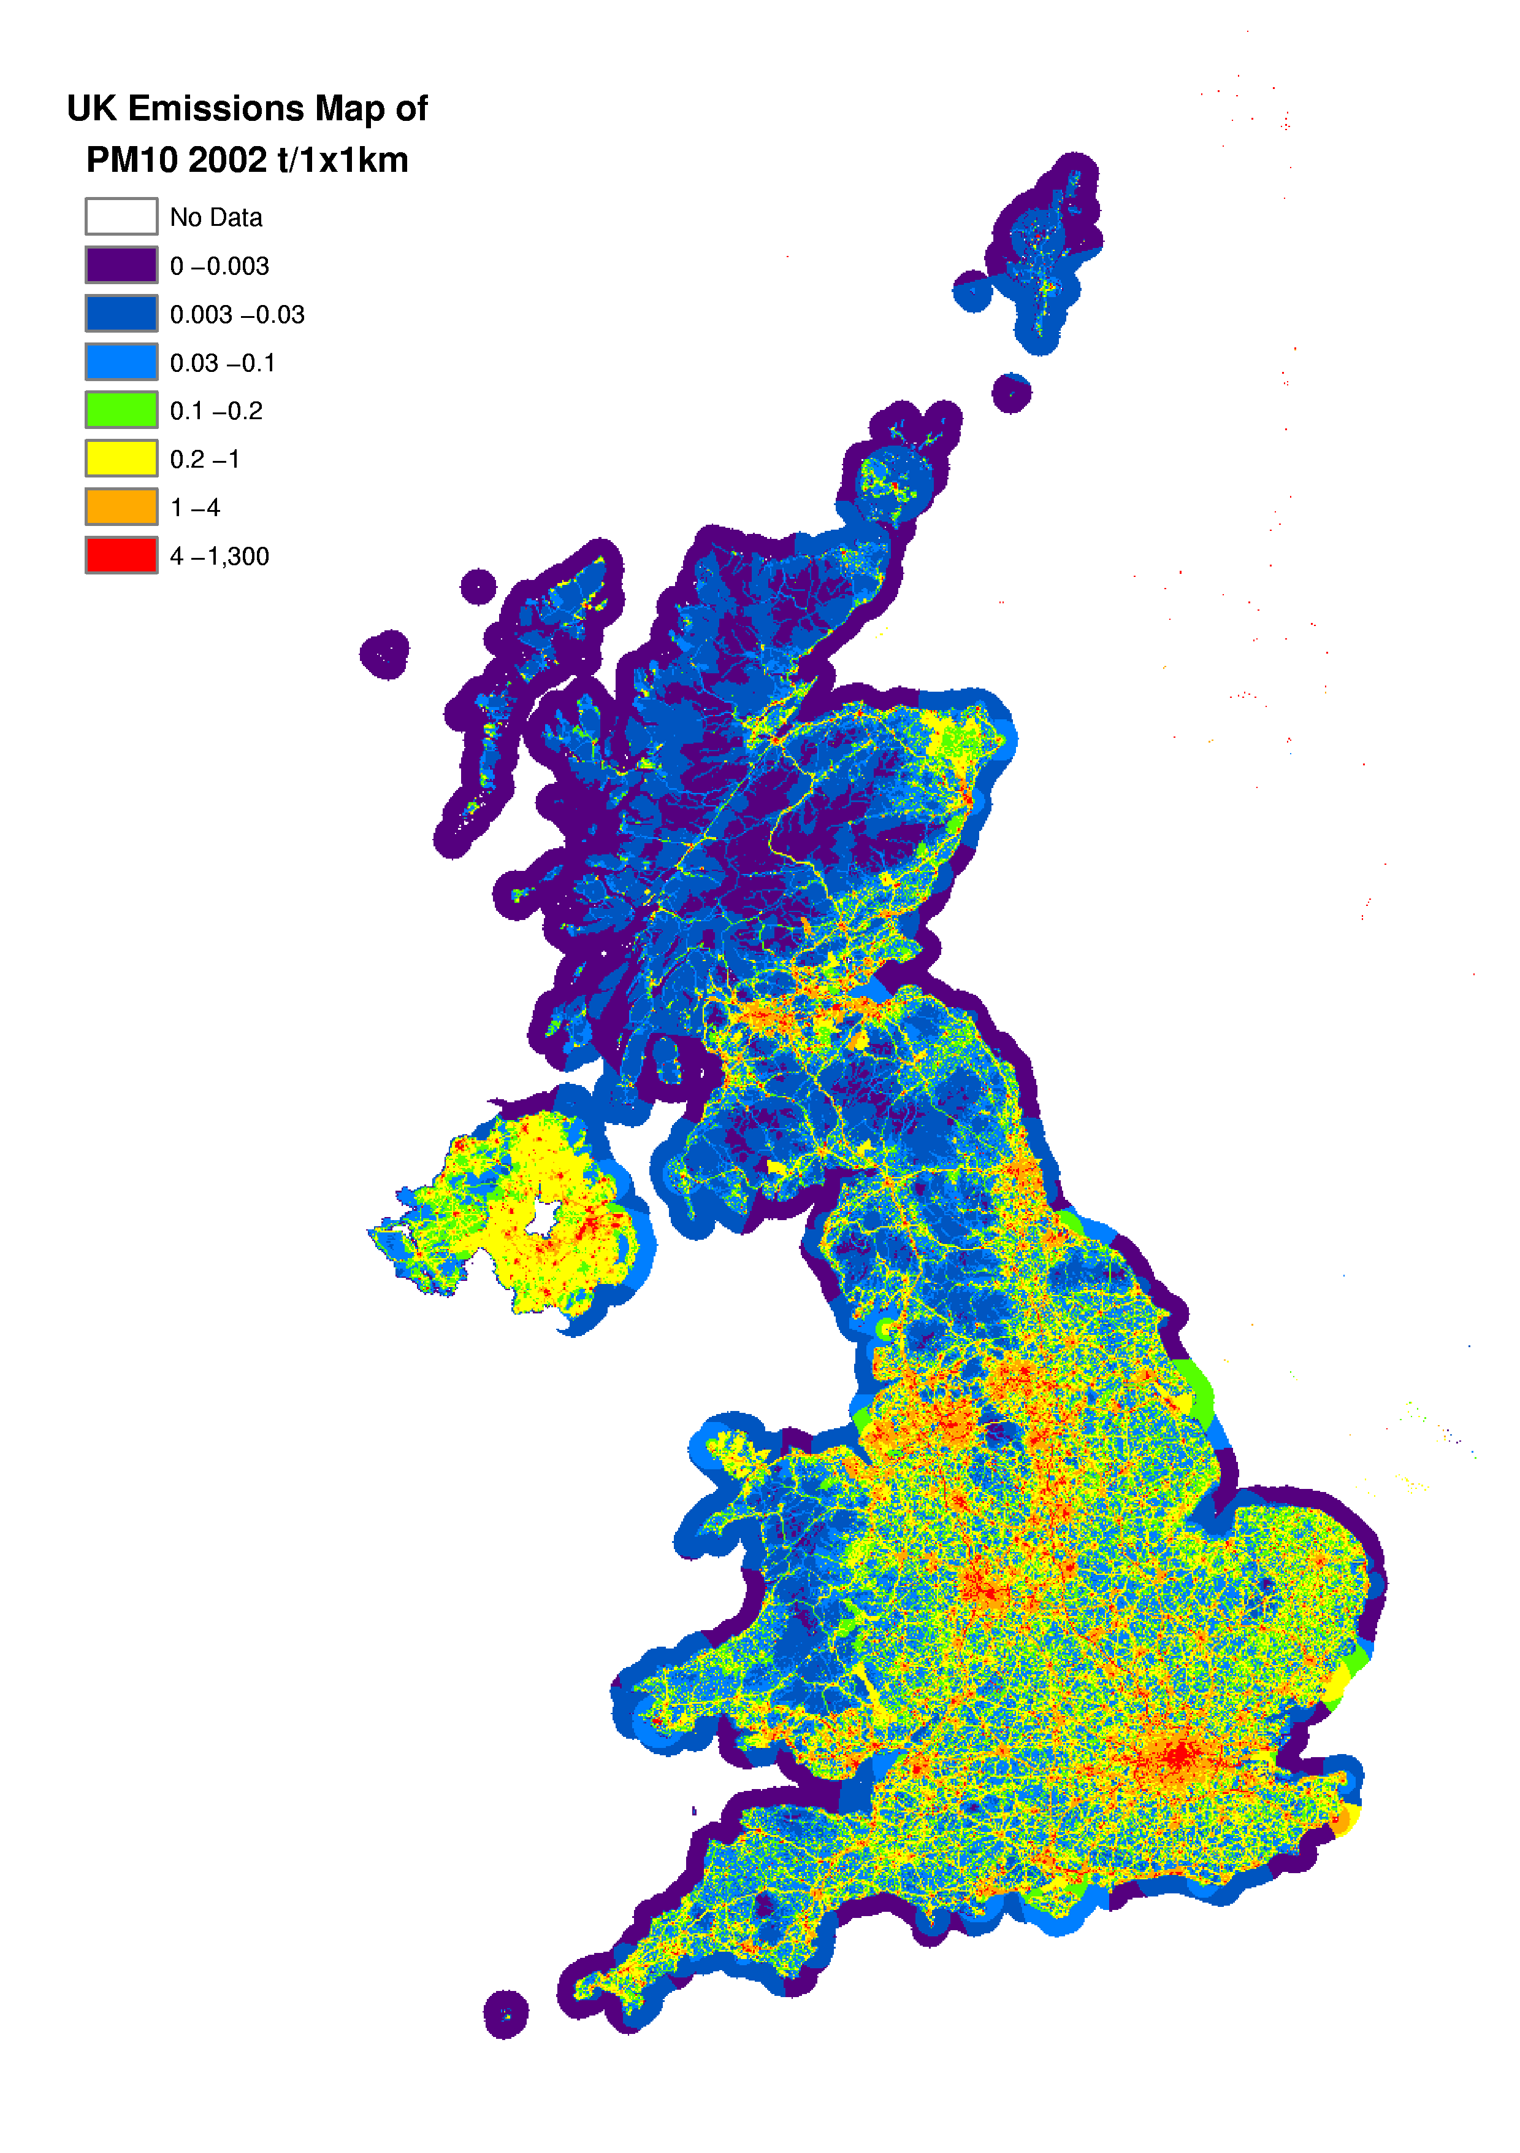

Finer Particulates: PM_{2.5}, PM_{1.0} and PM_{0.1}
Inventories for PM_{2.5}, PM_{1.0} and PM_{0.1} have been estimated from the PM₁₀ inventory and the mass fractions in these size ranges available for different emission sources and fuel types. A total of 33 different size distributions covering PM_{2.5} and PM_{1.0} emissions from different source sectors were taken from the USEPA (1995) as being applicable to sources in the UK; a smaller number of sectors with size fractions in the PM_{0.1} range were available from the study by the TNO Institute of Environmental Sciences, Energy Research and Process Innovation in the Netherlands for the Dutch National Institute of Public Health and Environment (RIVM) (TNO, 1997) which produced a particulates emissions inventory for Europe. In general, combustion processes emit a higher proportion of fine particles (<2.5 µm) than mechanical sources such as quarrying and construction. Gaseous fuels also tend to emit finer particles than petroleum and solid fuels.

Each of the detailed source sectors for which a PM₁₀ emission is estimated (a total of 236 individual sectors and sub-sectors) were allocated an appropriate size distribution and used to calculate emission inventories for PM_{2.5}, PM_{1.0} and PM_{0.1}. The results are shown in Tables 4.5-4.7 in the same format as for the PM₁₀ inventory.

Figures 4.3-4.5 show trends in emissions of each particle size by source sector. The results show a comparable decline in emissions of each particle size since 1990, although the PM_{0.1} size fractions indicate a larger decrease. Between 1990 and 2002, UK emissions of PM₁₀ fell by 48%, whereas emissions of PM_{2.5} fell by 46%, PM_{1.0} by 43% and PM_{0.1} by 38%. There is a gradual change in the relative source contribution with particle size. This is illustrated in Figures 4.2 to 4.5 which show the contribution of each sector to PM₁₀, PM_{2.5}, PM_{1.0} and PM_{0.1} emissions from 1990 to 2002. Road transport becomes an increasingly important sector as the particle size decreases. In 2002, it accounted for 25% of PM₁₀ emissions, but 52% of PM_{0.1} emissions.
Table 4.5 UK emissions of PM_{2.5} by sector (ktonnes) estimated for the mass fraction of particles below 2.5 µm in each sector in the PM₁₀ inventory
PM_{2.5} | 1990 | 1995 | 1996 | 1997 | 1998 | 1999 | 2000 | 2001 | 2002 | 2002%
Comb. in Energy Prod/Trans | 34 | 20 | 19 | 14 | 14 | 12 | 12 | 10 | 7 | 7%
Combustion in Comm/Resid | 27 | 20 | 21 | 21 | 20 | 21 | 18 | 20 | 18 | 19%
Combustion in Industry | 28 | 24 | 23 | 21 | 19 | 17 | 13 | 14 | 13 | 14%
Production Processes | 19 | 17 | 17 | 17 | 16 | 15 | 14 | 14 | 14 | 15%
Road Transport | 49 | 45 | 44 | 41 | 39 | 37 | 33 | 32 | 32 | 34%
Other Transport | 10 | 9 | 9 | 9 | 9 | 8 | 8 | 7 | 7 | 7%
Waste Treatment & Disposal | 3 | 2 | 2 | 2 | 2 | 2 | 2 | 3 | 1 | 2%
Agriculture/Forestry | 2 | 2 | 2 | 2 | 2 | 2 | 2 | 2 | 2 | 2%
TOTAL | 173 | 140 | 137 | 125 | 121 | 115 | 102 | 102 | 93 | 100%

Table 4.6 UK Emissions of PM_{1.0} by Sector (ktonnes) Estimated for the Mass Fraction of Particles below 1 µm in each Sector in the PM₁₀ Inventory
PM_{1.0} | 1990 | 1995 | 1996 | 1997 | 1998 | 1999 | 2000 | 2001 | 2002 | 2002%
Comb in Energy Prod/Trans | 16 | 10 | 10 | 7 | 8 | 7 | 7 | 6 | 4 | 6%
Combustion in Comm/Resid | 19 | 13 | 15 | 14 | 14 | 15 | 13 | 14 | 13 | 18%
Combustion in Industry | 18 | 16 | 15 | 13 | 12 | 11 | 9 | 10 | 9 | 13%
Production Processes | 9 | 8 | 8 | 8 | 8 | 7 | 7 | 7 | 7 | 10%
Road Transport | 42 | 38 | 37 | 34 | 32 | 31 | 27 | 26 | 26 | 38%
Other Transport | 9 | 8 | 9 | 8 | 8 | 8 | 7 | 7 | 6 | 9%
Waste Treatment & Disposal | 3 | 2 | 2 | 2 | 2 | 2 | 2 | 3 | 1 | 2%
Agriculture/Forestry | 2 | 2 | 2 | 2 | 2 | 2 | 2 | 2 | 2 | 3%
TOTAL | 119 | 98 | 97 | 89 | 86 | 82 | 73 | 74 | 68 | 100%

Table 4.7 UK Emissions of PM_{0.1} by Sector (ktonnes) Estimated for the Mass Fraction of Particles below 0.1 µm in each Sector in the PM₁₀ Inventory
PM_{0.1} | 1990 | 1995 | 1996 | 1997 | 1998 | 1999 | 2000 | 2001 | 2002 | 2002%
Comb. in Energy Prod/Trans | 6 | 4 | 4 | 3 | 3 | 3 | 3 | 3 | 2 | 6%
Combustion in Comm/Resid | 3 | 3 | 3 | 3 | 3 | 3 | 3 | 3 | 2 | 8%
Combustion in Industry | 8 | 7 | 7 | 6 | 6 | 5 | 5 | 5 | 4 | 15%
Production Processes | 2 | 2 | 2 | 2 | 2 | 2 | 2 | 2 | 2 | 6%
Road Transport | 22 | 21 | 21 | 19 | 18 | 18 | 16 | 15 | 15 | 52%
Other Transport | 2 | 2 | 2 | 2 | 2 | 2 | 2 | 1 | 1 | 4%
Waste Treatment & Disposal | 0 | 0 | 0 | 0 | 0 | 0 | 0 | 0 | 0 | 1%
Agriculture/Forestry | 2 | 2 | 2 | 2 | 2 | 2 | 2 | 2 | 2 | 7%
TOTAL | 47 | 41 | 40 | 37 | 36 | 34 | 31 | 31 | 29 | 100%

Figure 4.3 Time Series of PM_{2.5} Emissions (ktonnes)
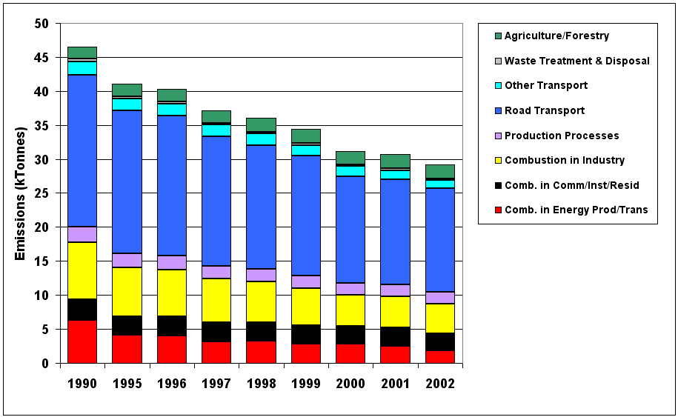

Figure 4.4 Time Series of PM_{1.0} Emissions (ktonnes)
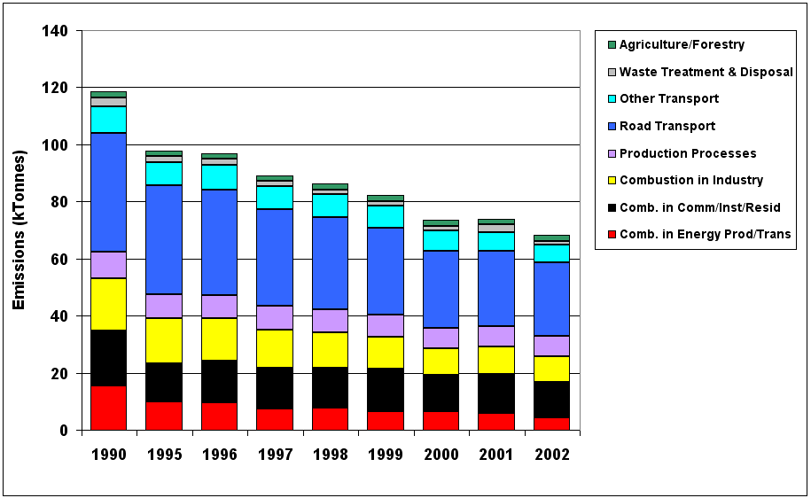

Figure 4.5 Time Series of PM_{0.1} Emissions (ktonnes)
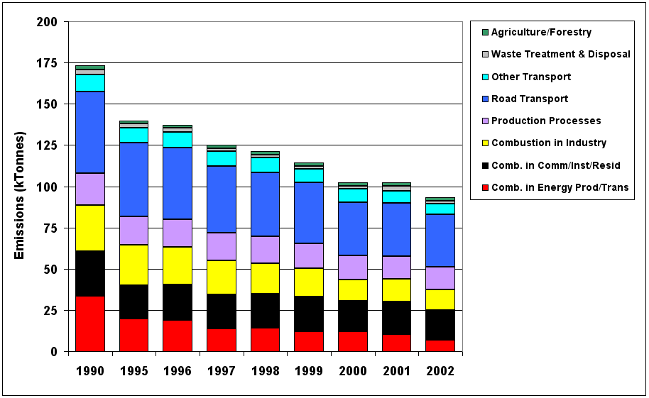

Air Quality Expert Group (AQEG) review
The NAEI has recently been carrying out a review of PM emission factors for a range of industrial processes, combustion, mining and quarrying and construction. It has highlighted some of the major uncertainties, made recommendations of changes to emission factors for specific sources to be adopted in the next inventory compilations and suggested further areas of research. This activity has in part been undertaken to aid the deliberations of AQEG which has recently published a draft report for consultation entitled “Particulate Matter in the United Kingdom”. This report considered sources of particulate matter in the atmosphere, including those directly emitted from sources and those formed in the atmosphere by chemical processes involving other pollutants released into the air.

A Recent Review of Particulate Matter Emission Factors for Industrial Processes and Combustion

Analysis of the most significant industrial emitters of PM10 and smaller particle sizes indicates several important sectors:

- ‘Coal combustion,’ and ‘Natural gas combustion’ for power generation public utility power stations or other industry sub sectors,
- ‘Iron and steel sintering plants’,
- ‘manufacture of non-fletton bricks’

Each of these sectors and the manufacture of cement clinker have been reviewed.

For many sources, the emission factor reference documents generally refer to the USEPA publication AP42 for sources of raw data (often via several other references). While AP42 is a valued reference, it is important to note that within a number of sections, emission data have not been updated for many years. This is particularly relevant to PM size speciation profiles some of which, despite advances in abatement technology, have not been updated for over a decade.

A brief summary of the main recommendations of the NAEI review and proposed changes to emission factors is given in the following sections.

Review of Industry Processes
The review of industrial emissions of PM10 has highlighted several issues including the fundamental question of what is PM10 when emitted from a process. In general, the NAEI has included emission estimates based on a ‘filterable’ PM10 release. However, the emission factors within the NAEI for natural gas combustion assessed in this Task also include a ‘condensable’ fraction.

The US Environmental Protection Agency (USEPA) defines two fractions to a PM10 emission from an industrial or combustion source. The filterable PM10 fraction in a stack emission can be determined using USEPA Method 201A and is essentially material which is smaller than nominally 10μm (separated from larger PM using a miniature cyclone) and which can be retained by a filter at stack temperature. Condensable PM is also considered to be PM10 and is material collected downstream of the sampling filter from probe rinses and material collected within a chilled impinger train (USEPA Method 202).

The test procedure for condensable PM (Method 202) is an official USEPA test procedure and emission inventories in the US are required to consider both filterable PM10 and the condensable PM10 emissions. However, the test method has been subject to considerable debate concerning whether it provides data representative of condensable emissions. It is intended to replicate secondary formation of particulate by condensation downstream of the stack. However, although the sampling procedure lowers the temperature of the sampled gases, there is no concurrent dilution action. Interferent effects are also possible. Limited evidence from dilution tunnel experiments suggests that Method 202 may overestimate condensable emissions.

The NAEI incorporates PM10 data reported by process operators to the regulatory authorities. The regulatory authorities require operators of selected processes to report PM10 emissions for inclusion in the Environment Agency Pollution Inventories (or EPER) above a threshold of 10 tonnes per year. This information is then incorporated into the NAEI. The methodologies adopted by process operators for estimating PM10 emissions includes a mixture of direct measurements, emission factors, or factors applied to a total particulate emission.

The protocol for inventory reporting adopted by the Electricity Supply Industry Joint Environment Programme (JEP) is typical in that it applies a PM10 factor to the total particulate emission. The JEP protocol states that the ESI total particulate emission data for coal-fired stations are based on continuous monitoring systems. These systems do not monitor the condensable fraction. Similarly other operators may base emissions data on short-term measurements of particulate emission, which almost certainly do not include assessment of the condensable fraction. Conversely, other operators may include condensable material in their reports through use of USEPA default emission factors for their process.

The scale of these inconsistencies and their impact on the NAEI is unknown. The consistency of the Environment Agency Pollution Inventories/EPER reporting by process operators will be addressed in time by various initiatives including guidance from the regulatory authorities or operator initiatives such as the JEP protocol.

Hence, methodology issues result in inconsistencies in the treatment of PM10 within the NAEI. The bulk of existing PM10 emission data in the NAEI are for ‘filterable’ PM10 and hence, to ensure consistency within the NAEI, only filterable PM10 data should be considered. Default PM10 and other PM10 emission factors used in the NAEI for industrial and combustion sources should be reviewed to determine if any include a condensable component.

The review has concluded that for the manufacture of cement clinker, combustion of coal and iron and steel sintering processes, no changes to the current PM10 emission factors should be made, but further work is required to develop more robust particle size speciation data for these sources. Currently used USEPA speciation data are considered out-of-date and not appropriate for UK plant. For the manufacture of non-fletton bricks, both a revision to the PM10 emission factor and measurements of size speciation data are recommended.

Review of Emissions from the Combustion of Natural Gas
Natural gas is a key fuel for industry and power generation. The combustion of natural gas appears in the highest five emitters of particulates for several PM fractions. This is perhaps surprising given the inherent low potential for particulate emission from combustion of refined gas. The scale of gas use is increasing and the significance of the sector is increasing as other sources decline. The emission of PM from combustion of natural gas is also significant for the ‘other industry’ sector.

At present, the UK Electricity Supply Industry JEP inventory reporting protocol reports PM10 emissions from gas combustion as zero or operators report emissions below the reporting threshold (10 tonnes per year). However, the NAEI estimates UK emissions of PM10 from combustion of natural gas using emission factors and activity statistics. For the electricity supply industry the NAEI default emission factor is currently 154 kg/Mtherm however, the source of this factor is unclear. The default factor is about half the USEPA emission factor for total PM (filterable and condensable PM), which is currently used for the ‘other industry’ and other gas combustion sectors within the NAEI (338 kg/Mtherm).

The review indicates that the USEPA emission factor for filterable PM from combustion of natural gas (84 kg/Mtherm) should be used by the NAEI in all sectors. Measurement of filterable PM10 at a power station combined cycle gas turbine for Defra and a smaller gas turbine for the EA and data for gas combustion published by EMEP, indicate PM10 emission factors of similar order to the default USEPA factor. However, it should be noted that these emission measurements are likely to have a high uncertainty.

The proposed emission factor is approximately half that of the current ‘default’ factor used for electricity generation but is traceable and is consistent with PM10 emissions from combustion in other areas of the NAEI (that is it is consistent with the definition of PM10 from other sources reported to the Pollution Inventory). Application of the filterable emission factor to combustion of gas in the domestic sector represents a 75% reduction in the emission factor currently used. The consequences of this change to estimates of low-level emissions of PM10 in urban areas can be expected to be significant and requires evaluation in the inventory.

Review of Emissions from Mining, Quarrying and Construction
A review of PM emissions from these sectors has been carried out, although the results of the review were available too late to be incorporated in the current version of the NAEI.

The existing methodologies, which were extremely simplistic, were compared with the approach given by the US EPA, the only source which has been found for emission factor information for these sectors. As a result, the methodology for estimating emissions of PM10 from both quarrying and construction will be revised for the next version of the NAEI. The revisions will lead to a substantial decrease in the estimates of emissions from both sectors as shown by the example of 2002 estimates given below:

Table 4.8 Revised estimation of emissions from quarrying and construction 2002 (ktonnes)
 | Current NAEI | Next (2003) NAEI
Quarrying | 20.6 ktonnes | 8.6 ktonnes
Construction | 4.6 ktonnes | 1.0 ktonnes

The revised estimates, while considered an improvement upon those they replace, are still subject to considerable uncertainty.

Review of Emissions from Bonfires, Bonfire Night and Accidental & Malicious Fires
A review of PM emissions from these sectors has been carried out, although the results of the review were available too late to be incorporated in the current version of the NAEI.

The NAEI currently does not include any estimates of particulate matter emissions from these sources but estimates based on the review recommendations should be included in the next version of the NAEI. The estimates shown below are provisional figures for 2002, and are subject to considerable uncertainty, probably being accurate to an order of magnitude only.

Table 4.9 Revised estimation of emissions from Bonfires, Bonfire Night and Accidental & Malicious Fires
Small scale waste burning | 3.6 ktonnes
Bonfire night | 0.9 ktonnes
Dwelling fires | 0.3 ktonnes
Fires in other buildings | 0.6 ktonnes
Vegetation fires (woodland) | 0.2 ktonnes
Vegetation fires (grassland) | 0.1 ktonnes
Vegetation fires (straw & hay) | 0.3 ktonnes
Vehicle fires | 0.8 ktonnes
Total | 6.8 ktonnes

It is worth noting that the estimates for grassland and woodland fires in 2003 using the same methodology would be significantly higher (1.3 and 0.8 ktonnes respectively) because of the exceptionally high incidence of major wildfires during Easter 2003.

Black Smoke
There has been less interest in the emissions of black smoke in recent years. This is because PM₁₀ has superseded black smoke as an indicator of particulate material in the air. As a result, black smoke emission estimates are presented here in less detail than previous years. The total emissions are included below in Table 4.10.

Table 4.10 UK Emissions of Black Smoke by UN/ECE Source Category (ktonnes)
 | 1970 | 1980 | 1990 | 1996 | 1997 | 1998 | 1999 | 2000 | 2001 | 2002
TOTAL | 1073 | 600 | 481 | 360 | 324 | 285 | 269 | 243 | 261 | 259

Carbon Monoxide Emission Estimates
Carbon monoxide arises from incomplete fuel-combustion and is of concern mainly because of its effect on human health and its role in tropospheric ozone formation. It leads to a decreased uptake of oxygen by the lungs and can lead to a range of symptoms as the concentration increases.

The UK emissions of carbon monoxide are shown in Figure 4.6 and Table 4.11 disaggregated by source and fuel. Over the period 1970-2002 emissions decreased by 63% reflecting significant reduction in emissions from road transport, agricultural field burning and the domestic sector.
Figure 4.6 Time Series CO Emissions (Mtonnes)

The spatial disaggregation of CO emissions is shown in Figure 4.7. The observed pattern of emissions is clearly dominated by road transport emissions. A large proportion of road transport emissions are from vehicles travelling at slow speeds on urban or minor roads, hence the map shows high emissions in urban conurbations.

Table 4.11 UK Emissions of CO by UN/ECE¹ Source Category and Fuel (ktonnes)
 | 1970 | 1980 | 1990 | 1996 | 1997 | 1998 | 1999 | 2000 | 2001 | 2002 | 2002%
BY UN/ECE CATEGORY²
Combustion in Energy Prod.
Public Power | 117 | 121 | 114 | 102 | 71 | 73 | 61 | 70 | 72 | 71 | 2%
Petroleum Refining Plants | 8 | 8 | 7 | 8 | 8 | 8 | 7 | 6 | 4 | 4 | 0%
Other Combustion & Trans. | 45 | 24 | 22 | 23 | 23 | 26 | 27 | 28 | 27 | 26 | 1%
Combustion in Comm/Inst/Res
Residential Plant | 1237 | 608 | 345 | 268 | 246 | 239 | 244 | 215 | 229 | 208 | 6%
Comm/Pub/Agri Combustion | 46 | 26 | 23 | 19 | 19 | 18 | 18 | 18 | 18 | 17 | 1%
Combustion in Industry
Iron & Steel Combustion | 757 | 215 | 385 | 347 | 353 | 339 | 343 | 241 | 281 | 253 | 8%
Other Ind. Combustion | 240 | 141 | 130 | 123 | 117 | 102 | 137 | 133 | 137 | 137 | 4%
Production Processes | 217 | 182 | 238 | 235 | 240 | 217 | 200 | 214 | 211 | 154 | 5%
Extr./Distrib. of Fossil Fuels | 2 | 2 | 7 | 3 | 3 | 3 | 1 | 1 | 1 | 1 | 0%
Road Transport | 5266 | 5302 | 5375 | 4044 | 3705 | 3384 | 3035 | 2548 | 2183 | 1916 | 59%
Other Trans/Machinery
Off-Road Sources | 30 | 28 | 32 | 26 | 25 | 23 | 22 | 21 | 20 | 19 | 1%
Other³ | 584 | 512 | 428 | 408 | 407 | 407 | 406 | 405 | 404 | 404 | 12%
Waste | 6 | 48 | 34 | 28 | 23 | 24 | 20 | 19 | 19 | 18 | 1%
Agriculture & Land Use Change | 288 | 449 | 276 | 10 | 10 | 10 | 10 | 10 | 10 | 10 | 0%
By FUEL TYPE
Solid | 2242 | 993 | 880 | 741 | 691 | 667 | 654 | 522 | 581 | 525 | 16%
Petroleum | 5918 | 5866 | 5854 | 4492 | 4149 | 3825 | 3472 | 2982 | 2614 | 2345 | 72%
Gas | 43 | 36 | 41 | 61 | 58 | 61 | 67 | 70 | 65 | 68 | 2%
Non-Fuel | 639 | 774 | 642 | 350 | 353 | 322 | 337 | 355 | 376 | 300 | 9%
TOTAL | 8842 | 7669 | 7417 | 5644 | 5251 | 4874 | 4531 | 3928 | 3636 | 3238 | 100%
1 UK emissions reported in IPCC format (Baggott et al, 2004) differ slightly due to the different source categories used.
2 See Annex 1 for definition of UN/ECE Categories
3 Including railways, shipping, naval vessels, military aircraft

Figure 4.7 Spatially Disaggregated UK Emissions of CO
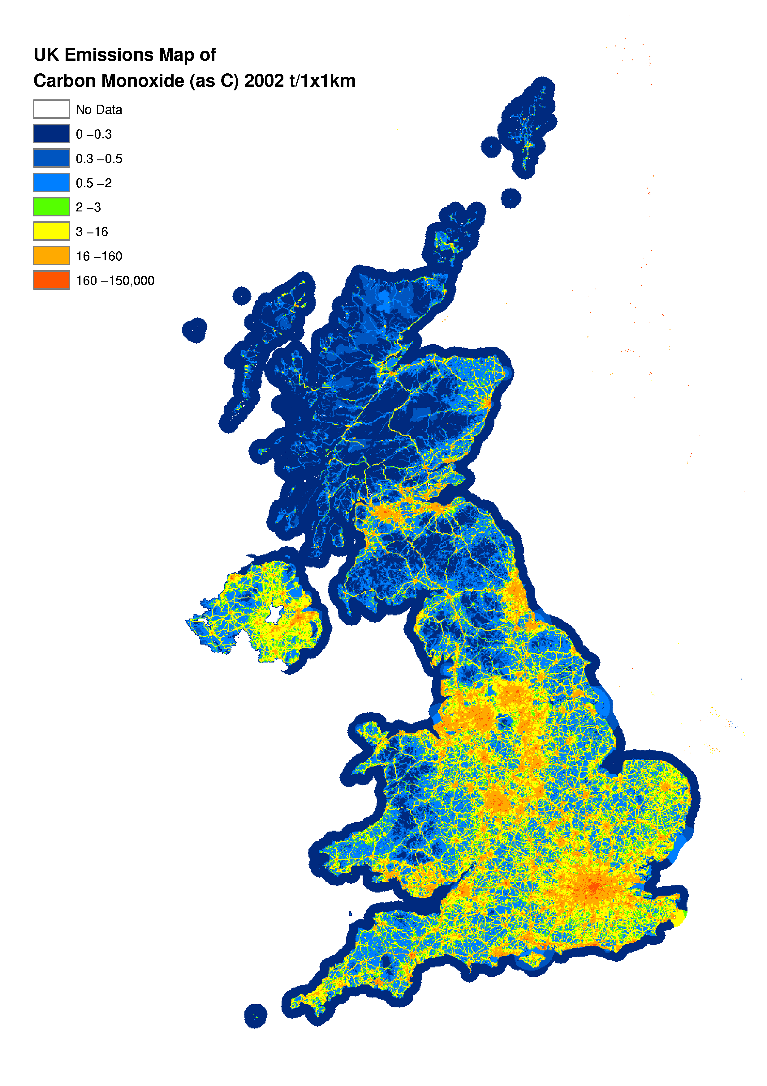

Transport
The most important source of CO is road transport and in particular petrol driven vehicles. Emissions from road transport fell only slightly between 1970 and 1990 but in recent years have declined more significantly. This is due primarily to the increased use of catalytic converters and to a lesser extent to fuel switching from petrol cars to diesel cars. The emissions from off-road sources includes portable generators, fork lift trucks, lawnmowers and cement mixers. The estimation of emissions from such machinery is very uncertain since it is based on estimates of equipment population and annual usage time.

Other Sources
Other emission sources of CO are small compared with transport and off-road sources. Combustion-related emissions from the domestic and industrial sectors have decreased by 83% and 61% respectively since 1970 due to the decline in the use of solid fuels in favour of gas and electricity. The sudden decline in emissions from the agricultural sector reflects the banning of stubble burning in 1993 in England and Wales. Currently power generation accounts for only 2% of UK emissions.

Benzene
Studies have shown that exposure to benzene gives rise to an increase in the risk of developing leukaemia, and that benzene exerts its effect by damaging the genetic make-up of cells i.e. it is a genotoxic carcinogen. Consequently it is important to understand sources of benzene and their relative strengths, and ensure that emissions do not give rise to unacceptably high concentrations of benzene.

Benzene emissions arise predominately from the evaporation and combustion of petroleum products. Emissions of benzene are dominated by the road transport sector, accounting for 33% of the 2002 emission estimate total. As benzene is a constituent of petrol, emissions arise from both evaporation and combustion of petrol. Benzene emissions for 1990 to 2002 are given in Table 4.12 and Figure 4.8 below.

Benzene emissions also arise as stack emissions and, more importantly, fugitive emissions from its manufacture and use in the chemical industry. Benzene is a major chemical intermediate, being used in the manufacture of many important chemicals including those used for the production of foams, fibres, coatings, detergents, solvents and pesticides.

Benzene emissions have been steadily decreasing since 1990. The most noticeable decrease between 1999 and 2002 arises from the road transport sector. This is because the benzene content of petrol was substantially decreased between 1999 and 2002, resulting in a corresponding decrease in emissions and due to the introduction of cars equipped with catalytic converters since 1991. Emissions from the domestic and industrial sectors are also falling, but the impact is relatively small compared with the changes in the emissions from transport.

Table 4.12 UK emissions of Benzene by UN/ECE¹ Source Category and Fuel (ktonnes)
 | 1990 | 1995 | 1996 | 1997 | 1998 | 1999 | 2000 | 2001 | 2002 | 2002%
BY UN/ECE CATEGORY¹
Combustion in Energy Prod.
Petroleum Refining Plants | 0.00 | 0.01 | 0.01 | 0.01 | 0.01 | 0.01 | 0.01 | 0.01 | 0.01 | 0%
Other Combustion & Trans. | 0.29 | 0.14 | 0.16 | 0.18 | 0.18 | 0.19 | 0.19 | 0.17 | 0.17 | 1%
Combustion in Comm/Res
Residential Plant | 4.16 | 3.19 | 3.37 | 3.21 | 3.29 | 3.40 | 3.03 | 3.18 | 3.03 | 22%
Comm/Pub/Agri Combustion | 0.11 | 0.14 | 0.15 | 0.14 | 0.14 | 0.15 | 0.15 | 0.15 | 0.14 | 1%
Combustion in Industry
Iron & Steel Combustion | 0.01 | 0.03 | 0.03 | 0.03 | 0.03 | 0.03 | 0.03 | 0.03 | 0.02 | 0%
Other Ind. Combustion | 0.72 | 0.78 | 0.81 | 0.84 | 0.78 | 0.74 | 0.76 | 0.70 | 0.58 | 4%
Production Processes | 4.31 | 4.54 | 4.06 | 3.50 | 2.38 | 2.01 | 1.61 | 1.47 | 1.32 | 10%
Extr./Distrib. of Fossil Fuels | 1.13 | 1.18 | 1.02 | 1.38 | 1.34 | 1.16 | 0.89 | 0.88 | 0.85 | 6%
Road Transport
Combustion | 37.85 | 26.55 | 24.17 | 21.35 | 18.64 | 15.97 | 5.19 | 4.91 | 4.34 | 32%
Evaporation | 2.30 | 1.73 | 1.36 | 1.26 | 1.00 | 0.82 | 0.17 | 0.15 | 0.13 | 1%
Other Trans/Machinery | 2.44 | 2.27 | 2.31 | 2.30 | 2.22 | 2.19 | 2.17 | 2.09 | 2.03 | 15%
Waste | 0.94 | 0.91 | 0.93 | 0.89 | 0.92 | 0.92 | 0.91 | 0.90 | 0.89 | 7%
By FUEL TYPE
Solid | 3.7 | 2.8 | 2.9 | 2.8 | 2.8 | 2.9 | 2.5 | 2.6 | 2.4 | 18%
Petroleum | 42.6 | 30.6 | 27.9 | 24.9 | 21.9 | 19.0 | 7.5 | 7.2 | 6.5 | 48%
Gas | 1.5 | 1.4 | 1.5 | 1.5 | 1.5 | 1.5 | 1.5 | 1.5 | 1.5 | 11%
Non-Fuel | 6.4 | 6.7 | 6.1 | 5.9 | 4.7 | 4.2 | 3.6 | 3.4 | 3.1 | 23%
TOTAL | 54.3 | 41.5 | 38.4 | 35.1 | 30.9 | 27.6 | 15.1 | 14.6 | 13.5 | 100%
1 See Annex 1 for definition of UN/ECE Categories

Figure 4.8 Time Series of Benzene Emissions (ktonnes)

Spatially disaggregated emissions of benzene are shown in Figure 4.9. A high percentage of the total benzene emission arises from the road transport sector, and this is evident in the spatially disaggregated UK map. High emission densities (i.e. emission per 1x1 km grid square) may be found in areas of high population density, and it is apparent that the dominant emissions are arising from the road transport activities in these areas, although other urban sources do also make a significant contribution.

Road transport emissions of benzene fall with increasing speed (and then start rising at higher speeds). This results in relatively high emissions per km in urban areas, as can be seen in Figure 4.9. Although evident, motorways and other major roads are not associated with particularly high emissions evident from urban roads.

Figure 4.9 Spatially Disaggregated UK Emissions of Benzene
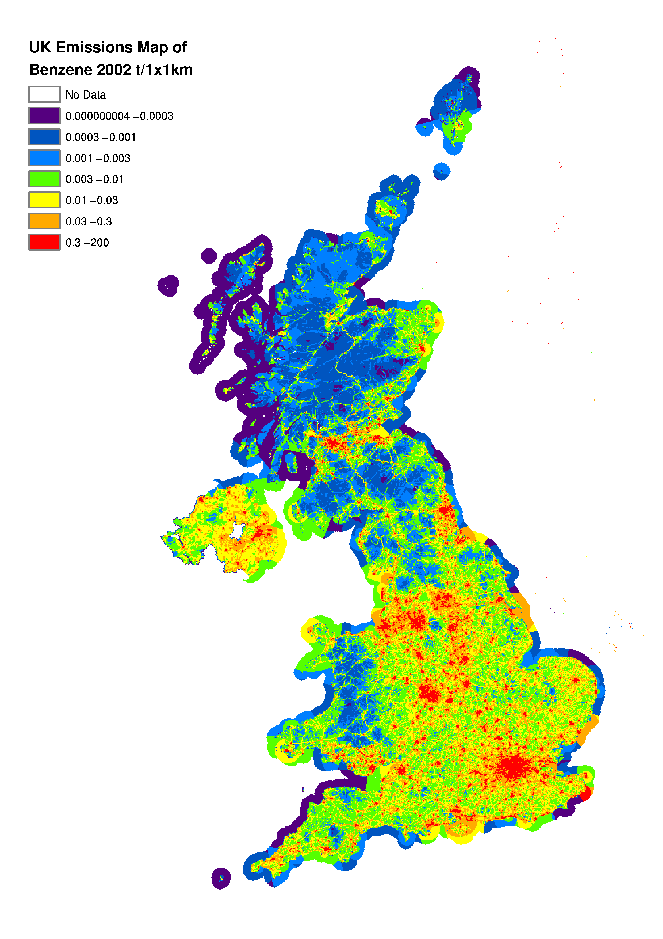

1,3-Butadiene
Studies have indicated that elevated concentrations of 1,3-butadiene give rise to a variety of cancers, and damages the genetic structures of cells i.e. 1,3-butadiene is a genotoxic carcinogen. Atmospheric concentrations have been determined at which the risk of adverse impacts is considered acceptably small, and it is therefore important to be able to understand the major sources of 1,3-butadiene which contribute to the ambient concentration.

Emissions of 1,3 butadiene arise from the combustion of petroleum products and its manufacture and use in the chemical industry. 1,3-Butadiene is not present in petrol but is formed as a by-product of combustion- hence it is not present in road transport evaporative emissions. The road transport sector dominates the UK emissions in 2002, contributing 75% of the total. Emissions of 1,3-butadiene for 1990 to 2002 are given in Table 4.13 and Figure 4.10 below.

As with benzene, the introduction of catalytic converters in 1991 has had a significant impact on the emissions from the road transport sector, causing a reduction in emissions of 74% from 1990 to 2002. Emissions from other significant combustion sources, such as other transportation and machinery, have not significantly decreased.

1,3-Butadiene emissions also arise as stack and, more importantly, fugitive emissions from its manufacture and extensive use in the chemical industry. 1,3- Butadiene is used in the production of various forms of synthetic rubber. Reported emission estimates for the chemical industry sectors (Environment Agency, 2003) have been incorporated into the NAEI.

Spatially disaggregated emissions of 1,3-butadiene are shown in Figure 4.11. Emissions of 1,3-butadiene arise almost exclusively from road transport activities, and an interesting comparison may be drawn with the UK emissions map for benzene (Figure 4.9), where other sources make a significant contribution to the total emissions. As with benzene, emissions of 1,3-butadiene per km from road transport decrease with increasing speed (but then increase at higher speeds). Consequently the emissions density is high in urban areas, and the major roads (such as motorways) are not particularly highlighted.

Benzene and 1,3-butadiene emission maps (Figures 4.9 and 4.11) may be contrasted with mapped NO_{x} emissions (Figure 5.2) as the emissions of NO_{x} at higher speeds are more significant than those for benzene or 1,3-butadiene.

Table 4.13 UK Emissions of 1,3-butadiene by UN/ECE¹ Category and Fuel (ktonnes)
 | 1990 | 1995 | 1996 | 1997 | 1998 | 1999 | 2000 | 2001 | 2002 | 2002%
BY UN/ECE CATEGORY¹
Combustion in Energy Prod. | 0.00 | 0.00 | 0.00 | 0.00 | 0.00 | 0.00 | 0.00 | 0.00 | 0.00 | 0%
Combustion in Comm/Res
Combustion in Industry | 0.01 | 0.01 | 0.01 | 0.01 | 0.01 | 0.00 | 0.00 | 0.00 | 0.00 | 0%
Production Processes | 0.91 | 0.70 | 0.52 | 0.42 | 0.33 | 0.52 | 0.38 | 0.35 | 0.28 | 8%
Extr./Distrib. of Fossil Fuels | 0.12 | 0.07 | 0.06 | 0.05 | 0.04 | 0.02 | 0.01 | 0.01 | 0.01 | 0%
Road Transport | 10.61 | 7.44 | 6.74 | 5.98 | 5.25 | 4.51 | 3.79 | 3.21 | 2.74 | 75%
Other Trans/Machinery | 0.77 | 0.69 | 0.71 | 0.69 | 0.70 | 0.67 | 0.65 | 0.63 | 0.61 | 17%
Waste | 0.02 | 0.02 | 0.01 | 0.01 | 0.01 | 0.01 | 0.01 | 0.01 | 0.01 | 0%
By FUEL TYPE
Solid | 0.0 | 0.0 | 0.0 | 0.0 | 0.0 | 0.0 | 0.0 | 0.0 | 0.0 | 0%
Petroleum | 11.4 | 8.1 | 7.5 | 6.7 | 5.9 | 5.2 | 4.4 | 3.8 | 3.3 | 92%
Gas | 0.0 | 0.0 | 0.0 | 0.0 | 0.0 | 0.0 | 0.0 | 0.0 | 0.0 | 0%
Non-fuel | 1.1 | 0.8 | 0.6 | 0.5 | 0.4 | 0.6 | 0.4 | 0.4 | 0.3 | 8%
TOTAL | 12.4 | 8.9 | 8.1 | 7.2 | 6.3 | 5.7 | 4.8 | 4.2 | 3.7 | 100%
1 See Annex 1 for definition of UN/ECE Categories

Figure 4.10 Time Series of 1,3-Butadiene Emissions (ktonnes)

Figure 4.11 Spatially Disaggregated UK Emissions of 1,3- Butadiene
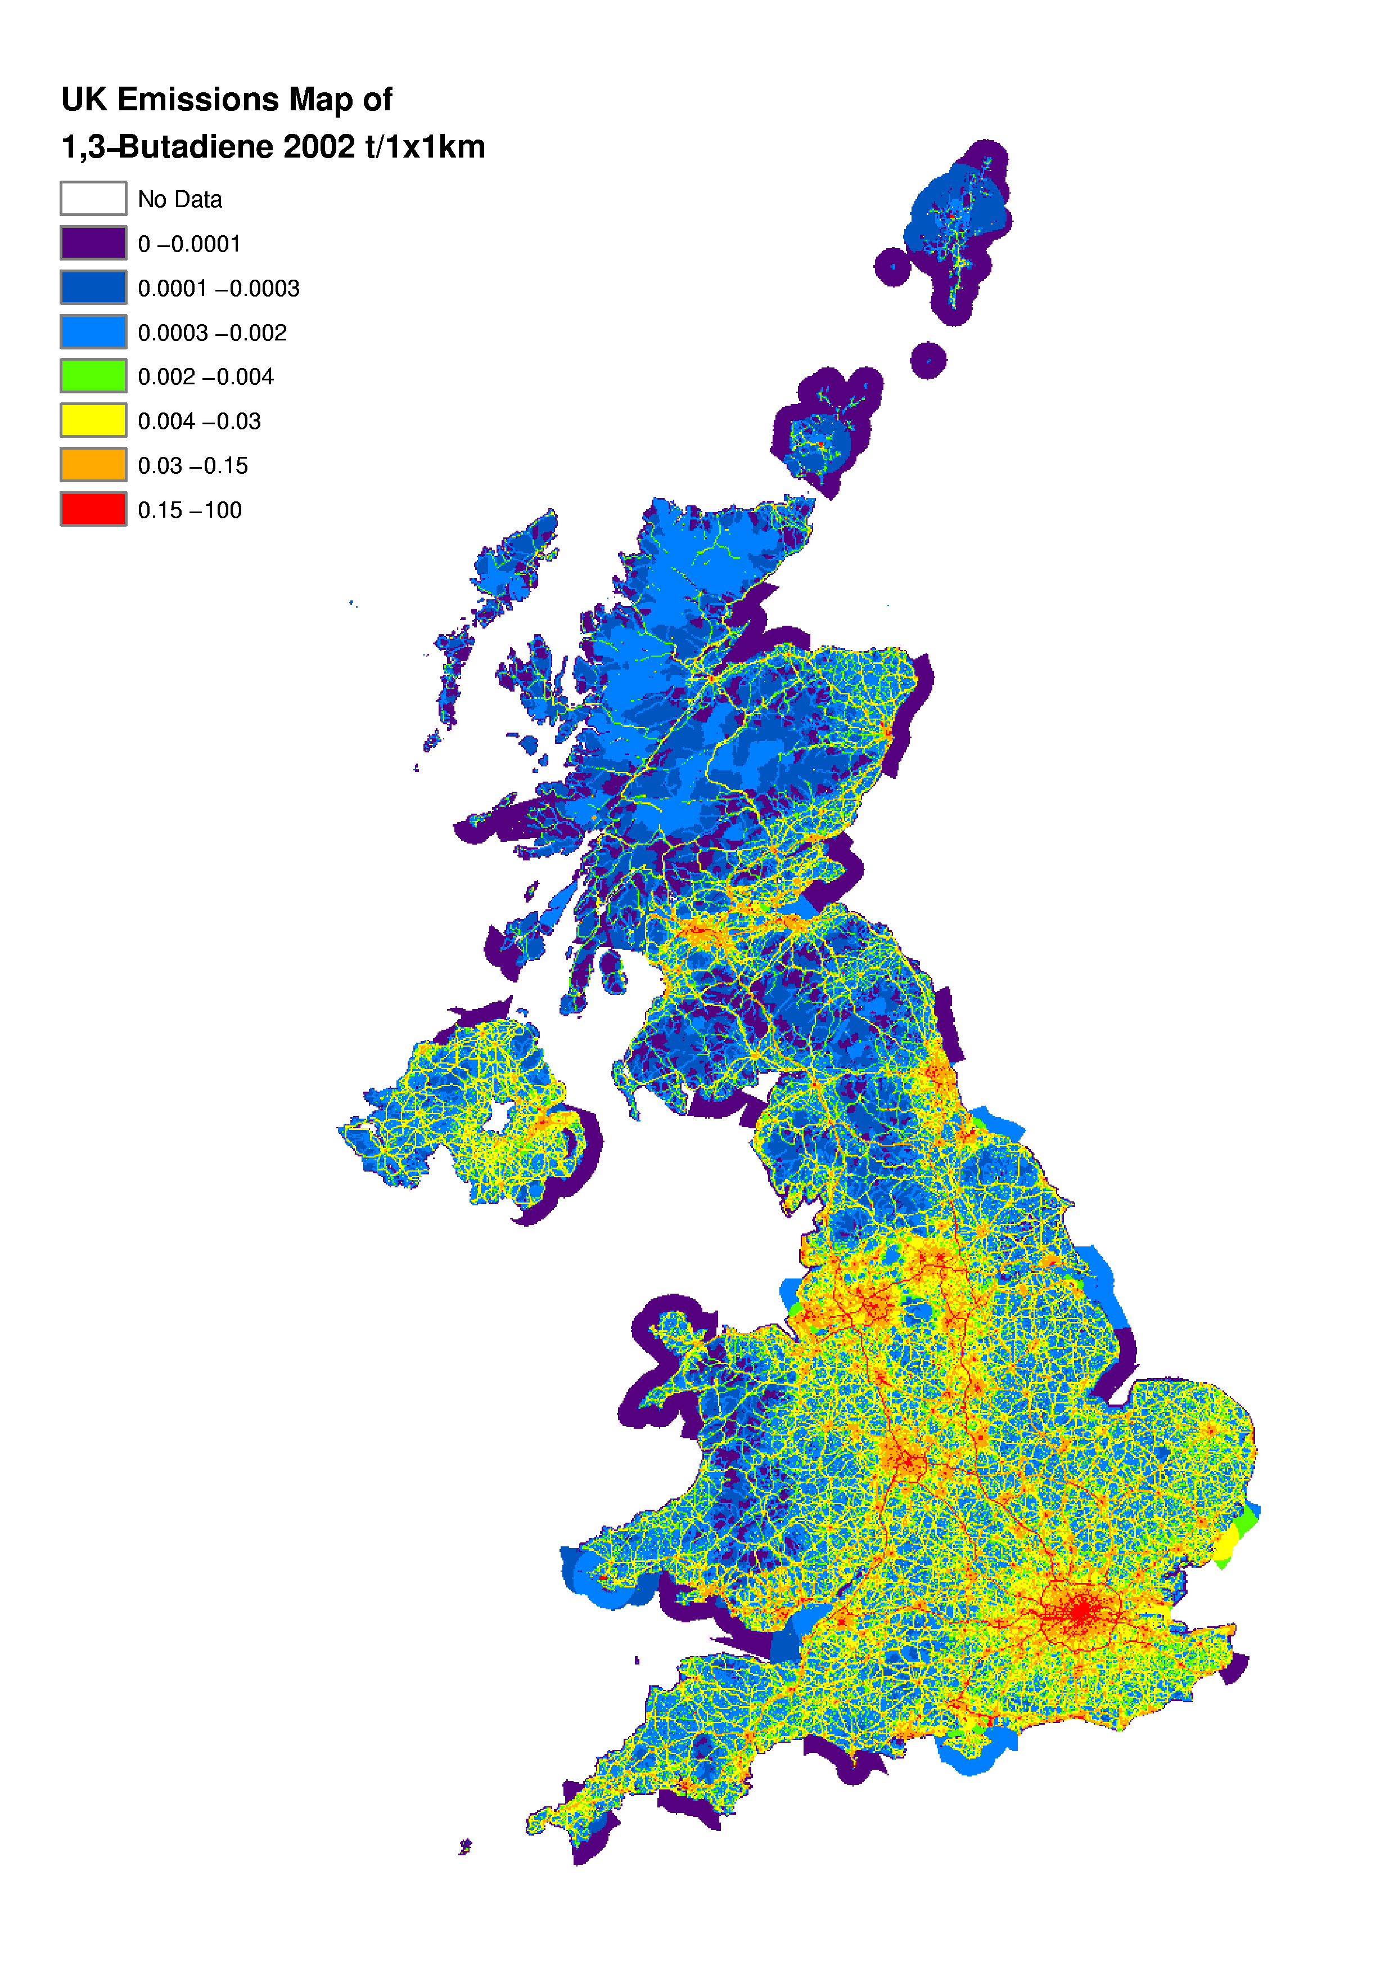

Accuracy of Emission Estimates of Air Quality Strategy Pollutants
Quantitative estimates of the uncertainties in emission inventories are based on calculations made using a direct simulation technique, which corresponds to the IPCC Tier 2 approach recommended for greenhouse gases and also the methodology proposed in draft guidance produced by the UN/ECE Taskforce on Emission Inventories. This work is described in more detail by Passant (2002b). Uncertainty estimates are shown in Table 4.14.

Table 4.14 Uncertainty of the Emission Inventories for Air Quality Strategy Pollutants
Pollutant | Estimated Uncertainty %
Carbon Monoxide | +/- 20
Benzene | -20 to + 30
1,3-butadiene | +/- 20
PM₁₀ | -20 to +50
PM_{2.5} | -20 to +30
PM_{1.0} | -10 to +20
PM_{0.1} | +/- 10
Black smoke | -50 to +90

Carbon Monoxide Estimates
Carbon monoxide emissions occur almost exclusively from combustion of fuels, particularly by road transport. Emission estimates for road transport are highly uncertain, due to the relatively small number of measurements made of emissions which appear to be highly variable. Emissions from stationary combustion processes are also variable and depend on the technology employed and the specific combustion conditions. The emission factors used in the inventory have been derived from relatively few measurements of emissions from different types of boiler. As a result of the high uncertainty in major sources, emission estimates for CO are much more uncertain than other pollutants such as NO_{x}, CO₂ and SO₂ which are also emitted mainly from combustion processes.

Benzene and 1,3-Butadiene Estimates
There has been much improvement in the benzene and 1,3-butadiene emission estimates in recent years. Information gained in speciating the emissions of NMVOC (see Section 5.5) has helped the generation of more robust emission inventories for both benzene and 1,3-butadiene. However, due in particular to the uncertainty in the levels of both pollutants in NMVOC emissions from road transport and other combustion processes, the uncertainty in these inventories is much higher than the uncertainty in the NMVOC inventory.

Particulate Matter Estimates
The emission inventory for PM₁₀ has undergone considerable revision over the last three versions of the NAEI and must be considered significantly more robust now than, say, in 1997. Nonetheless, the uncertainties in the emission estimates must still be considered high. These uncertainties stem from uncertainties in the emission factors themselves, the activity data with which they are combined to quantify the emissions and the size distribution of particle emissions from the different sources.

Emission factors are generally based on a few measurements on an emitting source which is assumed to be representative of the behaviour of all similar sources. Emission estimates for PM₁₀ are based whenever possible on measurements of PM₁₀ emissions from the source, but sometimes measurements have only been made on the mass of total particulate matter and it has been necessary to convert this to PM₁₀ based either on the size distribution of the sample collected or, more usually, on size distributions given in the literature. Many sources of particulate matter are diffuse or fugitive in nature e.g. emissions from coke ovens, metal processing, or quarries. These emissions are difficult to measure and in some cases it is likely that no entirely satisfactory measurements have ever been made.

Emission estimates for combustion of fuels are generally considered more reliable than those for industrial processes, quarrying and construction. All parts of the inventory would need to be improved before the overall uncertainty could be reduced to the levels seen in the inventories for CO₂, SO₂, NO_{x}, or NMVOC.

The approach adopted for estimating emissions of the smaller particle sizes, while it is currently the only one available, includes a number of assumptions and uncertainties. The approach depends on the PM₁₀ emission rates estimated for each sector which themselves have great uncertainties. The emission estimates for the smaller particles will be even more uncertain for a given source as there are additional uncertainties in the size fractions and their applicability to individual emission source sectors. The relevance of US and Dutch size fraction data to UK emission sources can also be questioned. Perhaps surprisingly, the inventories for the smaller particles are less uncertain overall than the PM₁₀ inventory. This is because the most uncertain PM₁₀ emissions are those from industrial processes, quarrying and construction and these sources emit very little of the finer particles, road transport dominating instead.

Black Smoke Estimates
Black smoke emissions are less accurate than those for PM₁₀ due to the fact that, since its importance as a policy tool has declined, the black smoke inventory methodology has not been revised for many years and the relevance of the emission factors used in the inventory to current industrial technology is in doubt.

Acidifying Gases and Tropospheric Ozone Precursors

Introduction
The deposition of acidifying species can have adverse effects on buildings and vegetation, as well as acidifying streams and lakes and damaging the aquatic environment. Sulphur dioxide and nitrogen oxides from fuel combustion are major contributors to acidification (Review Group on Acid Rain-RGAR, 1997). Ammonia (NH₃) plays an important part in the long range transport of the acidifying pollutants by the formation of relatively stable particles of ammonium sulphate and ammonium nitrate. Although ammonia is a basic gas it deposits to soil surfaces and has an indirect effect on acidification. The biological transformation of NH₄⁺ to NO₃⁻ in soils (nitrification) and plant uptake both release acidity into the soil contributing to acidification. NH₃ deposition can also give rise to terrestrial eutrophication- where nutrient enrichment gives rise to changes in ecosystems.

There are no significant ozone emissions from anthropogenic activities. Tropospheric, or ground level, ozone occurs naturally but atmospheric levels can be increased in-situ by the photochemical reaction of precursor pollutants such as carbon monoxide, nitrogen oxides and volatile organic compounds. Specific non-methane volatile organic compounds (NMVOC) and groups of compounds play a key role in ozone formation. Ozone episodes in which concentrations rise substantially above background levels occur in summer months when there are long periods of bright sunshine, temperatures above 20º C and light winds. Ozone can affect human health and can damage plants and crops. The total 2002 UK emissions of acidifying gases and ozone precursors are summarised in Table 5.1.

Table 5.1 Total UK Emissions of Acidifying and Ozone Precursors
Pollutant | Total 2002 emission (ktonnes)
Nitrogen oxides (as NO₂) | 1582
Sulphur dioxide | 1002
Hydrogen chloride | 58
Non-methane volatile organic compounds (NMVOC) | 1364
Ammonia | 285
Hydrogen fluoride | 5.4

The UK is committed to reducing acidifying gas and ozone precursor emissions and is a party to several protocols under the UN/ECE’s Convention on Long-Range Transboundary Air Pollution.

Under the Second Sulphur Protocol, the UK must reduce its total SO2 emissions by 50% by 2000, 70% by 2005 and 80% by 2010 (all from a 1980 baseline). The UK is well on track to meet these targets, and by the end of 2000 had achieved a 76% reduction from 1980 baseline levels, 26% ahead of the UN/ECE target level for the year 2000.

The NMVOC Protocol requires the UK to achieve a 30% reduction of anthropogenic NMVOC emissions by 1999 from a 1988 baseline. The emission estimates given in the 1999 version of the emissions inventory indicated that this was achieved. Emissions excluding those from forests fell from 2475 ktonnes in 1988 to 1577 ktonnes in 1999 - a reduction of 36%. This reduction was achieved largely as a result of emission controls for road vehicles and industrial processes, introduced by European Directives and the Environmental Protection Act 1990 respectively.

Other factors also had an impact:
- prohibition of the burning of crop residues in England and Wales since 1993, except in limited cases of exemption.
- a decline in the use of coal as a fuel by electricity generators, industry and domestic users in favour of gas;
- a decline in the use of petrol as a fuel for cars in favour of diesel;
- improvements in technology introduced for economic reasons, or in response to health & safety legislation (e.g. the introduction of more efficient dry cleaning machines with lower emission levels);
- measures introduced either voluntarily, or in response to pressure from end-users for improved environmental or health and safety performance (e.g. the formulations of many consumer products have been changed, resulting in lower levels of solvent in those products and therefore lower emissions of NMVOC during their use).

The NOx Protocol required that the total emissions of NOx in 1994 should be no higher than they were in 1987; UK emissions were 17% lower in 1994 than in 1987 and have fallen substantially since 1994.

In 1996, the UN/ECE started negotiating a new multi-effect, multi-pollutant protocol on nitrogen oxides and related substances. This was aimed at addressing photochemical pollution, acidification and eutrophication. The Protocol to Abate Acidification, Eutrophication and Ground-level Ozone was adopted in Gothenburg in December 2000, where it was signed by the UK. The multi-pollutant protocol incorporates several measures to facilitate the reduction of emissions:-

- Emission ceilings are specified for sulphur, nitrogen oxides, NH₃ and NMVOCs. These are summarised in the following table.

Table 5.2 Emissions Ceilings for 2010 (ktonnes) in the Gothenburg Protocol
Country | Sulphur  (as SO₂) | NO_{x}  (as NO₂) | NH₃ | VOC
Armenia | 73 | 46 | 25 | 81
Austria | 39 | 107 | 66 | 159
Belarus | 480 | 255 | 158 | 309
Belgium | 106 | 181 | 74 | 144
Bulgaria | 856 | 266 | 108 | 185
Croatia | 70 | 87 | 30 | 90
Czech Rep. | 283 | 286 | 101 | 220
Denmark | 55 | 127 | 69 | 85
Finland | 116 | 170 | 31 | 130
France | 400 | 860 | 780 | 1100
Germany | 550 | 1081 | 550 | 995
Greece | 546 | 344 | 73 | 261
Hungary | 550 | 198 | 90 | 137
Ireland | 42 | 65 | 116 | 55
Italy | 500 | 1000 | 419 | 1159
Latvia | 107 | 84 | 44 | 136
Liechtenstein | 0.11 | 0.37 | 0.15 | 0.86
Lithuania | 145 | 110 | 84 | 92
Luxembourg | 4 | 11 | 7 | 9
Netherlands | 50 | 266 | 128 | 191
Norway | 22 | 156 | 23 | 195
Poland | 1397 | 879 | 468 | 800
Portugal | 170 | 260 | 108 | 202
Rep. of Moldova | 135 | 90 | 42 | 100
Romania | 918 | 437 | 210 | 523
Slovakia | 110 | 130 | 39 | 140
Slovenia | 27 | 45 | 20 | 40
Spain | 774 | 847 | 353 | 669
Sweden | 67 | 148 | 57 | 241
Switzerland | 26 | 79 | 63 | 144
Ukraine | 1457 | 1222 | 592 | 797
United Kingdom | 625 | 1181 | 297 | 1200

- The protocol gives emission limits for sulphur, nitrogen oxides and NMVOCs from stationary sources.
- The protocol indicates limits for CO, hydrocarbons, nitrogen oxides and particulates from new mobile sources
- Environmental specifications for petrol and diesel fuels are given.
- Several measures to reduce NH₃ emissions from the agriculture sector are required.

The Gothenburg protocol forms a part of the Convention on Long-range Transboundary Air Pollution. More detailed information on both of the Gothenburg protocol and the Convention may be found at the UN/ECE web site:- http://www.unece.org/env/lrtap/

Within the EU, the National Emission Ceilings Directive was agreed in 2001. It sets emission ceilings to be achieved from 2010 onwards for each Member State for the same 4 pollutants as in the Gothenburg Protocol. A number of Member States reduced their ceilings somewhat below the levels included in the Protocol. The UK reduced its SO₂ ceiling to 585 ktonnes and its NO_{x} ceiling to 1167 ktonnes. Ceilings for NH₃ and NMVOCs were the same as in the Gothenburg Protocol. The ceilings for the EU 15 are summarised above in Table 5.2.

Sulphur dioxide has long been recognised as a pollutant because of its role, along with particulate matter, in forming winter-time smogs. Estimates of sulphur dioxide emissions have been produced since the inception of the NAEI. Fuel combustion accounts for more than 94% of UK SO₂ emissions with the sulphur arising from the fuel itself. The SO₂ emission can be calculated from knowledge of the sulphur content of the fuel and from information on the amount of sulphur retained in the ash. Published fuel consumption data (DTI, 2003), published sulphur contents of liquid fuels (Watson, 2003) and data from coal producers regarding sulphur contents of coals enable reliable estimates to be produced.

The main sources of NO_{x} in the UK are also combustion processes. However, the estimation of these emissions is complex since the nitrogen can be derived from either the fuel or atmospheric nitrogen. The emission is dependent on the conditions of combustion, in particular temperature and excess air ratio, which can vary considerably. Thus combustion conditions, load and even state of maintenance are important. The estimation of NO_{x} emissions is often based on relatively few measurements and, in view of the possible variation in emissions from apparently similar combustion plant, there is greater uncertainty in the estimates than for SO₂ .

Within the UK, the implementation of the EC’s Large Combustion Plant Directive and other associated policy measures has led to substantial reductions in acidifying pollutants from power plants and industrial sources. Emissions of NO_{x} from road traffic peaked in 1989 but have since been declining.

The inventories for SO₂, NO_{x} , HCl, NMVOC, NH₃ and HF are discussed in the following sections. Full details of the methodologies used to compile the inventories, changes to the methodology since the 2001 inventory and detailed time series for these pollutants are presented in the Appendices (see the NAEI website: http://www.naei.org.uk).

NO_{x} Emission Estimates
Since 1970 there has been a reduction in total NO_{x} emissions of 37%, however this decrease in emissions has not been constant (Figure 5.1). Up to 1984 the NO_{x} emission profile was relatively flat with small peaks in 1973 and 1979, as seen previously for CO₂, which were due largely to the cold winters in those years. However, from 1984, emissions rose markedly as a result of the growth in road traffic reaching a peak in 1989 (Table 5.3). Since then, total emissions have declined by 43% as a result of a 51% reduction from power stations and 45% decrease from road transport.

The spatially disaggregated UK emission inventory of NO_{x} emissions, based on a 1x1 km grid, is shown in Figure 5.2. Data files are also available from the NAEI internet site (http://www.naei.org.uk). A large fraction (the order of 30%) of the total NO_{x} emission is concentrated in approximately 50 grid squares, which contain point sources. Road transport is a significant source, with approximately one third of the UK NO_{x} emission deriving from major sections of road. Vehicles travelling at high speeds contribute most. As a result the major route-ways (e.g. Motorways and primary routes) are clearly defined on the map. Conurbations and city centres show high emissions resulting from large volumes of road transport, residential and commercial combustion. A combination of high national shipping emission and relatively few large ports result in significant localised emissions from shipping in port areas.
Table 5.3 UK Emissions of Nitrogen Oxides (as NO₂) by UN/ECE¹ Category & Fuel (ktonnes)
 | 1970 | 1980 | 1990 | 1996 | 1997 | 1998 | 1999 | 2000 | 2001 | 2002 | 2002%
BY UN/ECE CATEGORY²
Combustion in Energy Prod
Public Power | 812 | 861 | 781 | 449 | 372 | 365 | 338 | 365 | 379 | 379 | 24%
Petroleum Refining Plants | 43 | 42 | 40 | 35 | 33 | 38 | 31 | 28 | 28 | 31 | 2%
Other Combustion & Trans. | 56 | 42 | 61 | 47 | 47 | 50 | 53 | 53 | 53 | 64 | 4%
Combustion in Comm/Res
Residential Plant | 62 | 64 | 64 | 75 | 69 | 71 | 71 | 72 | 75 | 74 | 5%
Comm/Agri Combustion | 74 | 46 | 38 | 39 | 36 | 34 | 34 | 32 | 32 | 28 | 2%
Combustion in Industry
Iron & Steel Combustion | 20 | 6 | 10 | 13 | 14 | 13 | 14 | 13 | 13 | 9 | 1%
Other Ind. Combustion | 401 | 279 | 232 | 236 | 218 | 197 | 174 | 151 | 146 | 139 | 9%
Production Processes | 13 | 14 | 11 | 4 | 4 | 4 | 4 | 4 | 3 | 2 | 0%
Extr./Distrib. of Fossil Fuels | 0 | 0 | 1 | 1 | 1 | 1 | 1 | 1 | 1 | 1 | 0%
Road Transport | 762 | 978 | 1295 | 1079 | 1026 | 973 | 910 | 826 | 760 | 711 | 45%
Other Trans/Machinery
Off-Road Sources | 120 | 117 | 131 | 114 | 110 | 99 | 94 | 91 | 79 | 70 | 4%
Other³ | 120 | 104 | 89 | 89 | 87 | 88 | 81 | 78 | 73 | 69 | 4%
Waste | 6 | 12 | 9 | 7 | 5 | 5 | 4 | 4 | 4 | 4 | 0%
Land Use Change | 10 | 15 | 9 | 0 | 0 | 0 | 0 | 0 | 0 | 0 | 0%
By FUEL TYPE
Solid | 913 | 886 | 806 | 485 | 387 | 363 | 325 | 321 | 339 | 325 | 21%
Petroleum | 1378 | 1411 | 1652 | 1376 | 1294 | 1227 | 1141 | 1044 | 966 | 904 | 57%
Gas | 99 | 172 | 216 | 267 | 271 | 281 | 290 | 302 | 295 | 308 | 19%
Non-Fuel | 110 | 112 | 97 | 63 | 71 | 68 | 55 | 50 | 47 | 45 | 3%
TOTAL | 2499 | 2580 | 2771 | 2190 | 2022 | 1938 | 1810 | 1718 | 1647 | 1582 | 100%
1 UK emissions reported in IPCC format (Baggott et al, 2004) differ slightly due to the different source categories used.
2 See Annex 1 for definition of UN/ECE Categories.
- Including railways, shipping, naval vessels, military aircraft.

Figure 5.1 Time Series of NO_{x} Emissions (Mtonnes)
Figure 5.2 Spatially Disaggregated UK Emissions of NO_{x}
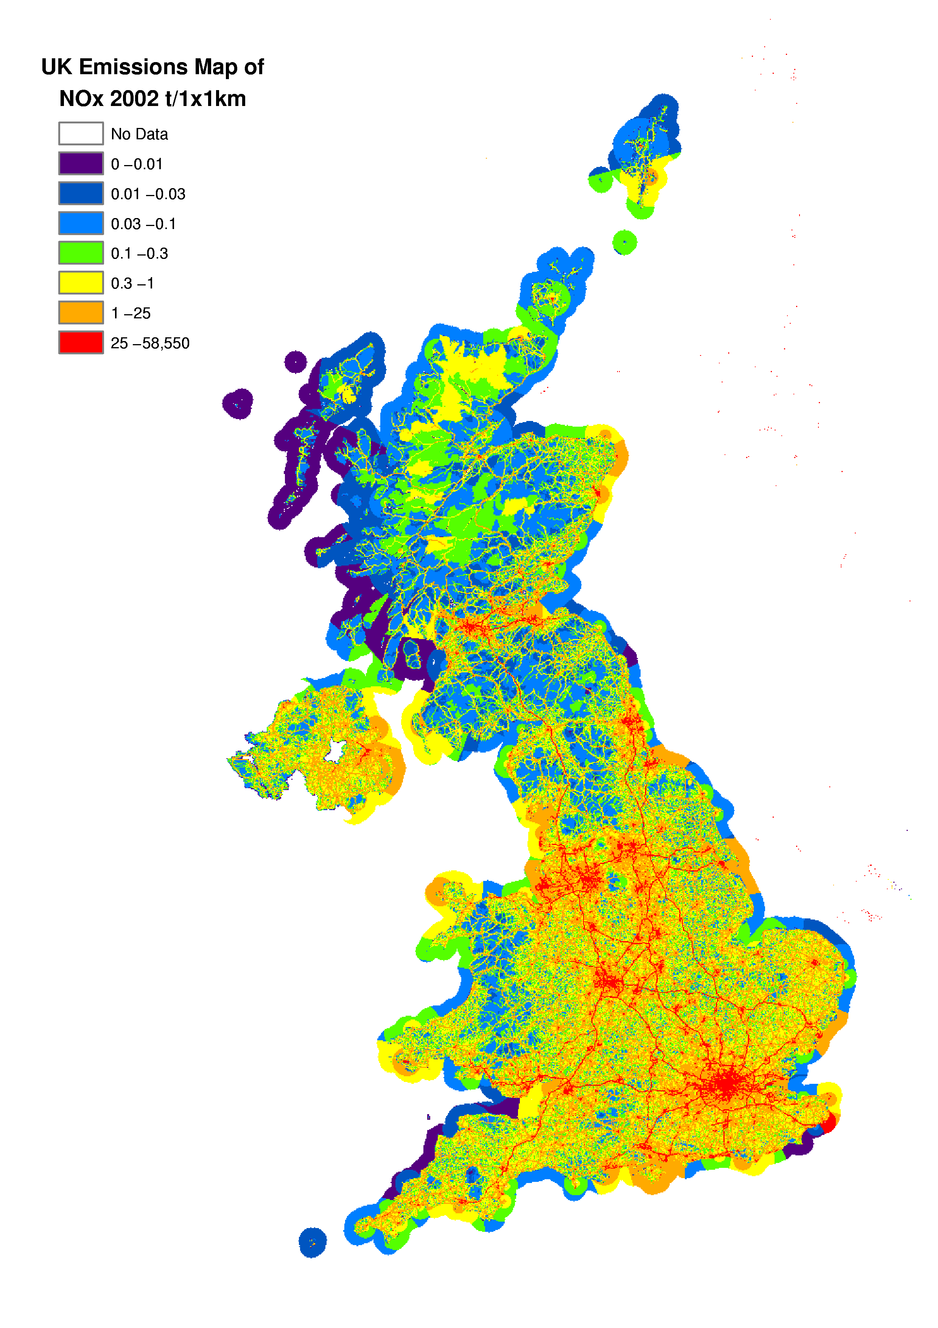

Transport
In 2002 the major source of NO_{x} emissions in the UK is the transport sector with road vehicles and off-road vehicles contributing 45% and 4%, respectively, to the total emission. Road emissions rose steadily between 1970 and 1989 reflecting the overall growth in road traffic in the UK. During this period emissions from total petrol consumption, predominantly cars, rose by 103% compared to the 1970 level and emissions from diesel consumption rose by 38%. Figure 5.3 clearly shows the growth in the vehicle fleet and vehicle mileage during this period. Since 1989 there has been a steady decline in emissions due to the introduction of catalytic converters on cars and stricter regulations on truck emissions.

Figure 5.3 Emissions of NO_{x} from Road Transport by Vehicle Type (ktonnes)

Figure 5.4 shows the average NO_{x} emissions per vehicle kilometre for different vehicle types. Various emission regulations on new petrol cars which have come into effect in stages since 1976 have led to the gradual reduction in emission rates from petrol cars. The more rapid decline in emissions from 1992 is due to the penetration of cars fitted with three-way catalysts. Limits on emissions from diesel cars and Light Goods Vehicles (LGVs) did not come into effect until 1993/94. Overall emissions per kilometre from Heavy Goods Vehicles (HGVs) showed a small rise from 1970-1987 due to the increasing usage of larger HGVs for freight movement. Limits on emissions from HGVs first came into effect in 1988 leading to a gradual reduction in emission rates as new HGVs penetrated the fleet, accelerated by tighter limits on emissions from new HGVs in 1993/94.

Figure 5.4 NO_{x} Emissions per Vehicle km by Vehicle Type

Figure 5.5 shows emissions per passenger km and by tonne km of freight. Technological improvements to HGVs give rise to approximately half the emissions per tonne of freight moved in 2002 compared with 1970. Emissions per passenger km from cars, vans and taxis have significantly decreased since 1970 due mainly to the introduction of catalytic convertors in 1992 now penetrating the car fleet. Per passenger km emissions from buses and coaches have increased from 1970 to 1993. This was due to the gradual decrease in occupancy rate of buses and their under utilisation over this period. Since 1993, this rise in per passenger km emissions has been halted by the penetration of buses meeting tighter emission standards into the fleet.

Figure 5.5 Emissions of NO_{x} (grammes) by Mode for Passenger and Freight Transport (tonnes)

In 2002 other transport and machinery contributed a further 4% to total UK NO_{x} emissions. Of these only those from civil aircraft have grown steadily over the period 1970 to 2002 (take-off and landing cycles up to an altitude of 1000 m only are considered here in accordance with UN/ECE guidelines). However, these emissions contribute only a small percentage of the total emission.

Power Generation
Emissions from power stations have declined over the period 1970-2002 by 53%. Emissions in the seventies were fairly constant from year to year, with peaks in severe winters. Since 1979 emissions have declined with a significant decrease at the time of the miners strike in 1984. Prior to 1989 this decline was due to the increased use of nuclear power and an increase in the average efficiency of the thermal power stations. Since 1988 the electricity generators have adopted a programme of progressively fitting low NO_{x} burners to their 500 Mwe (megawatt electric) or larger coal fired units. More recently the increased use of nuclear generation and the introduction of CCGT (Combined Cycle Gas Turbine) plant burning natural gas (See Section 2.2.2) have further reduced NO_{x} emissions. The emissions from the low NO_{x} turbines used are much lower than those of pulverised coal fired plant even when low NO_{x} burners are fitted. Given that these trends continue, power station emissions are expected to fall further.

Industry
The emissions from industrial combustion have declined by 65% since 1970 and they currently contribute 10% to total UK emissions. This is due to the decline in coal use in favour of gas and electricity.

SO₂ Emission EStimates
Since 1970 there has been a substantial overall reduction of more than 84% in SO₂ emissions (Figure 5.6). The emission profile exhibits a steady decline between 1970 and 2002 with the exception of small peaks in 1973 and 1979 corresponding to the harsh winters in those years, and a short period at the end of the 1980s when emissions were relatively constant from year to year. It is also evident that there is little decrease between total SO₂ emissions in 1997 and 1998. This occurs because the large reductions in emissions from the power generation sector are not as substantial between 1997 and 1998. However the downward trend resumes between 1998 and 2002.

Table 5.4 shows emissions broken down by fuel categories. The two main contributors are solid fuel and petroleum products. Emissions from solid fuel use have declined by 79% since 1970 and those from petroleum by 94%. The most important factors in the fall in emissions from petroleum use are the decline in fuel oil use and the reduction in the sulphur content of gas oil and DERV. The reduction in the sulphur content of gas oil is particularly significant in sectors such as domestic heating, commercial heating and off-road sources where gas oil is used extensively. The sulphur content of DERV has steadily reduced across recent years, giving rise to a significant reduction in SO₂ emissions. SO₂ emissions from DERV in the early 1990’s were relatively constant, however between 1994 and 2001 there has been a 98% reduction in emissions.

Figure 5.6 Time Series of SO₂ Emissions (Mtonnes)

Table 5.4 UK Emissions of SO₂ by UN/ECE¹ Source Category and Fuel (ktonnes)
 | 1970 | 1980 | 1990 | 1996 | 1997 | 1998 | 1999 | 2000 | 2001 | 2002 | 2002%
BY UN/ECE CATEGORY²
Combustion in Energy Prod.
Public Power | 2913 | 3007 | 2723 | 1320 | 1025 | 1072 | 776 | 821 | 742 | 680 | 68%
Petroleum Refining Plants | 242 | 262 | 153 | 144 | 134 | 98 | 93 | 72 | 72 | 66 | 7%
Other Combustion & Trans. | 231 | 25 | 8 | 3 | 6 | 7 | 9 | 10 | 8 | 5 | 0%
Combustion in Comm/Inst/Res
Residential Plant | 522 | 226 | 108 | 71 | 63 | 53 | 52 | 45 | 46 | 39 | 4%
Comm/Pub/Agri Combustion | 451 | 218 | 93 | 57 | 47 | 34 | 27 | 17 | 17 | 12 | 1%
Combustion in Industry
Iron & Steel Combustion | 35 | 10 | 18 | 17 | 17 | 15 | 15 | 11 | 12 | 10 | 1%
Other Ind. Combustion | 1794 | 896 | 417 | 269 | 249 | 207 | 159 | 133 | 142 | 127 | 13%
Production Processes | 120 | 95 | 71 | 56 | 51 | 52 | 45 | 38 | 40 | 33 | 3%
Extr./Distrib. of Fossil Fuels | 5 | 5 | 16 | 7 | 6 | 6 | 1 | 1 | 1 | 1 | 0%
Road Transport | 44 | 42 | 63 | 37 | 27 | 23 | 14 | 6 | 3 | 3 | 0%
Other Trans/Machinery³ | 93 | 61 | 47 | 44 | 42 | 38 | 34 | 32 | 27 | 25 | 3%
Waste | 5 | 6 | 5 | 2 | 2 | 2 | 5 | 3 | 3 | 1 | 0%
By FUEL TYPE
Solid | 3669 | 3137 | 2769 | 1353 | 1152 | 1186 | 886 | 902 | 849 | 772 | 77%
Petroleum | 2546 | 1548 | 811 | 558 | 395 | 294 | 229 | 185 | 166 | 149 | 15%
Gas | 60 | 11 | 10 | 12 | 19 | 19 | 19 | 20 | 14 | 11 | 1%
Non-Fuel | 181 | 156 | 131 | 105 | 105 | 109 | 94 | 83 | 85 | 71 | 7%
TOTAL | 6455 | 4852 | 3721 | 2028 | 1670 | 1607 | 1229 | 1189 | 1115 | 1002 | 100%
1 UK emissions reported in IPCC format (Baggott et al, 2004) differ slightly due to the different source categories used.
2 See Annex 1 for definition of UN/ECE Categories
3 Including railways, shipping, naval vessels, military aircraft and off-road sources

The geographical distribution of SO₂ emissions are shown in Figure 5.7. A large fraction (of the order of 80%) of the SO₂ emissions are concentrated into relatively few 1x1 km grid squares containing the major point sources such as refineries and power stations and large industrial plant. The resulting map highlights the main conurbations. High emissions in Plymouth and Newport result from a combination of shipping and industry. London and Birmingham, which are covered by Smoke Control Areas, show relatively low SO₂ emission levels. High emission densities are noted in Belfast where there is substantial consumption of solid fuels in the domestic sector for heating etc.
Figure 5.7 Spatially Disaggregated UK Emissions of SO₂
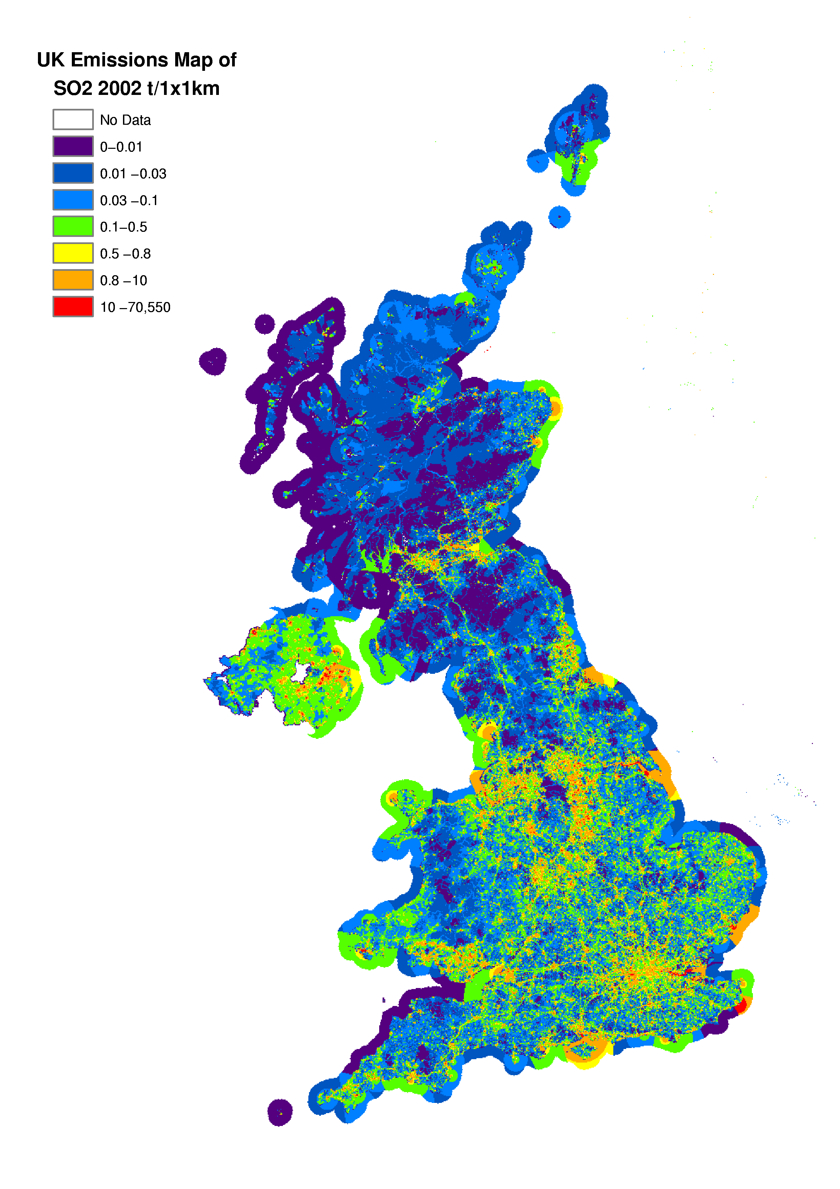

Power Generation
The largest contribution to SO₂ emissions is from power stations which accounts for 68% of the total in 2002. Historically coal combustion has been the most important source- the sulphur content of the coal being directly proportional to the emission estimate. Since 1970 there has been a gradual decline in power station emissions of around 77%. This reflects the changes in fuel mix and in the types of power plant which have taken place during the period. From 1970 to 1990 the reduction was due to a gradual increase in the use of nuclear plant and improvements in efficiency (See Section 2.2.2). Since 1990, this decline has accelerated because of the increase in the proportion of electricity generated in nuclear plant and the use of Combined Cycle Gas Turbine (CCGT) stations and other gas fired plant. CCGTs are more efficient than conventional coal and oil stations and have negligible SO₂ emissions. It is expected that these reductions will continue in the near future as more CCGT stations are built. Most recently the flue gas desulphurisation plants, constructed at Drax and Ratcliffe power stations, have had a significant effect on emissions.

Industry
Emissions of SO₂ from industry result from the combustion of coal and oil, some refinery processes and the production of sulphuric acid and other chemicals. Between 1970 and 2002 industrial emissions from combustion sources have fallen by 76% though most of the fall took place between 1970-1985 reflecting the decline in the energy intensive iron and steel industry and other heavy industries. There has been also been a decline in the use of coal and oil in favour of natural gas.

Transport
Road transport emissions account for less than 1% of the total SO₂ emissions. Between 1970 and the early 1990s, road transport emissions grew with the increase in road vehicles, however more recently emissions have declined with the reduction in the sulphur content of DERV. Similarly the reduction in sulphur content of gas oil is reflected in the emissions from off-road vehicles.

Other
Emissions from the remaining categories are low compared with those discussed above. Emissions from domestic and other commercial/institutional sectors have declined substantially during the period 1970-2002, reflecting the major changes in fuel mix from oil and coal to gas. The decrease in emissions from waste reflects the closure of a number of old incinerators due to the introduction of new emission standards and their replacement with modern equipment.

Hydrogen Chloride Emission Estimates
HCl is an acidic gas primarily released to air from combustion of fuels which contain trace amounts of chloride. This results in the emissions of HCl being dominated by the combustion of solid fuel.

Table 5.5 and Figure 5.8 summarise the UK emissions of hydrogen chloride. Emissions have fallen by 83% since 1970. The main source of these emissions is coal combustion so the fall is a result of the decline in coal use and also the installation of flue gas desulphurisation at Drax and Ratcliffe since 1993, and the impact of the miners strike of 1984 is clearly visible. The other significant source of hydrogen chloride is waste incineration. Here the commissioning of new incinerators and the closure or upgrading of old plant has resulted in a large decrease for all years since 1996.

Estimates of emissions of HCl from coal combustion at Alcan’s Ashington power station, have been revised downwards (due to provision of new data). As a result, overall emissions have also decreased (e.g. emissions in 2001 are now estimated at 76.1 ktonnes, compared with 79.9 ktonnes previously).

Table 5.5 UK Emissions of HCl by UN/ECE Source Category and Fuel (ktonnes)
 | 1970 | 1980 | 1990 | 1996 | 1997 | 1998 | 1999 | 2000 | 2001 | 2002 | 2002%
BY UN/ECE CATEGORY¹
Combustion in Energy Prod
Public Power | 222.3 | 257.8 | 239.4 | 110.3 | 74.5 | 104.8 | 64.3 | 74.7 | 62.6 | 47.3 | 81%
Petroleum Refining Plants | 0.0 | 0.0 | 0.0 | 0.0 | 0.0 | 0.0 | 0.0 | 0.0 | 0.0 | 0.0 | 0%
Other Combustion & Trans. | 4.5 | 1.6 | 0.3 | 0.0 | 0.0 | 0.0 | 0.0 | 0.0 | 0.0 | 0.0 | 0%
Combustion in Comm/Res
Residential Plant | 47.3 | 21.0 | 10.0 | 6.4 | 6.1 | 5.6 | 5.9 | 4.5 | 5.5 | 4.2 | 7%
Comm/Agricul Combustion | 9.9 | 4.3 | 3.6 | 2.1 | 1.5 | 1.0 | 0.9 | 0.7 | 0.8 | 0.4 | 1%
Combustion in Industry
Iron & Steel Combustion | 1.1 | 0.4 | 0.8 | 0.8 | 0.8 | 0.8 | 0.8 | 0.7 | 0.6 | 0.6 | 1%
Other Ind. Combustion | 40.6 | 13.5 | 11.4 | 9.0 | 7.4 | 6.4 | 6.8 | 4.1 | 6.0 | 5.3 | 9%
Production Processes | 0.2 | 0.2 | 0.3 | 0.3 | 0.3 | 0.3 | 0.2 | 0.2 | 0.2 | 0.2 | 0%
Road Transport | 0.4 | 0.4 | 0.1 | 0.1 | 0.0 | 0.0 | 0.0 | 0.0 | 0.0 | 0.0 | 0%
Other Trans/Machinery² | 0.0 | 0.0 | 0.0 | 0.0 | 0.0 | 0.0 | 0.0 | 0.0 | 0.0 | 0.0 | 0%
Waste | 10.6 | 10.6 | 8.0 | 3.2 | 0.1 | 0.1 | 0.1 | 0.1 | 0.1 | 0.1 | 0%
By FUEL TYPE
Solid | 324 | 298 | 261 | 120 | 88 | 116 | 77 | 83 | 74 | 56 | 97%
Petroleum | 1 | 1 | 0 | 0 | 0 | 0 | 0 | 0 | 0 | 0 | 0%
Gas | 0 | 0 | 0 | 0 | 0 | 0 | 0 | 0 | 0 | 0 | 0%
Non-Fuel | 13 | 12 | 12 | 12 | 3 | 3 | 2 | 2 | 2 | 2 | 3%
TOTAL | 337 | 310 | 274 | 132 | 91 | 119 | 79 | 85 | 76 | 58 | 100%
1 See Annex 1 for definition of UN/ECE Categories
2 Including railways, shipping, naval vessels, military aircraft and off-road sources

Figure 5.8 Time Series of HCl Emissions (ktonnes)
Figure 5.9 Spatially Disaggregated UK Emissions of HCl
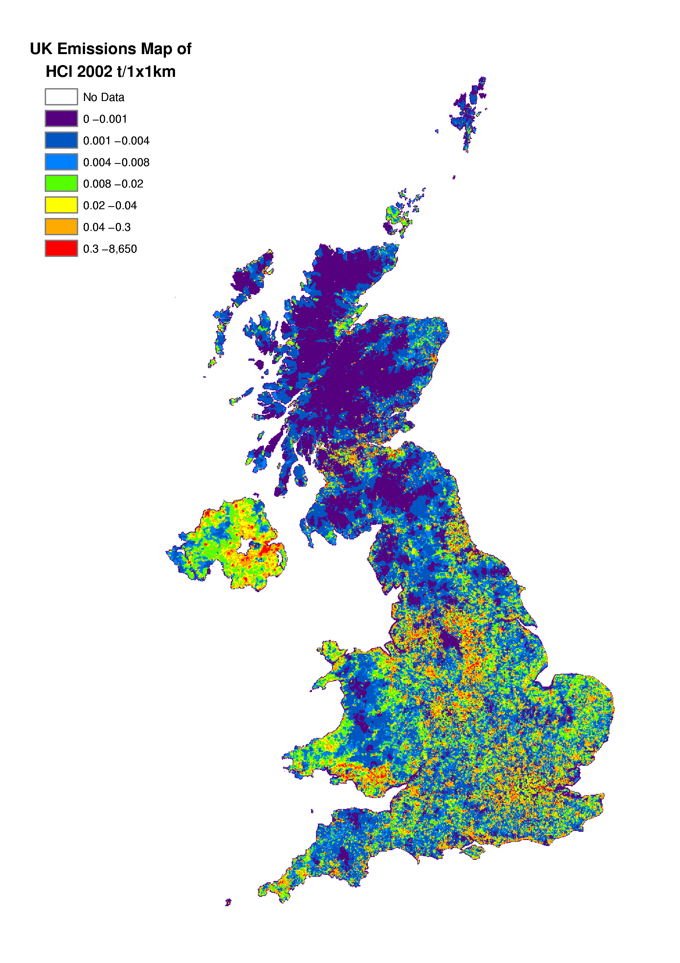

non-methane volatile organic compounds
NMVOCs are organic compounds which may differ widely in their chemical composition. These organic compounds are often grouped under the NMVOC label as the majority display similar behaviour in the atmosphere. NMVOCs are emitted to air as combustion products, as vapour arising from handling or use of petroleum distillates, solvents or chemicals, and from numerous other sources.

Interest in NMVOC emissions has grown as their role in the photochemical production of ozone has been appreciated. The diversity of processes which emit NMVOCs is huge, covering not only many branches of industry, but also transport, agriculture and domestic sources.

The NMVOC inventory is summarised in Table 5.6. Only 24% of the NMVOC emissions arise from combustion sources (unlike SO₂ and NO_{x} where the contribution from combustion sources is much higher). Of these emissions from combustion sources, it is the transport sector which dominates. Other major sources of NMVOC emissions are the use of solvents and industrial processes. Natural emissions of NMVOCs are included here as per UN/ECE guidelines. The NMVOC emission profile, presented in Figure 5.10, shows a small overall increase in emissions between 1970 and 1989 with minor peaks in 1973 and 1979, followed by a steady reduction in emissions during the 1990s. The latter is largely a reflection of the increasingly stringent emission limits across a range of sectors.

Figure 5.10 Time Series of NMVOC Emissions (Mtonnes)

VOC emission estimates for organic solvent-borne wood preservatives, industrial adhesives, and car-care aerosols have all been revised downwards. These changes, together with the revisions to estimates from road transport, have led to a decrease in overall VOC emission estimates compared with the previous version of the NAEI.
Table 5.6 UK Emissions of NMVOCs by UN/ECE¹ Source Category and Fuel (ktonnes)
 | 1970 | 1980 | 1990 | 1996 | 1997 | 1998 | 1999 | 2000 | 2001 | 2002 | 2002%
BY UN/ECE CATEGORY²
Combustion in Energy Prod
Public Power | 7 | 8 | 7 | 9 | 8 | 6 | 8 | 8 | 8 | 9 | 1%
Petroleum Refining Plants | 1 | 1 | 1 | 1 | 1 | 1 | 1 | 1 | 1 | 1 | 0%
Other Combustion & Trans. | 2 | 2 | 2 | 1 | 1 | 1 | 1 | 1 | 1 | 1 | 0%
Combustion in Comm/Res | 296 | 131 | 67 | 43 | 40 | 42 | 45 | 36 | 39 | 35 | 3%
Combustion in Industry | 19 | 14 | 9 | 9 | 9 | 9 | 7 | 9 | 8 | 8 | 1%
Production Processes
Petroleum Refining Plants | 107 | 99 | 100 | 74 | 66 | 59 | 46 | 45 | 37 | 35 | 3%
Chemicals manufacture | 95 | 115 | 150 | 141 | 127 | 116 | 80 | 76 | 61 | 53 | 4%
Food & Drink Manufacture | 74 | 81 | 73 | 76 | 77 | 78 | 78 | 77 | 77 | 77 | 6%
Other processes | 16 | 14 | 18 | 16 | 13 | 10 | 10 | 10 | 10 | 10 | 1%
Extr./Distrib. of Fossil Fuels
Gas Leakage | 12 | 38 | 42 | 39 | 67 | 66 | 66 | 63 | 65 | 64 | 5%
Offshore Oil&Gas | 5 | 98 | 147 | 181 | 182 | 160 | 155 | 168 | 169 | 162 | 12%
Gasoline Distribution | 47 | 72 | 111 | 96 | 99 | 88 | 62 | 58 | 54 | 51 | 4%
Solvent Use
Industrial solvent use | 512 | 485 | 522 | 388 | 375 | 360 | 324 | 289 | 264 | 246 | 18%
Domestic solvent use | 83 | 97 | 152 | 138 | 138 | 138 | 138 | 140 | 140 | 143 | 11%
Road Transport
Combustion | 477 | 554 | 639 | 420 | 375 | 331 | 288 | 239 | 201 | 171 | 13%
Evaporation | 50 | 103 | 230 | 136 | 126 | 100 | 82 | 61 | 48 | 40 | 3%
Other Trans/Machinery³ | 78 | 72 | 66 | 64 | 63 | 62 | 61 | 61 | 60 | 59 | 4%
Waste | 12 | 58 | 45 | 38 | 33 | 31 | 26 | 22 | 22 | 20 | 1%
Land Use Change | 37 | 58 | 35 | 0 | 0 | 0 | 0 | 0 | 0 | 0 | 0%
Nature | 178 | 178 | 178 | 178 | 178 | 178 | 178 | 178 | 178 | 178 | 13%
By FUEL TYPE
Solid | 300 | 132 | 66 | 39 | 35 | 34 | 37 | 27 | 30 | 27 | 2%
Petroleum | 611 | 732 | 937 | 621 | 565 | 495 | 432 | 362 | 310 | 271 | 20%
Gas | 7 | 12 | 15 | 19 | 19 | 20 | 22 | 23 | 23 | 23 | 2%
Non-Fuel | 1189 | 1402 | 1579 | 1367 | 1358 | 1287 | 1166 | 1129 | 1080 | 1043 | 76%
TOTAL | 2107 | 2278 | 2597 | 2047 | 1978 | 1836 | 1657 | 1542 | 1443 | 1364 | 100%
1 UK emissions reported in IPCC format (Baggott et al, 2004) differ slightly due to the different source categories used.
2 See Annex 1 for definition of UN/ECE Categories
3 Including railways, shipping, naval vessels, military aircraft and off-road sources

The spatial disaggregation of NMVOC emissions in the UK is shown in Figure 5.11. A large proportion of emissions are caused either as a result of the activities of people in and around their homes (e.g. domestic solvent use or domestic combustion), or by widespread industrial activities such as small-scale industrial coating processes, dry cleaning shops, and small bakeries, which are present in towns and cities throughout the UK. Consequently the resulting emissions map is well correlated with population density.

The NMVOC map includes a large number of point sources, including oil refineries, crude oil terminals, large combustion plant, chemicals manufacture, iron and steel processes, whisky manufacture, large bread bakeries, and industrial solvent using processes. The domestic sources are distributed using population density statistics, and the sources arising from other industrial processes are mapped using information on the size and locations of industrial installations.

Unlike the map presented previously for NO_{x}, the NMVOC map has little major road definition except where the major roads go through rural areas. This reflects the fact that NMVOC emissions are dependent on vehicle speed and are higher on minor and urban major roads than on the high speed motorways and major roads.
Figure 5.11 Spatially Disaggregated UK Emissions of NMVOC
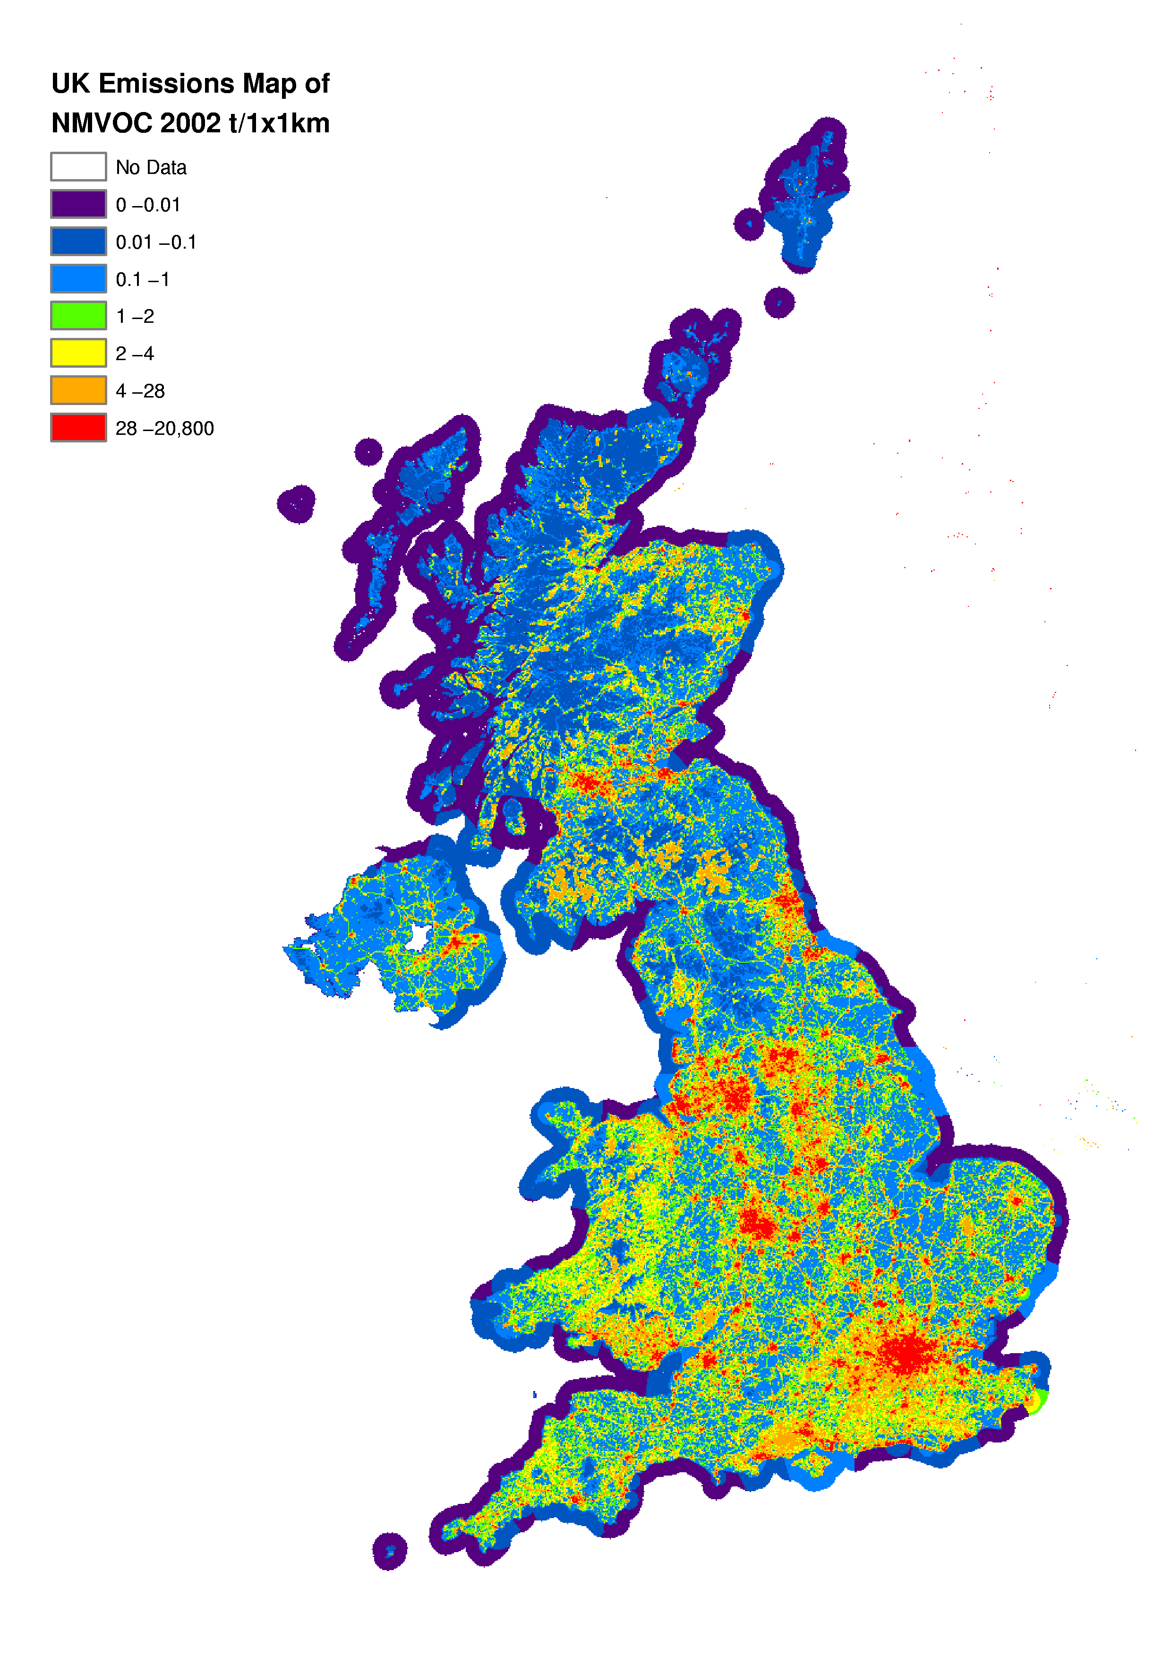

Solvent Use and Production Processes
Solvent use and production processes are responsible for 29% and 14%, respectively, of the 2002 emission total. The estimates are derived either based on plant specific data provided by process operators or regulators or by use of appropriate emission factors combined with solvent consumption data or industrial production data. The NMVOC inventory has been subject to a continuous programme of review and improvement over the past decade, and estimates can be considered reasonably reliable.

The solvent use sector comprises both industrial and domestic applications, both being significant sources. Emissions from industrial solvent use reached their peak in 1973, then dipped to a low in 1982, before increasing again until 1989. Since 1989 emissions have fallen as a result of emission controls, technological changes, and reduced manufacturing output in some sectors. In comparison, domestic solvent emissions showed little trend until the mid 1980s when they increased sharply. Since 1990 however, emissions have fallen back by 6% due to a trend towards formulating products such as paints and aerosols with lower solvent contents.

The production processes sector includes emissions from the chemical industry, petroleum refining, and food and drink manufacture as well as minor sources such as iron and steel production and road construction. Emissions from the chemical industry grew steadily until 1989, since when tightening emission controls have led to a reduction in emissions of 65%. The emissions from the petroleum refining sector show little trend over the period from 1970 until 1994, but since then emission controls and, latterly, refinery closures have led to emissions falling by 64% since 1994.

Emissions from the food and drink industry comprised 6% (77 ktonnes) of the total NMVOC emission in 2002. The largest source is whisky maturation although bread baking, animal feed manufacture, fat and oil processing and barley malting are also important. Emissions from the sector peaked in 1980 before falling again. Since 1987 emissions increased by an average of 1% per year until 2000 when they dropped slightly. The trends with time are primarily driven by production in these sectors.

Transport
Total transport emissions are currently responsible for 20% of NMVOC emissions of which 16% are a result of road transport. With increasing car numbers emissions rose from 477 ktonnes in 1970, to a peak of 663 ktonnes in 1989. Since then it has declined by 74% owing to the increased use of catalytic converters and fuel switching from petrol to diesel cars. Emissions from the road transport sector for 2002 has decreased by 64% since 1970.

Other Sectors
Offshore oil and gas emissions have increased substantially since 1970 with the growth of the UK’s offshore industry and now constitute 12% of the 2002 emissions total. The most important sources of NMVOC emissions are tanker loading, flaring and fugitive emissions.

Emissions from gas leakage currently comprise around 5% of the total NMVOC emission. This estimate has been significantly revised upwards in light of new data. Even though the mass of mains gas being released has decreased (due to pipe replacement), there is an upward temporal trend of NMVOC emission. This is caused by the increasing NMVOC content of mains gas.

The evaporative losses from the distribution and marketing of petrol rose between 1970 and the early 1990s reflecting the growth in road transport. Since then they have decreased, partly as a result of fuel switching to diesel, and partly as a result of increasing usage of petrol vapour recovery systems to prevent emissions from petrol terminals and service stations. They currently account for 3% of national NMVOC emissions.

The contribution from domestic heating has fallen by 88% between 1970 and 2002 as the use of coal for domestic heating has declined. It now accounts for just 3% of the UK emission.

NMVOC emissions from waste treatment and disposal contribute 1% to national emissions. Data from the Environment Agency (2003) shows emissions from municipal waste incinerators to be very small.

NMVOCs, in particular isoprene and mono-terpenes, are emitted from several natural and agricultural sources- such as forests. The entries under Land Use Change and Nature in Table 5.6 represent emissions from forests and forestry, heathland, pastures and crops.

Speciation of NMVOCs
As mentioned previously, the term NMVOC covers a wide range of compounds and although a total NMVOC inventory is sufficient for some purposes, in other cases greater detail is required concerning the nature and concentration of individual compounds. For example, when assessing the photochemical production of ozone, individual species have different ozone creation potentials hence information is required on the concentration of individual species (QUARG, 1993). Table 5.7 shows the emissions of the 50 most important NMVOC species disaggregated as far as possible by source. "Unspeciated" emissions are those where no suitable speciation profile is available. In some cases the speciation profile that is available includes groups of compounds (e.g. C6's- representing all hydrocarbons with six carbon atoms). These are reported in the table as "other grouped species".

A more detailed speciation of all NMVOCs estimated by the NAEI (currently over 600) is given on the NAEI website (http://www.naei.org.uk).
Table 5.7 The 50 Most Significant NMVOC Species in Terms of Mass Emission (ktonnes)
¹ biogenic NMVOCs. ² Some speciation profiles give disaggregation into groups of compounds (e.g. C6's)
An entry of "0.00" represents a value of <0.005 ktonnes (i.e. <5 tonnes)

Photochemical Ozone Creation Potential
Table 5.7 (and Appendix 5) is a useful reference for finding the emission of a particular NMVOC compound. However, species specific emissions do not reflect the fact that NMVOC compounds have different efficiencies in generating ozone through photochemical reactions. To resolve this, the concept of a photochemical ozone creation potential (POCP) was created. This POCP identifies, on a relative basis, the ozone creation potential for each NMVOC compound through modelling studies. The creation potentials are then normalised by defining ethene as a creation potential of 1.

It is therefore possible to determine which NMVOCs are the most important for the photochemical formation of ozone in the atmosphere. This is achieved by scaling the emissions of each NMVOC by the corresponding POCP to determine a weighted total (Table 5.8).
Table 5.8 POCP Weighted NMVOC Emissions
biogenic NMVOCs. ² Some speciation profiles give disaggregation into groups of compounds (e.g. C6's)
An entry of "0.00" represents a value of <0.005 ktonnes (i.e. <5 tonnes)

Ammonia Emission Estimates
NH₃ emissions play an important role in a number of different environmental issues including acidification, nitrification and eutrophication (see Section 5.1). The atmospheric chemistry of NH₃ and NH₄⁺ mean that transport of the pollutants can vary greatly. As a result NH₃ emissions can impact on a highly localised level, as well as contributing to effects from long-range pollutant transport.

Emission estimates for NH₃ are only available from 1990 onwards. This is because earlier data from the most significant industrial sources are not available, or considered reliable enough, to use in emission estates.

Emissions in 2002 represent a decrease of 17% on the 1990 emissions. The primary source of NH₃ emissions in the UK is manure management from livestock, and in particular cattle. The most significant cause of reductions in recent years has been decreasing cattle numbers in the UK.

Table 5.9 gives a sectoral breakdown of the emissions of NH₃ in the UK.

Table 5.9 UK Emissions of NH₃ by UN/ECE Source Category and Fuel (ktonnes)
 | 1990 | 1995 | 1996 | 1997 | 1998 | 1999 | 2000 | 2001 | 2002 | 2002%
BY UN/ECE CATEGORY¹
Combustion in Energy Prod
Public Power | 0 | 0 | 0 | 0 | 0 | 0 | 0 | 0 | 0 | 0%
Other Combustion & Trans. | 0 |  | 0 | 0 | 0 | 0 | 0 | 0 | 0 | 0%
Combustion in Comm/Res |  | 0
Residential Plant | 5 | 4 | 4 | 4 | 3 | 4 | 3 | 3 | 3 | 1%
Commercial/Agricul Comb | 0 | 0 | 0 | 0 | 0 | 0 | 0 | 0 | 0 | 0%
Combustion in Industry | 1 | 1 | 1 | 1 | 1 | 1 | 1 | 1 | 1 | 0%
Production Processes | 7 | 7 | 8 | 6 | 9 | 5 | 4 | 4 | 3 | 1%
Solvent Use | 1 | 1 | 1 | 1 | 1 | 1 | 1 | 1 | 1 | 0%
Road Transport | 1 | 9 | 12 | 12 | 12 | 12 | 12 | 12 | 12 | 4%
Off road sources | 0 | 0 | 0 | 0 | 0 | 0 | 0 | 0 | 0 | 0%
Waste
Landfill | 8 | 7 | 7 | 6 | 5 | 5 | 4 | 4 | 3 | 1%
Non Landfill Waste | 10 | 10 | 10 | 10 | 10 | 9 | 9 | 9 | 9 | 3%
Agriculture
Animal Wastes | 254 | 248 | 252 | 253 | 248 | 244 | 232 | 221 | 214 | 75%
Non Livestock Agriculture | 63 | 39 | 33 | 38 | 36 | 40 | 35 | 41 | 39 | 14%
By FUEL TYPE
Solid | 5 | 4 | 4 | 4 | 3 | 4 | 3 | 3 | 3 | 1%
Petroleum | 1 | 9 | 12 | 12 | 12 | 12 | 12 | 12 | 12 | 4%
Gas | 0 | 0 | 0 | 0 | 0 | 0 | 0 | 0 | 0 | 0%
Non-Fuel | 344 | 314 | 312 | 314 | 308 | 304 | 285 | 280 | 270 | 95%
TOTAL | 350 | 326 | 327 | 330 | 324 | 320 | 300 | 295 | 285 | 100%
1 See Annex 1 for definition of UN/ECE Categories

Table 5.9a UK Emissions of NH₃ from other sources (ktonnes)
 | 1990 | 1995 | 1996 | 1997 | 1998 | 1999 | 2000 | 2001 | 2002
Domestic and Wild Animals | 23.0 | 21.6 | 21.5 | 21.1 | 21.4 | 21.6 | 21.5 | 21.0 | 20.7
Humans | 1.5 | 1.6 | 1.6 | 1.6 | 1.6 | 1.6 | 1.6 | 1.6 | 1.6
TOTAL | 24.5 | 23.2 | 23.1 | 22.7 | 23.0 | 23.2 | 23.1 | 22.6 | 22.3

There have been a number of significant improvements to the NH₃ inventory across the last several years. In particular efforts have been made to unify estimates being made by different organisations to arrive at a definitive emissions inventory for the UK.

Agricultural Sources
Ammonia emissions in 2002 are dominated by agricultural sources with emissions from livestock and their wastes comprising 75% of the total emission. These emissions derive mainly from the decomposition of urea in animal wastes and uric acid in poultry wastes. Emissions depend on animal species, age, weight, diet, housing systems, waste management and storage techniques. Hence emissions are affected by a large number of factors which make the interpretation of experimental data difficult and emission estimates uncertain.

Emissions from the agricultural sector are taken directly from the agricultural ammonia (NH₃) inventory compiled for Defra each year by a consortium of organisations. This inventory considers each source in detail, drawing on official livestock datasets and using combinations of emission factors from the literature considered to be the most appropriate available. As part of this work, the agricultural NH₃ emissions inventory is reviewed each year to capture the most up to date livestock numbers, emission factors and views on methodologies (Misselbrook et al 2003).

As well as emissions from livestock, the agriculture inventory includes emissions from fertiliser use, crops and decomposition of agricultural vegetation. These estimates are particularly uncertain owing to the complexity of the processes involved, and less data available from the literature.

NH₃ emissions from agricultural livestock are decreasing with time. This is driven by decreasing animal numbers. In addition, there is a decline in fertiliser use, which also gives rise to decreasing emissions.

Other Sources
The non-agricultural sources comprise a number of diverse sources and equal 11% of the total. However, emission estimates for these sources are high in uncertainty due to a lack of data. A combination of estimates are used from the NETCEN emissions inventory team and from CEH Edinburgh (Dragosits and Sutton 2003).

Emissions of NH₃ from road transport although relatively small have been increasing as a result of the increasing number of three way catalysts in the vehicle fleet. However, emissions are projected to fall across the next several years as the second generation of catalysts (which emit less NH₃ than first generation catalysts) penetrate the vehicle fleet.

Emission estimates from domestic/wild animals and humans are not included in the standard UN/ECE reporting format and (and hence not included in Table 5.9 or Figure 5.12). However for completeness the emission estimates from these sources are included in Table 5.9a.

Figure 5.12 Time Series of NH₃ Emissions (ktonnes)

Figure 5.13 shows mapped NH₃ emissions. High emission densities are observed in agricultural areas, for example East Anglia, the South West and the North of England and Northern Ireland. Non-agricultural emissions are also noted to give rise to high emission densities in major urban areas such as London.
Figure 5.13 Spatially Disaggregated UK Emissions of NH₃
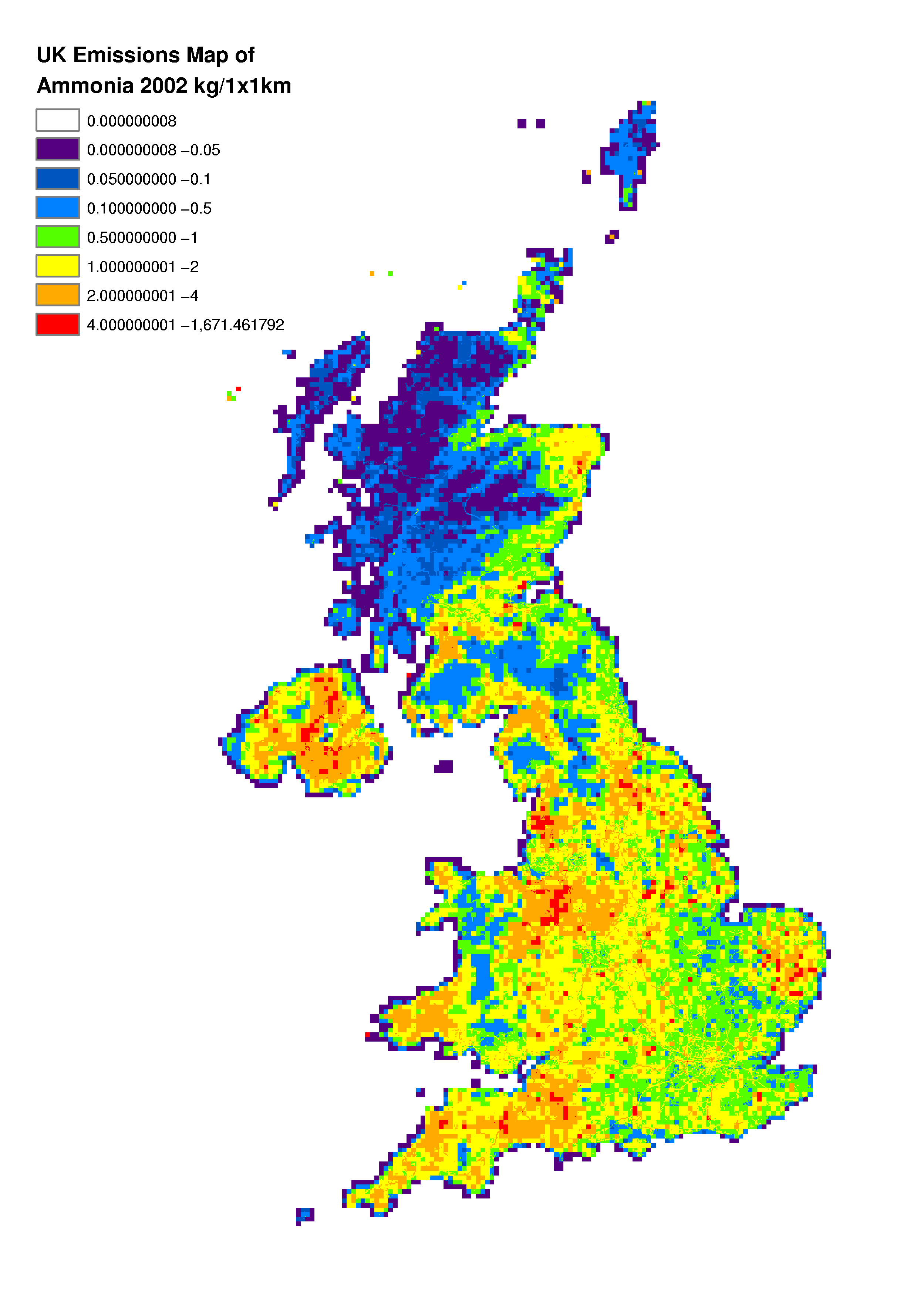

Hydrogen Fluoride Emission Estimates
Hydrogen fluoride (HF) is an acidic gas released to air from combustion of fuels which contain trace amounts of fluoride. Some industrial processes use HF as a an acidic reagent (or produce HF), giving rise to emissions. HF is chemically very similar to HCl.

The emissions of HF displays a similar source pattern to HCl (see Section 5.4). However, the emissions of HF from the power generation sector do not account for such a high percentage of the total (see Table 5.10). The reduction of the emissions from this sector with time is an indication of the increased use of emission abatement equipment in power stations. Emissions of HF from the residential sector have decreased with time. This is due to the decreasing use of coal in domestic heating. These trends with time are highlighted in Figure 5.14, and the impact of the miners strike in 1984 is apparent.

The increase of 32% in HF emission between 1999 and 2002 is caused by the increased coal consumption in electricity generation. Interestingly this trend is not noted for HCl (which exhibits a decrease of 27% from 1999 to 2002). This is because the HCl emission per unit of coal consumed decreased between 1999 and 2002, whereas that for HF remained reasonably constant.

An estimate for hydrogen fluoride emissions from non Fletton brickworks has been added to the inventory for the first time. These works are a significant source, and although emission estimates for Alcan’s Ashington power station and industrial and commercial coal combustion have all been revised downwards, overall emissions have increased.

Table 5.10 UK Emissions of HF by UN/ECE Source Category and Fuel (ktonnes)
 | 1970 | 1980 | 1990 | 1996 | 1997 | 1998 | 1999 | 2000 | 2001 | 2002 | 2002%
BY UN/ECE CATEGORY¹
Combustion in Energy Prod
Public Power | 6.13 | 7.11 | 6.56 | 2.86 | 2.04 | 2.10 | 1.75 | 1.82 | 2.31 | 3.58 | 66%
Other Combustion & Trans. | 2.83 | 1.10 | 0.99 | 0.78 | 0.79 | 0.79 | 0.76 | 0.78 | 0.71 | 0.59 | 11%
Combustion in Comm/Res
Residential Plant | 1.81 | 0.81 | 0.38 | 0.24 | 0.23 | 0.21 | 0.23 | 0.17 | 0.21 | 0.16 | 3%
Commercial/Agricul Comb | 0.38 | 0.16 | 0.11 | 0.05 | 0.06 | 0.04 | 0.03 | 0.03 | 0.03 | 0.02 | 0%
Combustion in Industry
Iron & Steel Combustion | 0.04 | 0.01 | 0.03 | 0.03 | 0.03 | 0.03 | 0.03 | 0.02 | 0.02 | 0.02 | 0%
Other Ind. Combustion | 2.75 | 1.45 | 1.22 | 1.00 | 0.96 | 0.87 | 0.82 | 0.70 | 0.68 | 0.64 | 12%
Production Processes | 0.56 | 1.94 | 1.43 | 1.17 | 1.19 | 1.21 | 0.46 | 0.40 | 0.47 | 0.38 | 7%
Waste | 0.01 | 0.01 | 0.01 | 0.00 | 0.00 | 0.00 | 0.00 | 0.00 | 0.00 | 0.00 | 0%
By FUEL TYPE
Solid | 13.3 | 10.2 | 8.8 | 4.4 | 3.6 | 3.5 | 3.2 | 3.1 | 3.6 | 4.7 | 87%
Petroleum | 0.0 | 0.0 | 0.0 | 0.0 | 0.0 | 0.0 | 0.0 | 0.0 | 0.0 | 0.0 | 0%
Gas | 0.0 | 0.0 | 0.0 | 0.0 | 0.0 | 0.0 | 0.0 | 0.0 | 0.0 | 0.0 | 0%
Non-Fuel | 1.2 | 2.4 | 1.9 | 1.7 | 1.7 | 1.7 | 0.9 | 0.9 | 0.8 | 0.7 | 13%
TOTAL | 14.5 | 12.6 | 10.7 | 6.1 | 5.3 | 5.2 | 4.1 | 3.9 | 4.4 | 5.4 | 100%
1 See Annex 1 for definition of UN/ECE Categories

Figure 5.14 Time Series of Hydrogen Fluoride Emissions (ktonnes)

Accuracy of Emission Estimates of Acidifying Gases and Tropospheric Ozone Precursors
Quantitative estimates of the uncertainties in emission inventories have been based on calculations made using a direct simulation technique, which corresponds to the IPCC Tier 2 approach recommended for greenhouse gases and also the methodology proposed in draft guidance produced by the UN/ECE Taskforce on Emission Inventories. This work is described in detail by Passant (2002b). Uncertainty estimates are shown in Table 5.11.

Table 5.11 Uncertainty of the Emission Inventories
Pollutant | Estimated Uncertainty %
Sulphur Dioxide | +/- 3
Oxides of Nitrogen | +/- 8
Non-Methane Volatile Organic Compounds | +/- 10
Ammonia | +/- 20
Hydrogen Chloride | +/- 20
Hydrogen Fluoride | +/- 20 ¹
¹ Assumed to be same as for hydrogen chloride (see text below for discussion)

Sulphur Dioxide
Sulphur dioxide emissions can be estimated with most confidence as they depend largely on the level of sulphur in fuels. Hence the inventory, being based upon comprehensive analysis of coals and fuel oils consumed by power stations and the agriculture, industry and domestic sectors, contains accurate emission estimates for the most important sources.

Oxides of Nitrogen
NO_{x} emission estimates are less accurate than SO₂ because they are calculated using measured emission factors, however these emission factors can vary widely with combustion conditions. Hence, emission factors given in the literature for combustion sources show large variations. In the case of road transport emissions, while the inventory methodology takes into account variations in the amount of NO_{x} emitted as a function of speed and vehicle type, significant variations in measured emission factors have been found even when keeping these parameters constant.

From the above, one might expect the NO_{x} inventory to be very uncertain, however the overall uncertainty is in fact lower than any pollutant other than SO₂. This is probably largely as a result of two factors. First, while emission factors are uncertain, activity data used in the NO_{x} inventory is very much less uncertain. This contrasts with inventories for pollutants such as volatile organic compounds, PM₁₀, metals, and persistent organic pollutants, where some of the activity data are very uncertain. Second, the NO_{x} inventory is made up of a large number of emission sources with many of similar size and with none dominating (the largest source category contributes just 18% of emissions, and a further 42 sources must be included to cover 90% of the emission). This leads to a large potential for error compensation, where an underestimate in emissions in one sector is very likely to be compensated by an overestimate in emissions in another sector. The other extreme is shown by the inventories for PCP, HCH and HCB (see Section 6.2.4) where one or two sources dominate and the inventories are highly uncertain.

Non-Methane Volatile Organic Compounds
The NMVOC inventory is more uncertain than those for SO₂ and NO_{x}. This is due in part to the difficulty in obtaining good emission factors or emission estimates for some sectors (e.g. fugitive sources of NMVOC emissions from industrial processes, and natural sources) and partly due to the absence of good activity data for some sources. As with NO_{x}, there is a high potential for error compensation, and this is responsible for the relatively low level of uncertainty compared with most other pollutants in the NAEI.

Ammonia
Ammonia emission estimates are more uncertain than those for SO₂, NO_{x} and NMVOC due largely to the nature of the major agricultural sources. Emissions depend on animal species, age, weight, diet, housing systems, waste management and storage techniques. Hence emissions are affected by a large number of factors which make the interpretation of experimental data difficult and emission estimates uncertain (DOE, 1994). Emission estimates for non-agricultural sources such as wild animals are also highly uncertain. Unlike the case of NO_{x} and NMVOC, a few sources dominate the inventory and there is limited potential for error compensation.

Hydrogen Chloride
The hydrogen chloride inventory is equally as uncertain as the ammonia inventory. As with ammonia, a few sources dominate the inventory and the levels of uncertainty in these sources is generally quite high.

Hydrogen Fluoride
Uncertainty analysis has not been performed on the hydrogen fluoride inventory as this is not a core part of the NAEI. However, the sources of hydrogen fluoride are very similar to those for hydrogen chloride and the level of uncertainty in emission factors might also be expected to be similar. As a result it seems reasonable to assume the same level of overall uncertainty as for hydrogen chloride.

Parts II and III in other files

Different pollutants can be expressed as a carbon equivalent emission by taking their global warming potential relative to CO₂ into account. This then allows comparisons across different pollutant species on a like for like basis.

