UK Greenhouse Gas Inventory,1990 to 2001

(Annual Report for forsubmission under the Framework Convention on Climate Change
Annual Report for submission under the Framework Convention on Climate Change

Baggott, SL
Davidson, I
Dore, C
Goodwin, J
Milne, R
Murrells, TP
Rose, M
Watterson, JD
Underwood, B

July 2003

UK Greenhouse Gas Inventory, 1990 to 2001:
Annual Report for submission under the Framework Convention on Climate Change

Baggott, SL, Davidson, I, Dore, C, Goodwin, J, Milne, R, Murrells, TP, Rose, M, Watterson, JD, Underwood, B

July 2003

Title | UK Greenhouse Gas Inventory 1990 to 2001: Annual Report for submission under the Framework Convention on Climate Change

Customer | Department for Environment, Food and Rural Affairs

Customer reference | EPG/1/1/62

Confidentiality, copyright and reproduction | Copyright AEA Technology plc  All rights reserved.  Enquiries about copyright and reproduction should be addressed to the Commercial Manager, AEA Technology plc.

File reference | /tmp/in/input.doc
NAEI contacts database reference | 47052001/2001/CD1783/JW

Reference number | AEAT/ENV/R/1396

Issue number | Two

AEA Technology
National Environmental Technology Centre
E5 Culham
Abingdon
Oxon
OX14 3ED

Telephone 01235 463118

Facsimile 01235 463005

AEA Technology is the trading name of

AEA Technology plc

AEA Technology is certified to ISO9001

Report Manager | Name | J D Watterson

Approved by | Name | J Goodwin

 | Signature | 

 | Date | 24/07/2003

Executive Summary

The United Nations Framework Convention on Climate Change (FCCC) was ratified by the UK in December 1993 and came into force in March 1994. As a Party to the Convention, the UK has achieved its objective of returning emissions of greenhouse gases to 1990 levels by 2000, when, according to latest published data for 2000, greenhouse gas emissions were about 13% below 1990 levels.

The UK ratified the Kyoto Protocol along with all EU Member States on 31 May 2002. The Kyoto Protocol commits the UK to reducing emissions by 12.5 % below 1990 levels in the period 2008 - 2012, taking into account the subsequent redistribution of commitments agreed in June 1998 under the UK Presidency of the European Union. The Government has also adopted a domestic goal of reducing CO₂ emissions by 20% below 1990 levels by 2010. The UK is committed to monitoring progress towards achieving these targets by:

- developing, periodically updating, publishing and making available national inventories of anthropogenic emissions by source and removals by sinks of all greenhouse gases not controlled by the Montreal Protocol;
- using comparable methodologies for inventories of greenhouse gas emissions and removals.
The UK submits emission inventories of the six direct greenhouse gases under the Kyoto Protocol. These are:

- Carbon dioxide
- Methane
- Nitrous oxide
- Hydrofluorocarbons
- Perfluorocarbons
- Sulphur hexafluoride.

These gases contribute directly to climate change owing to their positive radiative forcing effect. Also reported are four indirect greenhouse gases:

- Nitrogen oxides (reported as NO₂)
- Carbon monoxide
- Non-methane volatile organic compounds (NMVOC)
- Sulphur dioxide.

Of these, nitrogen oxides, carbon monoxide and NMVOC can produce increases in tropospheric ozone concentrations which increase radiative forcing. Sulphur dioxide, however, contributes to aerosol formation in the atmosphere. This is believed to have a negative net radiative forcing effect, tending to cool the surface.

To provide a single, comprehensive source of information on the methodologies and data used in the UK Inventory, a National Inventory Report (NIR) has been published annually since 1995, (Salway, 1995, 1996, 1997, 1998, 1999, 2000, 2001, 2002). The current report extends the data for all gases to 2001 and provides additional information related to the 2001 National Inventory recently submitted to the FCCC.

Total GWP weighted emissions, excluding carbon dioxide removals, declined by 12% between 1990 and 2001. Carbon dioxide fell by 5.3%, methane by 40.0% and nitrous oxide by 37.6%. Fluorinated compounds included in the Kyoto basket fell by 22% over this period. For the base year, which is comprised of 1990 data for carbon dioxide, methane and nitrous oxide, and 1995 data for the fluorinated compounds, then the corresponding falls in emissions to 2001 are: carbon dioxide, 5.3%; methane, 40.0%; nitrous oxide, 37.6%; fluorinated compounds, 36%; total GWP weighted emissions (excluding carbon dioxide removals), 12.3%. Releases of sulphur hexafluoride have increased since 1990 but since 1996 are fairly constant. Reasons for the changing emission levels are discussed in the report. Tables ES1 and ES2 summarise the emissions of each greenhouse gas expressed in terms of carbon dioxide and carbon equivalent emissions respectively.

Emissions of nitrogen oxides, carbon monoxide, non-methane volatile organic compounds, and sulphur dioxide have also declined significantly over the same time period.

The UK Greenhouse Gas Inventory is submitted to the FCCC in the form of the Common Reporting Format. This is attached to this report in the form of a CD ROM containing EXCEL spreadsheets. It should be noted that in this report, carbon dioxide emissions and removals are reported separately and that carbon dioxide removals are reported with a negative sign. However, in the CRF, carbon dioxide is reported as net emissions (=emissions +removals). Hence the National Total Emission quoted is a gross figure, not allowing for removals, and so is higher than the figure quoted on the CRF basis.

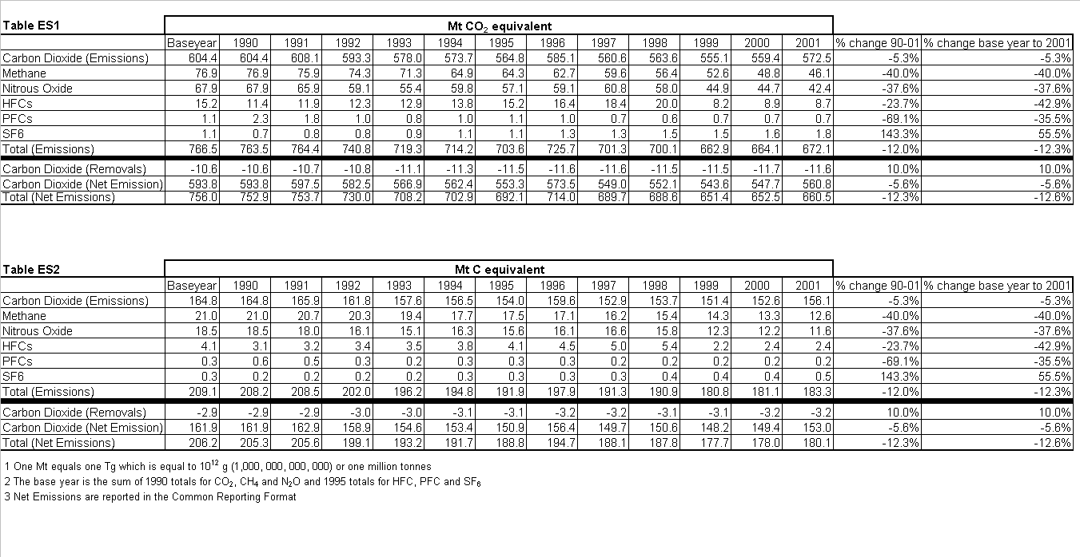
Contacts

This work forms part of the Global Atmosphere Research Programme of the Department for Environment, Food and Rural Affairs. (Contract EPG/1/1/120 ). The land use change and forestry estimates were provided by the Centre for Ecology and Hydrology (Edinburgh) (Contract EPG/1/1/106)

Technical enquiries should be directed to Dr JD Watterson, AEA Technology plc, National Environmental Technology Centre, E5 Culham Abingdon, Oxfordshire, OX14 3ED, UK (Tel +44 (0) 1235 46 3188, fax: +44 (0) 463005, E-mail. John.D.Watterson@aeat.co.uk

Technical enquiries on land use change and forestry should be addressed to Dr R Milne, Centre for Ecology and Hydrology (Edinburgh), Bush Estate, Penicuik, EH26 OQB, UK (Tel +44 (0) 131 445 8575. fax +44 (0) 131 445 3943, E-mail, rmilne@ceh.ac.uk.

Technical enquiries on agriculture should be addressed to Dr I Davidson, DEFRA Land Management Improvement Division, Area 4/E Ergon House, 17 Smith Square, London, SW1P 3JR, UK (Tel +44 (0) 207 238 6363, fax +44 (0) 207 238 6069, E-mail ian.davidson@defra.gsi.gov.uk

Science policy enquiries should be directed to Dr Jim Penman, Global Atmosphere Division, Department for Environment, Food and Rural Affairs, 3rd Floor, Ashdown House, 123 Victoria Street, London, SW1E 6DE, UK (Tel: +44 (0) 20 7944 5232, fax: +44 (0) 20 7944 5219, e-mail jim.penman@defra.gsi.gov.uk

A copy of this report and related data may be found on the website maintained by NETCEN for DEFRA: http://www.naei.org.uk/

Further copies of this report are available from:

DEFRA Publications
Admail 6000
London
SW1A 2XX
Tel: 08459 556 000
Fax: 020 8957 5012
Email: defra@iforcegroup.com

Contents
1 Introduction 1
2 Summary Reports of UK Greenhouse Gas Emissions 1990-2001 2
3 UK Emissions of Carbon Dioxide 16
3.1 Introduction 16
3.2 Development of the Methodology 16
3.3 Discussion of the Estimates 17
3.4 The IPCC Reference Carbon Dioxide Inventory 19
4 UK Emissions of Methane 21
4.1 Introduction 21
4.2 Development of the Methodology 21
4.3 Discussion of the Estimates 21
5 UK Emissions of Nitrous Oxide 24
5.1 IntroductioN 24
5.2 Development of the Methodology 24
5.3 Discussion of the Estimates 24
6 UK Emissions of Hydrofluorocarbons, Perfluorocarbons and Sulphur Hexafluoride 27
6.1 Introduction 27
6.2 Hydrofluorocarbons 27
6.3 Perfluorocarbons 28
6.4 Sulphur Hexafluoride 29
7 UK Emissions of Nitrogen Oxides 33
7.1 Introduction 33
7.2 Development of the Methodology 33
7.3 Discussion of the Estimates 33
8 UK Emissions of Carbon Monoxide 36
8.1 Introduction 36
8.2 Development of the Methodology 36
8.3 Discussion of the Estimates 36
9 UK Emissions of Non-Methane Volatile Organic Compounds 39
9.1 Introduction 39
9.2 Development of the Methodology 39
9.3 Discussion of the Estimates 40
10 UK Emissions of Sulphur Dioxide 43
10.1 Development of the Methodology 43
10.2 Discussion of the Estimates 44
11 Global Warming Potential of UK Emissions 46
11.1 Introduction 46
11.2 GWP Weighted Emissions 46
12 Methodological Changes to the Inventory 50
12.1 Energy (1A) 50
12.2 Fugitive Emissions (1B) 52
12.3 Industrial Processes (2) 52
12.4 Agriculture 53
12.5 Land Use Change and Forestry (5) 53
12.5 Waste (6) 54
13 References 55
14 Acknowledgements and Author responsibilities 57

sectoral tables 1990 58
sectoral tables 2001 71
Appendices
APPENDIX 1 The UK Greenhouse Gas Inventory and the Emission Source Classification A1.1
APPENDIX 2 Energy A2.1
APPENDIX 3 Energy (Fugitive Emissions) A3.1
APPENDIX 4 Industrial Processes and Solvents A4.1
APPENDIX 5 Agriculture A5.1
APPENDIX 6 Land Use Change and Forestry A6.1
APPENDIX 7 Waste A7.1
APPENDIX 8 Uncertainties A8.1
APPENDIX 9 Quality Assurance and Quality Control A9.1
APPENDIX 10 Verification of the UK Estimates of the Kyoto Gases A10.1
APPENDIX 11 Final Users data A11.1

Figures

Figure 1 UK Emissions of Carbon Dioxide
Figure 2 UK Emissions of Methane
Figure 3 UK Emissions of Nitrous Oxide
Figure 4 UK Emissions of HCFs
Figure 5 UK Emissions of PFCs
Figure 6 UK Emissions of Sulphur Hexafluoride
Figure 7 UK Emissions of Nitrogen Oxides
Figure 8 UK Emissions of Carbon Monoxide
Figure 9 UK Emissions of NMVOC
Figure 10 UK Emissions of Sulphur Dioxide
Figure 11 UK Emissions of Greenhouse Gases Weighted by GWP
Figure 12 UK Emissions of Greenhouse Gases by Source

Tables

Table 1 Summary Report for National Greenhouse Gas Inventories: 1990
Table 2 Summary Report for National Greenhouse Gas Inventories: 1991
Table 3 Summary Report for National Greenhouse Gas Inventories: 1992
Table 4 Summary Report for National Greenhouse Gas Inventories: 1993
Table 5 Summary Report for National Greenhouse Gas Inventories: 1994
Table 6 Summary Report for National Greenhouse Gas Inventories: 1995
Table 7 Summary Report for National Greenhouse Gas Inventories: 1996
Table 8 Summary Report for National Greenhouse Gas Inventories: 1997
Table 9 Summary Report for National Greenhouse Gas Inventories: 1998
Table 10 Summary Report for National Greenhouse Gas Inventories: 1999
Table 11 Summary Report for National Greenhouse Gas Inventories: 2000
Table 12 GWP of Greenhouse Gases on 100 Year Horizon
Table 13 GWP Weighted Greenhouse Gas Emissions (Mt CO₂ Equivalent)

Document revision history

Issue | Revision history
1 | - First issue - received by UNFCCC  Did not contain Final Users data  Final users data requested to be included by Defra, but Final Users data not required by UNFCCC  - 50 copies produced for Susan Donaldson, UK Defra GAD  - Released on UK Air Quality Archive and NAEI web sites April 2003
2 | - Second issue and version used for print run of 200 copies with accompanying CD  - Appendix 11 added containing Final User data and explanatory text  - Appendix 9 Section 3.2 title amended to read “… UNDERTAKEN IN 2002 TO 2003”  - Header of Appendix 4 amended as it contained an incorrect AEAT report number  - Released on UK Air Quality Archive and NAEI web sites July 2003

1 Introduction
The United Nations Framework Convention on Climate Change (FCCC) was ratified by the United Kingdom in December 1993 and came into force in March 1994. Parties to the Convention are committed to develop, publish and regularly update national emission inventories of greenhouse gases (GHG).

National greenhouse gas emission inventories have been submitted to the FCCC for the period 1990 to 2001. This report includes these annual emission inventories and describes the methodology on which the estimates are based. This report and the attached CRF tables comprise the UK's national inventory report compiled according to Decision 93/CP.5 of the Conference of Parties. The major source for the GHG inventory is the UK National Atmospheric Emissions Inventory (NAEI) compiled by the National Environmental Technology Centre of AEA Technology. The NAEI does not cover all the sources required by the Intergovernmental Panel on Climate Change (IPCC), and it has been necessary to add these sources. Emissions and removals from land use change and forestry are provided by the Centre of Ecology and Hydrology (CEH) and agricultural emissions by the Institute of Grassland and Environmental Research. (IGER)

This report and the CRF tables have been prepared according to FCCC guidelines (FCCC/CP/1999/7) and aim to be consistent with IPCC Good Practice Guidance (IPCC, 2000).

This report is divided into two parts. The main part of the report presents greenhouse gas emissions for the years 1990-2001, and discusses the reasons for the trends and any changes in the estimates due to revisions made since the last inventory. Tables 1-12 give the UK summary data for these years and the IPCC Sectoral Tables are given for the individual years 1990 and 2001. The Appendices describe in detail the methodology of the estimates and how the Greenhouse Gas Inventory relates to the IPCC Guidelines and the NAEI. They contain mappings between IPCC, NAEI source categories and fuel types as well as emission factors and references to the technical literature. The Appendices also include sections on the estimation of uncertainties, quality assurance and quality control systems, and atmospheric verification. The IPCC Good Practice Guidance (IPCC, 2000) requires that certain sets of activity data are reported as well as the Common Reporting Format Tables. These datasets are included on a CD ROM attached to this report.

The CRF reports much more detail than the IPCC Sectoral Tables, in that it contains additional tables of activity data as well as updated versions of the IPCC Sectoral Tables. It should be noted that in this report, carbon dioxide emissions and removals are reported separately and that carbon dioxide removals are reported with a negative sign. However, in the CRF, carbon dioxide is reported as net emissions (=emissions +removals). This means that the totals reported for CO₂ and total greenhouse gas emissions weighted by global warming potential are reported on a different basis between the CRF and the main report. Land Use Change and Forestry Data in both formats are discussed in Appendix 6. A copy of the CRF accompanies this report on a CD ROM.

2 Summary Reports of UK Greenhouse Gas Emissions 1990-2001
Tables 1-12 give summary data for UK greenhouse gas emissions for the years 1990-2001. These data are updated annually to reflect revisions in the methodology and the availability of new information. These adjustments are applied retrospectively to earlier years, which accounts for any differences in data published in previous reports, to ensure a consistent time series.

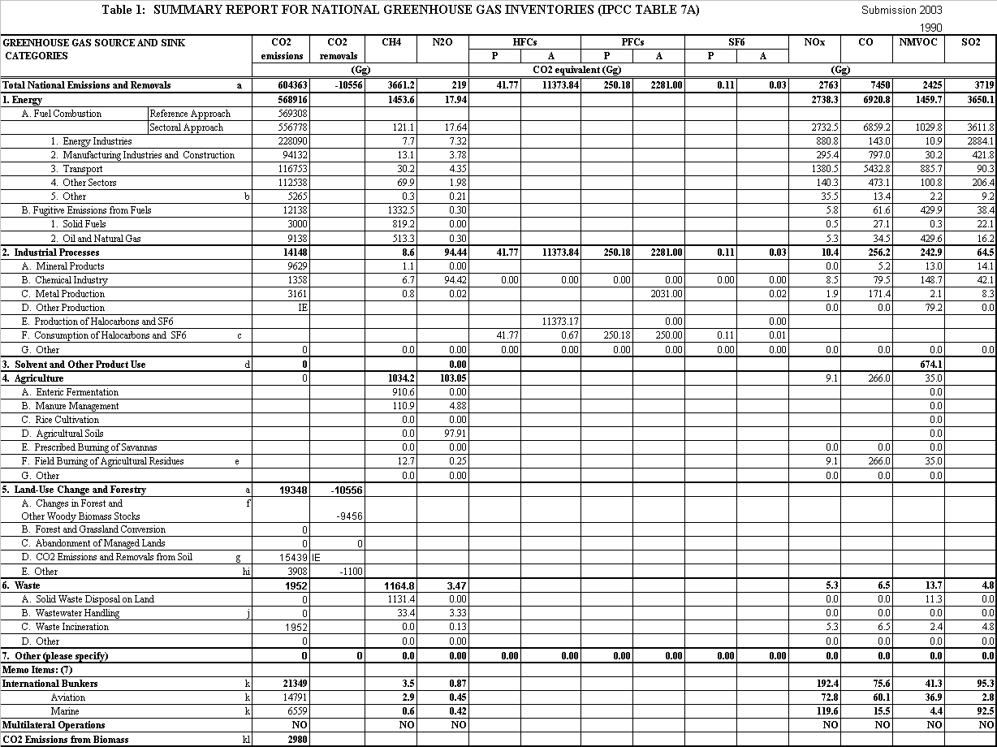
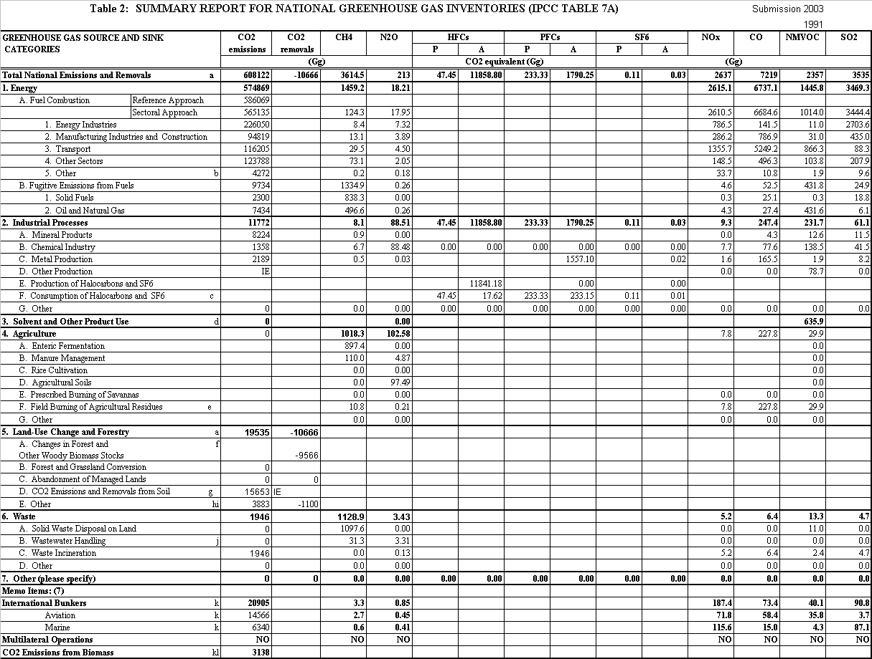
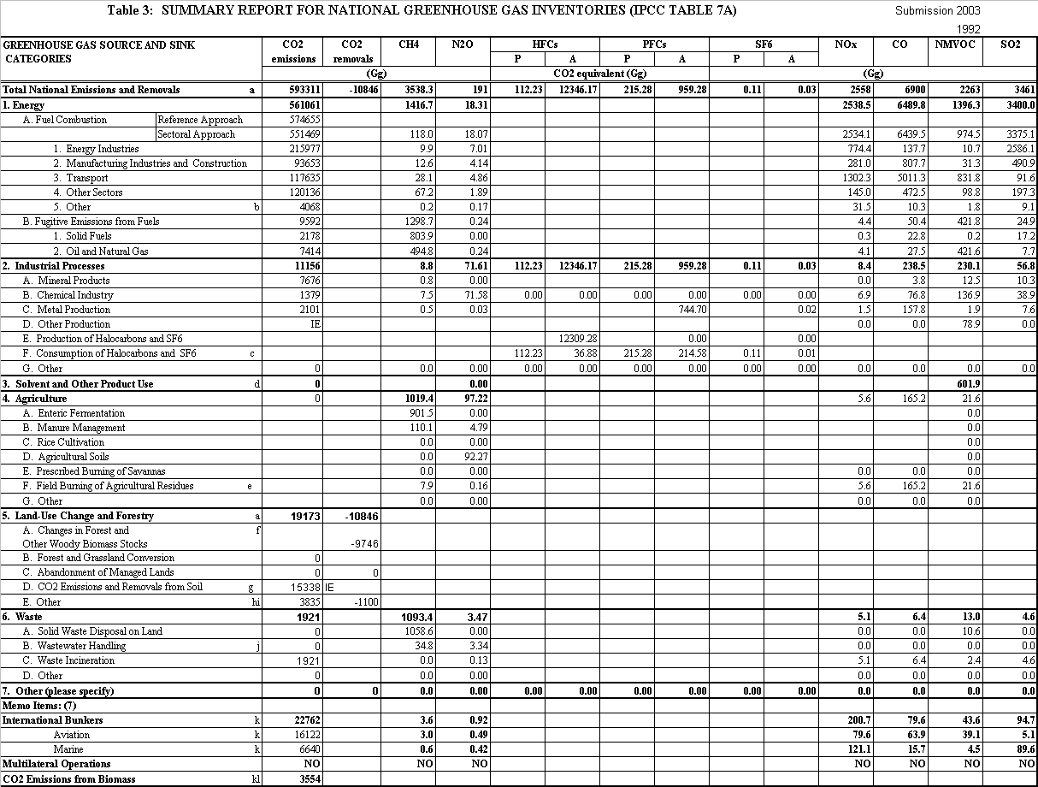
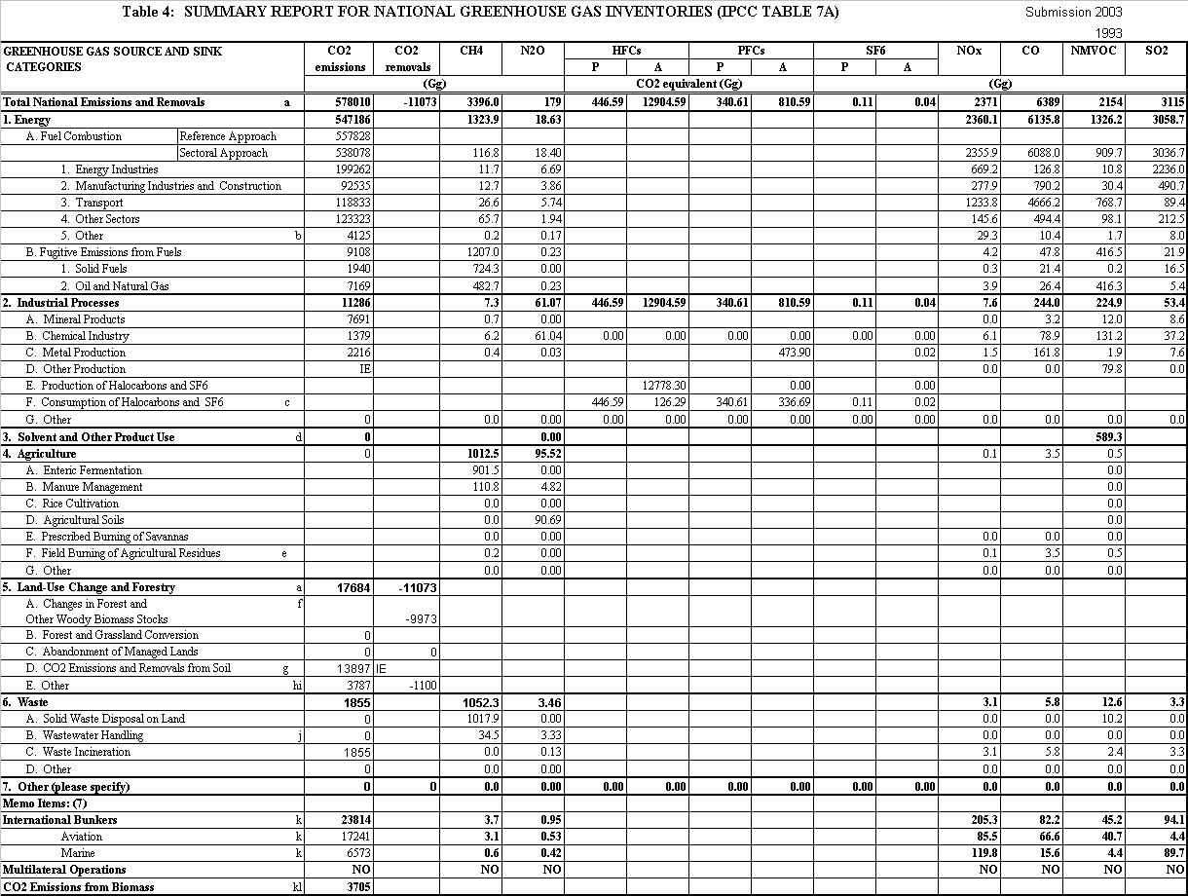
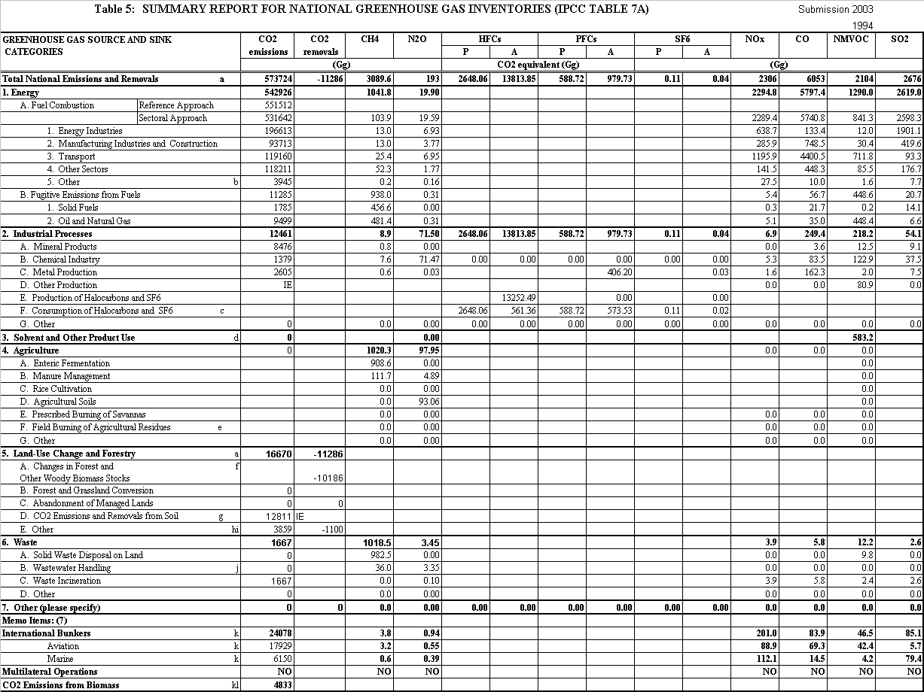
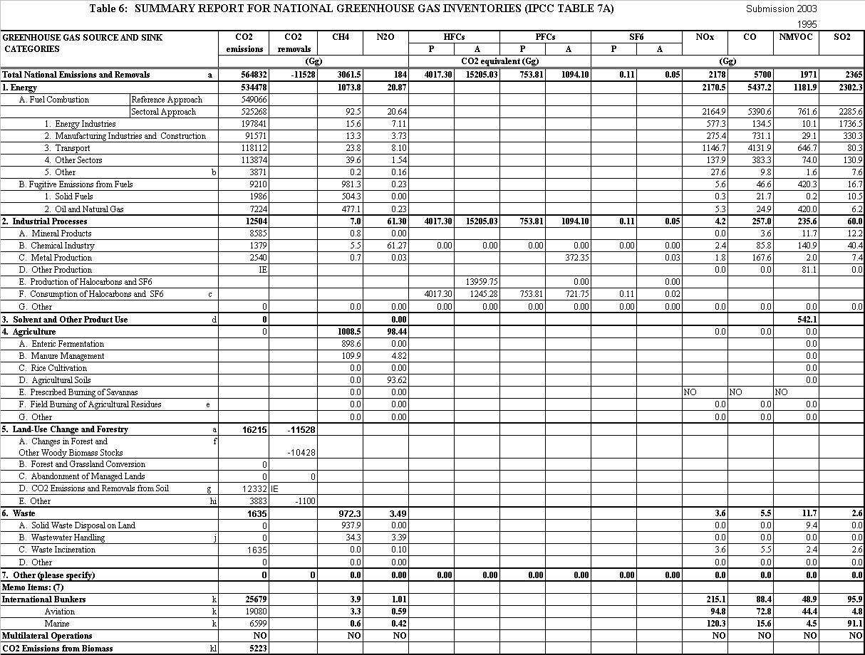
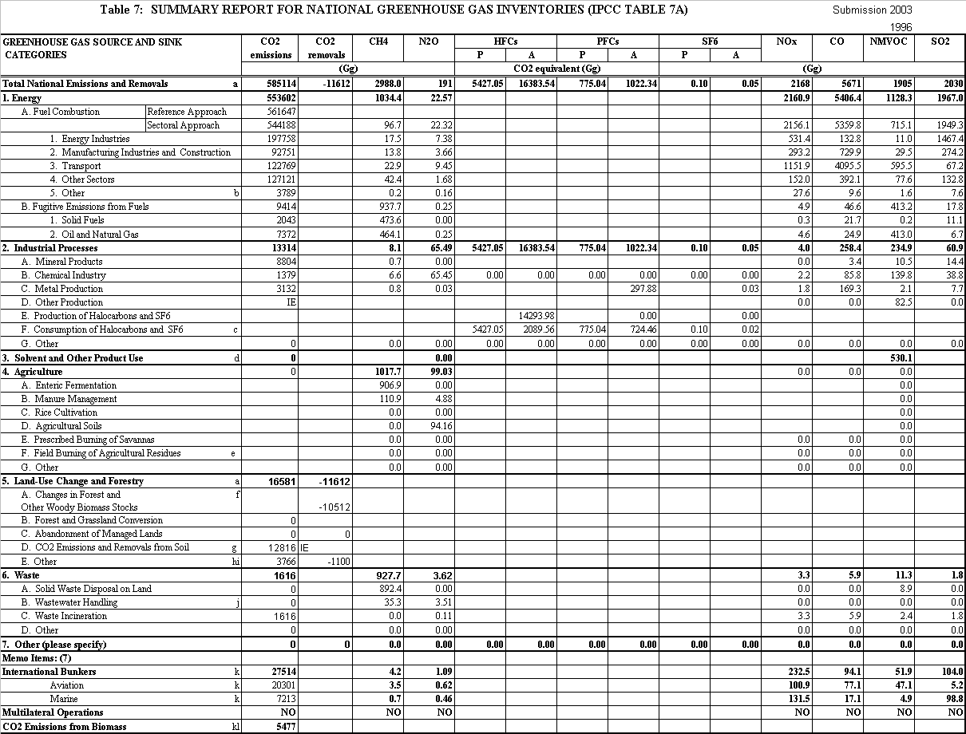
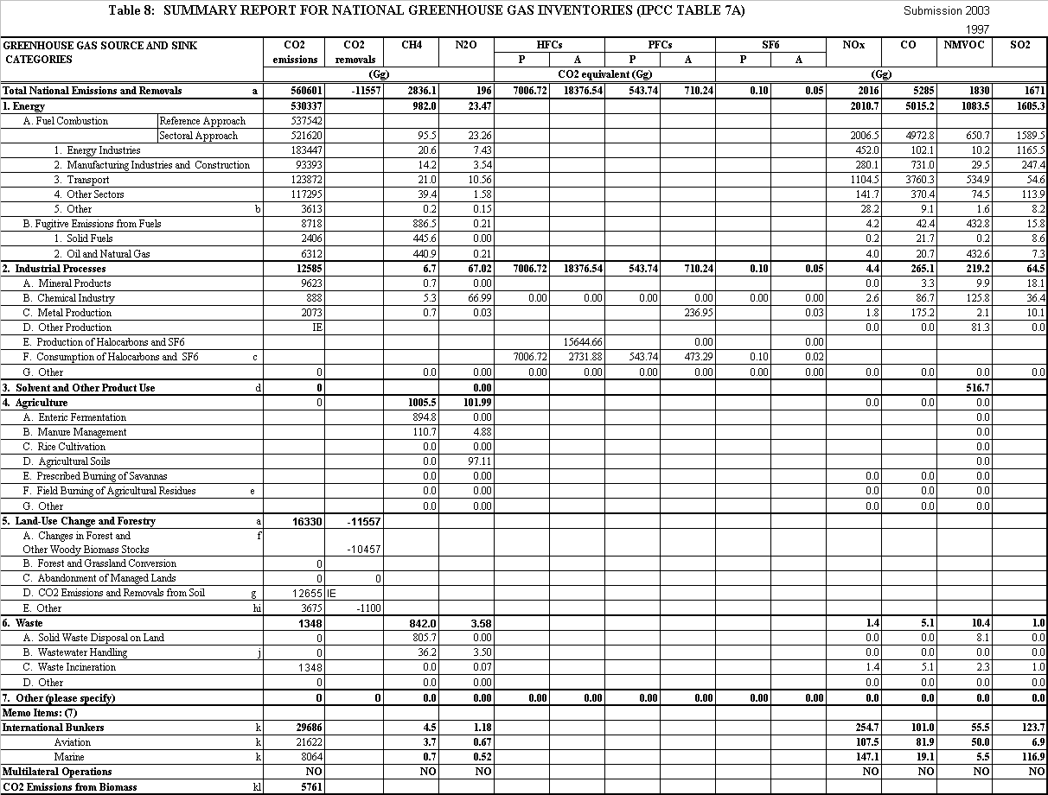
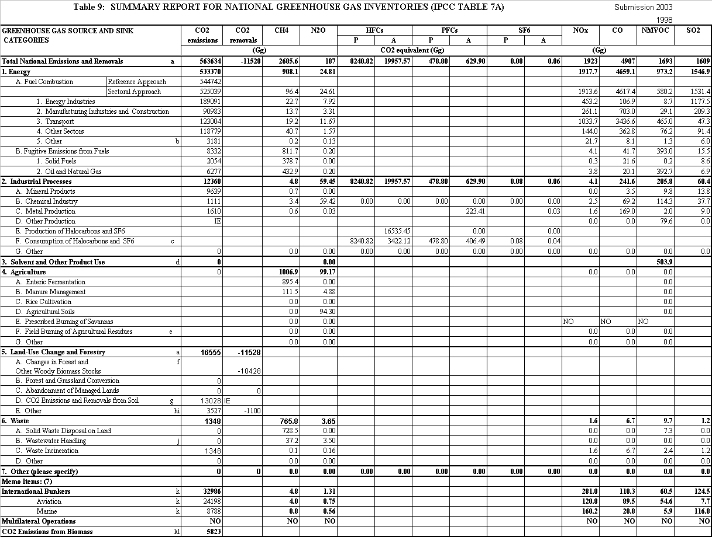
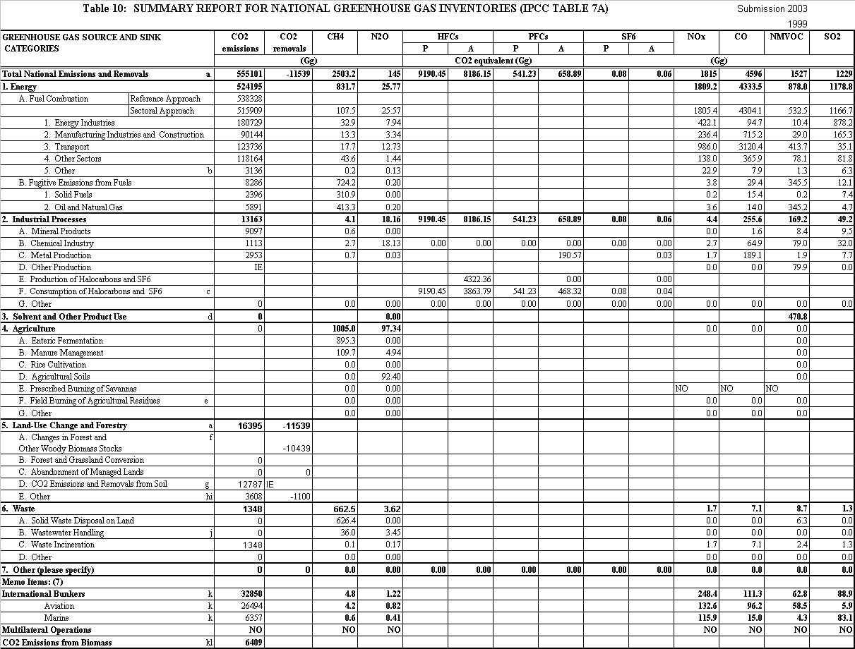
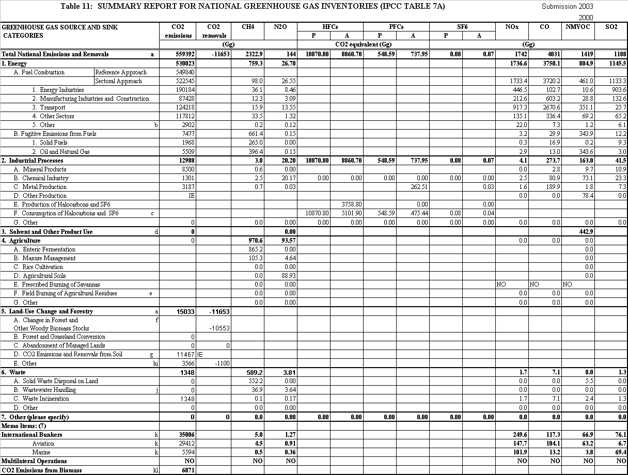

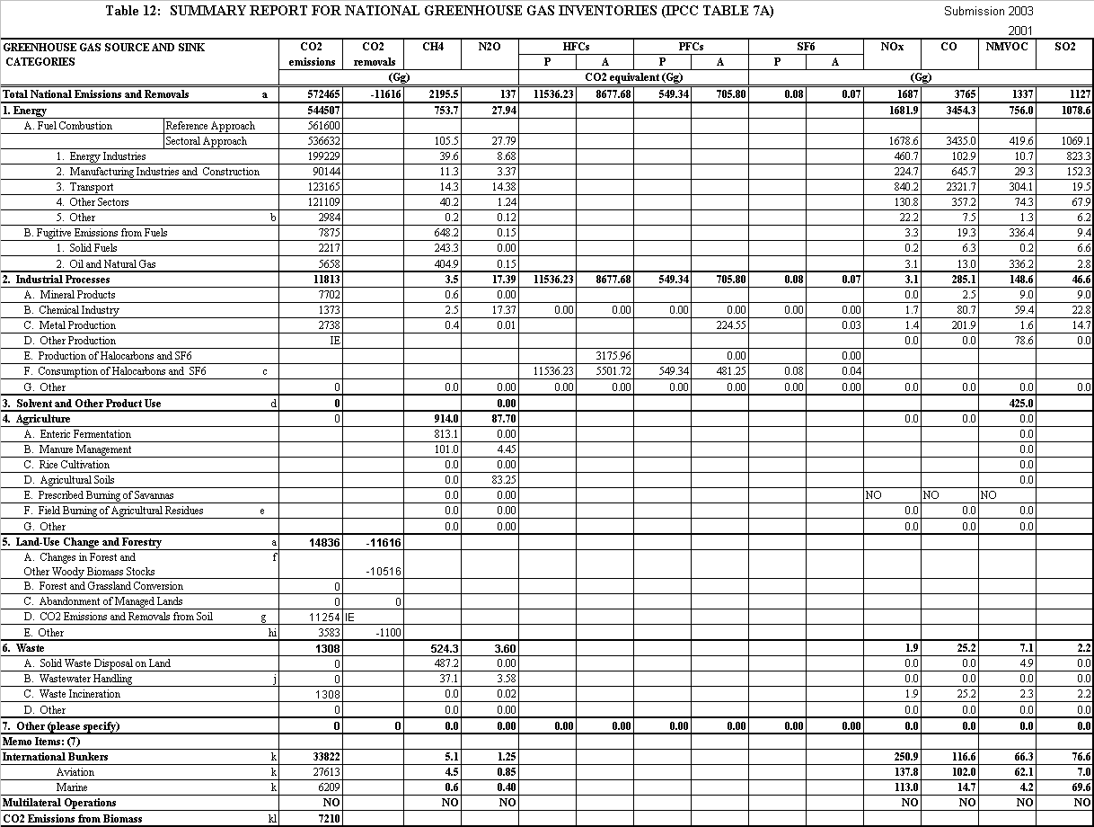

Footnotes for Tables 1 to 12

a Net flux may be estimated as the sum of emissions and removals
b Naval vessels and military aircraft
c Emissions arise from refrigeration, electronics applications, electrical insulation, foams, aerosols, training shoes and solvent cleaning
d The CO₂ equivalent of solvent NMVOC (excluding 3C) is 1641 Gg in 1990 and 1035 Gg in 2001
e Field burning ceased in 1994
f 5A removals are sum of removals to forest biomass, forest litter, forest soil and harvested wood products
g 5D Emissions are sum of emissions from soils and removals to soils due to land use change (not forestry), Set Aside and liming of agricultural land.
h 5E Emissions are sum of emissions from soils due to upland drainage, lowland drainage and peat extraction
i 5E Removals are increases in crop biomass
j Emissions from own wastewater treatment by industry are not estimated
k Emissions are for information only and are not totalled
l Emissions arise from wood, straw, biogases and poultry litter combustion for energy production

NE Not estimated
NO Not occurring
IE Included elsewhere

3 UK Emissions of Carbon Dioxide

3.1 Introduction
The major source of carbon dioxide in the UK is fossil fuel combustion. The UK CO₂ emission estimates use an emission factor for each fuel which were determined by fuel analysis. This is consistent with the IPCC (1997) methodology, though some uncertainty is introduced because the carbon content of some fuels may vary (by a few per cent) over time. Fuel consumption data are taken from the Digest of UK Energy Statistics (DTI, 2002) which is compatible with the IEA system of international energy statistics (though there are some small differences in reporting conventions), and has a similar level of uncertainty. Some additional imprecision is introduced because of uncertainties in CO₂ emissions from sources other than fuel combustion, though these make up around 6 per cent of the CO₂ inventory. The uncertainty in the 1995 total was estimated by analysing the uncertainties in each main source using a statistical simulation (Eggleston et al, 1998). For the 2001 inventory, quantitative estimates of the uncertainties in the emissions were calculated using Monte Carlo simulation. This corresponds to the IPCC Tier 2 approach discussed in the IPCC Good Practice Guidance. This method gave an uncertainty for CO₂ emissions of 2.2%.

Some carbon dioxide emissions, however, arise from biological sources that can also act as sinks because of the role of carbon dioxide in photosynthesis. Hence it is necessary to decide whether a source is a net emitter, part of the carbon cycle or indeed a net sink. IPCC (1997) specifies guidelines for the treatment of such sources and sinks. For example the category Land Use Change and Forestry contains both emissions and removals. For transparency, both emissions and removals are reported in the tables in this report. Removals are reported with a negative sign. This differs from the format used in the Common Reporting Format where net emissions are reported (=emissions +removals). Other examples include carbon dioxide emissions from sewage, which are excluded from the inventory since almost all of carbon dioxide from this source comes originally from uptake by plants and is therefore part of the natural carbon cycle. In the case of waste disposal, the issue is complex as the carbon content of waste can be from both fossil and recent sources: plastics are an example of a source of old carbon since they are normally made from fossil fuels, and crop residues are an example of recent carbon. Hence estimates have been made of the amounts of recent carbon in waste and the associated emissions excluded from the inventory.

3.2 Development of the Methodology
The methodology of these estimates is described in Appendices 1-7. There have been a number of changes in the methodology since the 2000 Inventory was published (Salway et al, 2002). Overall emissions have been revised upwards by 2186 Gg CO₂. Comparisons between the inventories refer to the year 2000 and the main changes are:

- Fuel Combustion
- There has been a decrease in emissions of CO₂ (337Gg) from Public Electricity Production in 2000. This arises from revisions in the energy statistics for fuel oil.
- There has been a small decrease in emissions reported from petroleum refineries (311.5Gg). This arises due to revisions in the energy statistics reported for natural gas.
- Emissions from the manufacturing industry have been revised up by 945Gg CO₂. Major changes within this category occur for natural gas. Emissions from autogenerators increased by 2279Gg CO₂ and emissions from other industry combustion decreased by 2851Gg CO₂. These changes arise due to the way in which emissions statistics are reported in DUKES (Dti, 2002). For the first time this year, the amount of energy transformed into and sold for consumption as heat was included in the annual energy balances (Dti, 2002). In previous years this data was always allocated to the final consumption data for the industry making the sale. This introduction of heat sold has not affected the individual fuel totals since the energy used to generate heat has been deducted from the final consumption section of the energy balance and transferred to the transformation section.
- Natural gas emissions from lime production increased by 957Gg CO₂.
- The combustion of both coal and petroleum coke within the cement industry decreased by 774Gg CO₂ and 598Gg CO₂ respectively. Natural gas emissions within the same sector increased by 816Gg CO₂. All changes occurred due to revisions in energy statistics.
- Road transportation showed an increase in emissions of 1716Gg CO₂ between the two inventories, due to a change in the fuel consumption data and emission factors used.
- Emissions from LPG fuelled road vehicles have been included. Emissions are estimated from 1996 to 2001. In 2001, LPG powered vehicles contributed 195Gg CO₂ to the road transport emission.
- There has been a small decrease in emissions from 1A4a Commercial and Institutional of 479Gg CO₂. This decrease arises mainly because of revisions to the fuel consumption data for natural gas reported for the public sector.
- Fugitive Emissions from Fuels
- Emissions from coke production using coal as a fuel have been revised downwards by 402Gg CO₂.
- Industrial Processes
- A small revision of 89 Gg CO₂ has occurred for category 2B1 Ammonia production, due to revisions in the natural gas statistics.
4. Land Use Change and Forestry
- An increase of 26Gg CO₂ occurred for category 5D, emissions from soil due to changes in methodology.
- Waste
- Emissions from chemical waste incinerators are now included in the inventory. These add 1140 Gg CO₂ to the total emissions from waste.

3.3 Discussion of the Estimates
Figure 1 shows emissions of carbon dioxide for the years 1990-2001 broken down by major IPCC source category. Emissions have declined by 5% since 1990, although a slight increase of approximately 2% was observed between 2000 and 2001, due to reduced nuclear output (especially in 2000), higher coal burn relative to gas, and lower outside temperatures.

Analysing emissions by source shows that emissions from energy industries contribute 35% of total CO₂ emissions in 2001. This sector has seen a decline in emissions of 13% between 1990 and 2001. The major components of this sector are electricity generation, refineries, offshore gas consumption and the manufacture of solid fuel and coke. Since the privatisation of the power industry in 1990, there has been a move away from coal and oil generation towards nuclear and combined cycle gas turbines (CCGT). Over this period there has been an increase of around 17% in the amount of electricity generated but a decrease in CO₂ emissions from power stations of around 18% due to:

(i) The greater efficiency of the CCGT stations compared with conventional stations - around 46% as opposed to 36%.•

(ii) The calorific value of natural gas per unit mass carbon being higher than that of coal and oil.

(iii) The proportion of nuclear generated electricity supplied increasing from 21% to 25%.

Between 2000 and 2001, emissions from power stations increased by 6%, partly as a result of a 10% increase in coal consumption. Overall, this sector contributes approximately 29% to the UK total during 2001.

The contribution from the other components of energy industries is much smaller. Emissions from refineries increased just 0.2% between 2000-2001 with levels being approximately 7% lower than in 1990. Emissions from other energy industries show a large decrease in the production of colliery methane and LPG and a large increase in natural gas production. Emissions from the solid fuel transformation industries are small in comparison and have declined.

Emissions from category 1A2a Manufacturing Industry and construction, Iron and steel have declined by 16% since 1990. This sector has seen a significant decrease in coke and fuel oil usage, with an increase occurring in the emissions of natural gas from combustion.

Emissions from transport have increased by 5.5% since 1990. Transport emissions are dominated by the contribution from road transport. This rose by 7% over the period. Petrol usage has declined by approximately 14% since 1990. But this was offset by an increased use of diesel fuel in cars as well as trucks.

The main components of 1A4 Other Sectors are residential and commercial/institutional. Residential emissions have increase by 13% since 1990, although emissions fluctuate from year to year and probably reflect average temperatures. Fuel consumption data shows a trend away from gas-oil, coke and coal and towards natural gas and burning oil usage. Overall emissions from 1A4 sector have increased by approximately 8% since 1990.

Land Use Change and Forestry differ from other categories in that they contain both sources and sinks of carbon dioxide. The removals are plotted as a negative quantity in Figure 1 and are reported separately from emissions in the inventory tables. Emissions from land use change and forestry were approximately 2.6% of the UK Total in 2001 and are declining gradually. Since 1990 they have fallen by 23%. Land use change and forestry emissions fell by 1% between 2000 and 2001. This reduction is explained by the variation in the underlying activity data. Removals from land use change have decreased by 10% since 1990 and in magnitude are 2% of the UK total emission.

International bunker emissions (international aviation and shipping) are not included in the national total but are reported separately. For the UK they are approximately 6% of the National Total. The shipping emission contributes 18% to bunker emissions in 2001. The remainder is air traffic and this has risen by approximately 87% since 1990.

3.4 The IPCC Reference Carbon Dioxide Inventory
Summary Table 7B includes the IPCC Reference Inventory total for carbon dioxide. This is a ‘top-down’ inventory calculated from national statistics on production, imports, exports and stock changes of fossil fuels. All other Sectoral Tables report emissions of pollutants estimated using a ‘bottom-up’ approach with emissions estimated from activity statistics (mostly fuel consumption) in the various economic sectors and processes.

In principle the IPCC Reference Total is comparable to the Table 1A total plus the fuel consumption emissions in 1B1 Solid Fuel Transformation and 2 Industrial Processes. However, the IPCC Reference approach produces totals that are 2-5% higher than the comparable sources estimated by the ‘bottom-up’ approach, largely because it is based on a different set of statistics. Reasons for the discrepancies between the two estimates are discussed in Appendix 2. Over the period, emissions estimated by the Reference Approach have fallen by 1.4% compared with 3.8 % for the comparable ‘bottom-up’ totals.

A detailed comparison between the IPCC Reference Inventory, the UK Greenhouse Gas Inventory and a UK Inventory based on the IPCC Default Methodology is given by Salway (1998a).

4 UK Emissions of Methane

4.1 Introduction
Methane is the second most important greenhouse gas after carbon dioxide. Unlike most of the other major pollutants in the Greenhouse Gas Inventory, fuel combustion is not the predominant source of methane. The major sources are agriculture, waste disposal, leakage from the gas distribution system and coal mining. Estimation of methane emissions is generally more uncertain than for CO₂ from combustion sources and the methodologies are subject to change as further research is undertaken. An estimate has been made of the overall uncertainty in methane emissions based on the uncertainties in the major sources. This showed that the overall uncertainty was 14%. A more detailed discussion of the approach used is given in Appendix 8.

4.2 Development of the Methodology
A number of changes have been made to the methane estimates since the 2000 Inventory. Overall emissions have been revised downwards by104 Gg. Comparisons between the inventories refer to the year 2000 and the main changes are:

1) Fuel combustion
- Manufacturing Industry and construction for the Iron and Steel category have been revised down by 0.35 Gg due to a revision in coke emissions from sinter plant.
- An increase of 0.24Gg from the Manufacturing industry occurs due to an increase in the emissions estimated from natural gas autogenerators.
- Road transportation has been revised down by 0.11 Gg due to changes in emission factors and fuel consumption data.
- Emissions from 1A4a Commercial and Institutional have been revised up slightly by 0.16Gg due to an increase in emissions estimated from non-fuel-sewage gas.
2) Fugitive emissions from fuels
- Emissions from gas leakage have been revised up by 2.6Gg. These estimates are based on data provided by Transco.
- Agriculture
- There have been only small changes in emissions of methane from agriculture. These have occurred due to an increase in enteric fermentation from sheep (1.53Gg) and an increase in emissions from the manure management from poultry (0.17Gg).
- Waste
- Managed waste disposal on land has been revised down by 108Gg due to changes in landfill emissions.

4.3 Discussion of the Estimates
The emissions of methane from the UK are shown in Figure 2. Total emissions are declining and have fallen by 40% since 1990.

The largest source of methane emissions in the UK is agriculture, which includes enteric fermentation emissions from livestock and emissions from their waste. Since 1990, overall cattle emissions have declined by 9.5%. In 2001, cattle contributed 31% of the UK total emissions of methane. Sheep contribute 8% to the total with pigs, goats, horses and poultry making up the remaining emissions.

The second largest component of the total methane emission is waste, which in 2001, contributed 24% of UK total methane. This comprises landfills, waste water treatment and waste incineration. Wastewater treatment emissions are small compared with landfill, and incineration is negligible. Wastewater emissions depend on the mode of disposal: sea dumping, land spreading or incineration. The sewage sludge disposed of in landfills is allocated to the landfill estimate. The UK ceased dumping sewage at sea in 1998.

The largest single source of emissions in the waste category is landfills and it is also the most uncertain. Estimates are derived from the amount of putrescible waste disposed of to landfill, and are based on a model of the kinetics of anaerobic digestion involving four classifications of landfill site. The model accounts for the effects of methane recovery, utilization and flaring. Methane emissions from landfill have declined by 57% since 1990, because of the implementation of methane recovery systems. This trend is likely to continue as all new landfill sites are required to have these systems and many existing sites may have systems retrofitted. However, uncertainties are great and the overall methane estimate from landfill maybe subject to revision, as more information becomes available.

Emissions from 1B2 Oil and Natural Gas have fallen by 21% over the period 1990 to 2001. Sources include leakage from the gas transmission and distribution system and offshore emissions. Estimates of leakage from the gas distribution system are based on leakage measurements made by Transco together with data on their gas main replacement programme, and have declined since 1990 as old mains are replaced. The major sources of emissions from the offshore oil and gas industry are venting, fugitive emissions, loading and flaring from offshore platforms. Emissions from cold vents and other fugitives have declined though those from flaring show little overall change. Emissions are estimated on the basis of a survey of operators by SCOPEC (2002). Other emissions in the oil and gas industries arise from fuel oil and gas combustion, but these are reported as energy emissions in category 1A1c.

The emission of methane from coal mining is the fourth largest component of the total UK emission. Emissions have fallen by 70% due to a general decline in coal production. The inventory currently reports emissions only from working mines because it was previously thought that those from closed mines were negligible. However, a recent review (Sage, 2001) reported estimates ranging from 20 to 300 Gg. DEFRA is planning further research to establish a more reliable estimate from this source.

5 UK Emissions of Nitrous Oxide

5.1 IntroductioN
Emissions of nitrous oxide are uncertain because there are many small sources, both natural and anthropogenic, and detailed emission factors for some man-made sources, (e.g. combustion) are not yet available. The main anthropogenic sources are agriculture, biomass burning, coal combustion and some industrial processes.

5.2 Development of the Methodology
A number of changes have been made in the methodology used for the emission estimates since the 2000 Inventory (Salway et al, 2002). Overall emissions have been revised upwards by 3 Gg N₂O. Comparisons between the inventories refer to the year 2000 and the main changes are:

1) Fuel combustion
- Emissions from Manufacturing industry and construction - increase of 0.12Gg due to an increase in natural gas from autogenerators. This arises due to the change in the way that energy statistics are reported in DUKES.
2) Industrial processes
- There has been a small increase in emissions of 0.23Gg from Nitric Acid production.
3) Agriculture
- Emissions from agriculture have increased by 2.5Gg due to a change in the emission estimates from fertilizer.

5.3 Discussion of the Estimates
UK Emissions of nitrous oxide have declined by around 38% over the period 1990 to 2001. Emissions are very uncertain with an estimated mean emission (estimated from the Tier 2 uncertainty analysis - see Table 4, Appendix 8) of 137 Gg in 2001 within a range of 36 Gg to 485 Gg. (See Appendix 8). Emissions are dominated by agriculture, which accounted for 64% of the total in 2001. Agricultural emissions arise from a number of sources:

- Cultivation of legumes
- Synthetic fertilizer application
- Crop residues
- Histosols
- Improved grass
- Manures from grazing animals
- Manure used as fertilizer
- Animal waste management systems
- Leaching
- Atmospheric deposition of NH₃ and NO_{x}
- Field Burning (Discontinued in 1993)

Emissions from agriculture have declined by 15% over the period 1990 to 2001 driven by a fall in synthetic fertilizer application and a decline in animal population over the period. Emissions fell by 6% between 2000 and 2001. The drivers for this fall appear to be synthetic fertiliser application and emissions from crops. Agricultural stubble burning was banned in England and Wales in 1993 resulting in a slight decrease in the agricultural emission.

There has been a large decline in N₂O emissions from industrial sources. Emissions fell by 82% between the years 1990 and 2001. This is because of reductions in emissions from adipic acid manufacture (a feedstock for nylon) and nitric acid production. The emissions from nitric acid manufacture show a fall in 1995 due to the installation of an abatement system at one of the plants. However, emissions show an increase between 1998 and 1999, because of the installation of an abatement system for NO_{x} which had the effect of raising N₂O emissions. Emissions from adipic acid manufacture fell notably in 1998 and 1999 as a result of the retrofitting of an emissions abatement system.

Between 1990 and 2001, emissions from road transport have increased by a factor of 4. This large increase is as a result of the increasing numbers of petrol driven cars fitted with three way catalytic converters. Catalytic converters are used to reduce emissions of nitrogen oxides, carbon monoxide and non-methane volatile organic compounds but a by-product is increase nitrous oxide emissions. During 2001, the contribution from the road traffic sector to the total emissions was 11%.

Unlike other pollutants, the nitrous oxide emission from public power shows little variation over the period 1990 to 2001 in spite of the trend away from coal towards natural gas combustion. The emission factor for gas combustion is similar to that for coal combustion so no particular trend is apparent. However, these estimates are uncertain because there are very limited data on N₂O emissions from large gas turbines. Public power emissions are around 5% of the total.

6 UK Emissions of Hydrofluorocarbons, Perfluorocarbons and Sulphur Hexafluoride

6.1 Introduction
This chapter discusses the emissions of:

- hydrofluorocarbons (HFCs)
- perfluorocarbons (PFCs)
- sulphur hexafluoride (SF₆)

HFCs and PFCs are used mainly as substitutes for chlorofluorocarbons (CFC) and hydrochlorofluorocarbons (HCFC) which are being phased out under the Montreal Protocol because they deplete the ozone layer. A detailed description of the usage, emission estimates and the methodology used to derive the emissions of these gases is given in MCG (1999).

The UK reports both actual and potential emissions of these gases.

- Actual emissions are estimates of the emission of a gas to atmosphere in a given year.
- Potential emissions are estimated as the apparent consumption of fluid in a given year. (IPCC, 1997). Apparent consumption is based on data on annual production, imports, exports and destruction of fluid. Hence, it is assumed that the entire emission occurs in the year of use and neglects leakage over the lifetime of a piece of equipment.

In this chapter, only actual emissions are discussed. Potential emissions provide a convenient benchmark to compare emissions between countries and are simpler to estimate but do not include emissions arising from metal or halocarbon production. The estimation of potential emissions in the UK is discussed in Appendix 4.

Emissions of individual halocarbon species are not reported individually because some of these are considered commercially sensitive data within the industries involved. Consequently, emissions data have been aggregated to protect this information. The total global warming potential of the aggregated emissions is reported based on actual global warming potential of the individual fluids.

6.2 Hydrofluorocarbons
Figure 4 shows the UK emissions of in terms of their global warming potential (GWP). The HFC emissions comprise many species each with its own GWP, hence it is more helpful to express emissions in terms of GWP as CO₂ equivalents. This allows the relative influence of sectors on Global Warming to be compared. This approach differs from previous reports where mass emissions were quoted. Eggleston et al (1998) estimated the uncertainty in the emissions as ± 25% in 1990. HFCs had limited usage prior to the phase out of CFCs, in the production of semiconductors and as refrigerants blended with CFCs. They are now being used increasingly as:

- substitutes for CFCs and HCFCs in domestic, commercial and industrial refrigeration and air conditioning
- substitutes for CFCs and HCFCs in plastic foam blowing
- substitutes for CFCs for industrial and specialist aerosols
- substitutes for CFCs for medical dose inhalers (MDI)
- firefighting fluids

Emissions of HFCs, increased between 1990 to 1998 but rapidly declined in 1999 to 43% of 1998 levels. Overall, emissions have decreased 24% since 1990. Emissions from refrigeration and air conditioning are the largest source of HFCs and contribute 41% to the total HFC emissions in 2001. Here emissions arise due to leakage from refrigeration and air conditioning equipment during its manufacture and lifetime. Emissions from the manufacture of halocarbons is the next largest source and these contribute 37% to the total. Aerosols contribute approximately 21% to the total emission, and here it is assumed that all the fluid is emitted in the year of manufacture. The category aerosols includes mainly industrial aerosols and also medical use in metered dose inhalers. The remaining emission sources, namely, foams, fire fighting, and solvents are very small and comprise 2.5% of total emissions.

6.3 Perfluorocarbons
Figure 5 shows the UK emissions of PFCs in terms of their GWP. Eggleston et al (1998) estimated the uncertainty in the emissions as ± 19% in 1990. PFCs had limited usage prior to the phase out of CFCs in the electronics and electrical industry in:

- etching processes in the semiconductor industry
- chemical vapour deposition in the electronics industry
- soldering processes
- leak testing of electrical components
- cooling electrical components, for example in super computers and radar systems.

Other significant uses include:
- refrigerant blended with HFC
- fire fighting in specialist applications
- cushioning in the soles of training shoes

Other minor uses were in cosmetics and as a tracer gas.

The main sources of PFCs are from the electronics industry and leakage from the soles of training shoes. Together these accounted for 63% of emissions in 2001.

PFCs also form as a by-product during aluminium smelting and this contributes around 32% of the UK GWP total of PFC emissions in 2001. The emissions are caused by the anode effect which occurs when alumina concentrations become too low in the smelter. This can cause very high electrical current and decomposition of the salt - fluorine bath. The fluorine released then reacts with the carbon anode, creating CF₄ and C₂F₆. Emissions from aluminium production have fallen by 89% since 1990 due to significant improvements in process control and an increase in the rate of aluminium recycling. Emissions from refrigeration, fire fighting and fugitives from PFC production are very small and together account for around 6% of emissions in 2001.

6.4 Sulphur Hexafluoride
Figure 6 shows the UK emissions of SF₆ in terms of its GWP. One tonne of sulphur hexafluoride is equivalent to 23900 tonnes of carbon dioxide in its effect on global warming. Eggleston et al (1998) estimated the uncertainty in the emissions as ± 13% in 1990. It has the following applications:

- insulation medium in high voltage applications such as switch gear and circuit breakers
- cover gas in magnesium foundries to protect the molten magnesium from re-oxidising when it is cast
- degasser in aluminium casting applications, though its use in the UK is rather limited
- insulating gas in double glazing applications, replacing vacuum as an insulation technique
- plasma etching of polysilicon and nitrite surfaces
- atmospheric tracer for scientific studies
- cushioning in the soles of training shoes

Emissions of sulphur hexafluoride have increased by a factor of 2.4 between 1990 and 2001. The largest source is from magnesium manufacture which accounted for 43% of the UK Total in 2001. It is not possible to recover the SF₆ so the total annual consumption is emitted to atmosphere. Another major source is electrical insulation accounting for 34 % of emissions in 2001. Emissions arise during the manufacture and filling of the circuit breakers and from leakage and maintenance during the equipment lifetime. This application has only been in use for the last 20 to 30 years and little of the equipment has been decommissioned. It is expected that users will take great care over future fluid recovery so that emissions will be minimised. The remaining sources are emissions from applications in the electronics industry and training shoes (23%).

7 UK Emissions of Nitrogen Oxides

7.1 Introduction
The main source of NO_{x} (NO + NO₂) in the UK is fuel combustion. However, such emissions are complex since the nitrogen can be derived from both the fuel and the combustion air. Emissions are also dependent on the conditions of combustion, in particular on the temperature and excess air ratio, which can vary considerably. Thus combustion conditions, load and even state of maintenance are important. The estimation of NO_{x} emissions is often based on relatively few measurements and, in view of the possible variation in emissions from apparently similar combustion plant, there is greater uncertainty in the estimates than for CO₂. It is estimated that the uncertainty in total NO_{x} emissions is about ±8%.

7.2 Development of the Methodology
A number of changes to the methodology have been made since the 2000 Inventory (Salway et al, 2002). Overall emissions have been revised upwards by 225Gg NO_{x} in 2000. Comparisons between the inventories refer to the year 2000 and the main changes are:

- Fuel combustion
- There has been a small increase of 8Gg from Public electricity and heat production due to an increase in emissions from natural gas power stations.
- Emissions due to road transportation have increased by 220Gg . This change can be attributed to the use of revised vehicle consumption and emission factors for the pollutant. These revised figures have lead to an increase in the estimate of emissions from Euro I and Euro II diesel vehicles.
- A small decrease of 0.5Gg occurred for emissions from petroleum refining, due to a decrease in natural gas emissions.
- Industrial processes
- Emissions from the chemical industry have increased by 0.3Gg as a result of increased emissions from the use of nitric acid.
- Waste Incineration
- Emissions from chemical waste and animal carcasses are now included in the inventory. This adds 0.6Gg to the total emissions from waste.

7.3 Discussion of the Estimates
Figure 7 shows the UK emissions of nitrogen oxides (as nitrogen dioxide) broken into source categories.

Since 1990, total emissions have fallen by 39%, mostly as a result of abatement measures on power stations, three-way catalytic converters fitted to cars and stricter emission regulations on trucks.

The main source of nitrogen oxide emissions is transport. In 2001, this contributed 50% towards the total UK emissions, with 43% arising from road transport. From 1970, emissions from transport increased (especially during the 1980s) and reached a peak in 1989, before falling by 39% since 1990. The total road vehicle kilometres in 2001 were 16% higher than in 1990. Hence the reduction in emissions is due to the requirement since the early 1990s for new petrol cars to be fitted with catalytic converters and the further tightening up of emission standards on these and all types of new diesel vehicles over the last decade.

Emissions from off-road sources are reported in the sectors in which they occur, namely, 1A2 Manufacturing Industry, 1A3 Other Transport, 1A4b Residential and 1A4c Agriculture. Emissions from machinery used in agriculture, construction, industry, gardening and aircraft support have declined over the period but contribute around 4% of the current total.

Emissions from the Energy Industry decreased by approximately 48% between 1990 and 2001. The main reason for this was a decrease in power station emissions of approximately 51%. Since 1988, the electricity generators adopted a programme of progressively fitting low NO_{x} burners to their 500 MWe coal fired units. Since 1990, further changes in the electricity supply industry such as the increased use of nuclear generation and the introduction of CCGT plant (see Section 2.3) have resulted in additional reductions in NO_{x} emissions. However, between 2000 and 2001, emissions increased by 4% due to an increased consumption of coal, fuel oil and MSW in power stations.

Fugitive emissions from 1B2 Oil and Natural Gas have fallen by 41% over the period 1990 to 2001. Most of this is flaring.

Emissions from Other Sectors combustion decreased between 1990 and 2001 by 13%. In 2001, this sector contributed 9% to the overall emissions from NO_{x}. Emissions from this category are variable since its main components are residential and commercial/institutional, which fluctuate from year to year depending on energy consumption.

International Bunkers are not included in the National total, but are reported separately. For the UK they are around 15% of the National total. Aviation emissions are the major component of this sector, accounting for 55% of bunker emissions in 2001.

8 UK Emissions of Carbon Monoxide

8.1 Introduction
Carbon monoxide (CO) arises from incomplete fuel-combustion. In 2001, 63% of emissions came from the transport sector. Many of the comments about the uncertainty of the emission estimates of nitrogen oxides also apply to carbon monoxide and the overall uncertainty in emissions of carbon monoxide is currently estimated to be ±20%.

8.2 Development of the Methodology
A number of changes have been made to the methodology since the 2000 Inventory. Overall emission have been revised downwards by 145 Gg in 2000. Comparisons between the inventories refer to the year 2000 and the main changes are:

- Fuel combustion
- Emissions from Public electricity production (1A1a) increased by 9.3 Gg CO, due to an increase in emissions from coal, sour gas and natural gas power stations.
- Road transportation was revised down by 230Gg as a result in the revision of vehicle fuel consumption and emission factors for CO.
- Fugitive emissions from Fuels
- There has been a small increase of 1.3Gg from coke production.
- Industrial processes
- Emissions from the chemical industry have increased by 71Gg. This is mostly as a result of the inclusion in the inventory for the first time of emissions from titanium dioxide, but also arises due to an increased contribution from the chemicals and manmade fibres section.
4) Waste incineration
- The inclusion of animal carcasses adds 3.3Gg to the emissions from waste incineration.

8.3 Discussion of the Estimates
National emissions of carbon monoxide are shown disaggregated into the main IPCC source categories in Figure 8. Since 1990, total emissions of carbon monoxide have fallen by 50%. The most important source is road transport where emissions have fallen by 57% since 1990 due primarily to the increased use of catalytic converters, although a proportion is a consequence of fuel switching from petrol cars to diesel cars. In 2001, emissions from this sector contribute 62% to the total UK emissions of CO. The other significant reduction is in the Agriculture category (91%) and this is mainly due to the cessation of agricultural stubble burning in 1993.

In comparison to transport, other emissions sources of CO are small. Industrial combustion is the second most significant source after transport, accounting for approximately 18% of total UK emissions in 2001.

Emissions from Other Sectors have decreased by 25% since 1990 almost entirely as a result of decreased residential solid fuel combustion in favour of gas and electricity. This consumption has fluctuated considerably over the period but has fallen markedly since 1993. Emissions from the residential sector were 238 Gg in 2001 accounting for 6% of the total. Around 89 Gg of this arises from house and garden machinery.

Emissions from off-road sources are reported in a number of sectors, namely: 1A2 Industry, 1A3 Other Transport and 1A4 Other Sectors. These include emissions from agricultural and construction equipment such as tractors, combine harvesters, portable generators, forklift trucks, lawnmowers, and cement mixers. The petrol-engined machinery is a particularly important source of CO emissions. These estimates are very uncertain because they are based on estimates of equipment population and annual usage time. Emissions from these sources are now believed to contribute approximately 11% of the total emission.

The large emissions from iron and steel processes and the chemical industry are based on data reported in the Pollution Inventory (Environment Agency, 2002). These emissions arise from blast furnaces, electric arc furnaces, basic oxygen furnaces, non-ferrous metals and various processes in the organic chemical industry. Iron and Steel processes make the largest contribution particularly emissions arising from basic oxygen furnaces. The estimates have been improved based on more detailed data provided by Corus (2002). Sinter plant emissions are the major component of iron and steel emissions but these are reported in the combustion category, 1A2a. The remaining iron and steel emissions are classified as process emissions and are reported in category 2C1 and account for around 2% of the total in 2001.

Other emission sources are small compared with transport, off-road sources and processes. Since 1990, power station emissions have decreased by 37% and in 2001, this sector accounted for 1.9% of the total.

9 UK Emissions of Non-Methane Volatile Organic Compounds

9.1 Introduction
The development of an accurate emission inventory for Non-Methane Volatile Organic Compounds (NMVOC) is complex. The diversity of processes which emit NMVOC is large, covering not only many branches of industry, but also transport, agriculture and domestic sources. Within a single industry sector such as printing, the variation in the quantity and composition of organic solvents used in the inks, the different printing processes used and the varying extent and types of abatement used on the different presses make it difficult to apply a single, generally valid, emission factor across the industry. Unlike CO₂, CO and NO_{x}, only about 31% of the UK estimate of NMVOC emissions come from fuel combustion sources.

Often emissions from sources are small individually, but important collectively. A good example of this is leakage from valves, flanges and other connections in petrochemical plants. A typical plant may have many other emission sources, each emitting a very small quantity of NMVOC which are difficult to locate and quantify.

The term NMVOC covers a large range of compounds and this can create difficulties when measuring emission factors. Many commonly employed measurement techniques such as flame ionisation detection do not respond with uniform sensitivity to all compounds. Large errors can therefore occur if emitted compounds are poorly detected by the measurement technique used. Methane is also associated with NMVOC emissions from many sources, for instance, combustion processes, transport, and the oil and gas industries. Methane is removed from the emission factors used so that NMVOC is reported rather than total hydrocarbons (THC).

NMVOC emissions are uncertain since data relating to emission from individual industrial processes and solvent use are incomplete. Therefore, the emission factors are very approximate and the uncertainty in total NMVOC emissions is currently estimated to be around ±8%.

9.2 Development of the Methodology

A number of changes have been made to the methodology since the 2000 Inventory. Overall emissions have been revised downwards by 80 Gg NMVOC in 2000. Comparisons between the inventories refer to the year 2000 and the main changes are:

1) Fuel combustion
- Road transport emissions have decreased by 62Gg due to revisions in the fuel consumption data and emission factors for the pollutant.

2) Fugitive emissions from fuels
- There has been a decrease of 21 Gg in emissions from the distribution of oil products due to decreases in emissions from deliveries to petrol stations, spillages, vehicle refuelling and storage tanks.
- A small increase of 2.4 Gg in emissions from the refining/storage sector has occurred due to an increase in emissions from oil production.
- Industrial processes
- There has been a small decrease of 0.2Gg from the food and drink sector due to a decrease in emissions from malt exports.
- A decrease of 5Gg occurred for industrial paint application. The most significant decrease was from decorative paint emissions, both trade and retail. A small decrease also occurred for metal and plastic coatings emissions.
- A decrease of 1.9 Gg occurred from the degreasing and dry cleaning sector, due to surface cleaning with trichloroethylene emissions decreasing.
- Solvent and other product use
- A net increase of 5Gg occurred as a result of numerous revisions to the data.
- Waste incineration
- An increase of 2.3Gg occurred for waste as a result of chemical incineration and animal carcasses being included for the first time.

9.3 Discussion of the Estimates
Figure 9 shows the UK emissions of NMVOC broken down by source category. The estimates suggest a decline in total emissions of 45% since 1990. Until 1998, the main source of emissions came from the transport sector. However, between 1990 and 2001, emissions from this sector have declined by 66% and now contribute 23% to the overall total of emissions of NMVOC in the UK. This reduction is due mainly to the increasing use of catalytic converters on cars, although a proportion is due to switching from petrol to diesel cars.

In 2001, the main source of emissions were from the solvent sector (32%). The largest of these emissions arise from the aerosol car-care source, as well as from industrial adhesive use and emissions from automotive products. Smaller emissions arise across the sector from sources such as paint use and wood impregnation.

Emissions from 1B2 Oil and Natural Gas have decreased 22% since 1990 and in 2001 constitute 25% of the UK Total. This includes emissions from gas leakage which comprise around 5% of the total. Emissions from oil transportation are around 9% of the UK total, with emissions from refining, storage and offshore accounting for the remainder.

Emissions from off-road sources have been included since the 1995 Inventory. Of particular importance are those from petrol-engined machinery. This includes portable generators, forklift trucks, lawnmowers and cement mixers. The estimation of emissions from such machinery is very uncertain since it is based on estimates of equipment population and annual usage time. They are believed to contribute around 4% of the total emissions. In the IPCC reporting format these sources are reported under 1A2 Industry, 1A3 Other Transport and 1A4 Other Sectors.

Other combustion emissions are small compared to the sources discussed above, and contribute approximately 9% to the overall UK total emissions.

Since 1990, Agriculture and Waste emissions have decrease by 85% due to the cessation of agricultural stubble burning in 1993.

10 UK Emissions of Sulphur Dioxide
Emissions of sulphur dioxide have been included in the Greenhouse Gas Inventory since the 1996. Sulphur dioxide is reported as an indirect greenhouse gas because of its role in aerosol formation. It has however, been reported as part of the NAEI for many years, originally because of its role in smog formation but more recently because of interest in acidification.

Fuel combustion accounts for more than 99% of UK SO₂ emissions with the sulphur deriving from the fuel itself. Hence, SO₂ emissions can be calculated from knowledge of the sulphur content of the fuel and information of the amount of sulphur retained in the ash. The uncertainty in the emissions is estimated as ±3%.

10.1 Development of the Methodology
A number of changes have been made to the methodology since the 2000 Inventory (Salway et al, 2002). Overall emissions have been revised upwards by 23 Gg SO₂ in 2000. Comparisons between the inventories refer to the year 2000 and the main changes are:

- Fuel combustion
- There has been an overall decrease of 5Gg in emissions from public electricity production. Within this sector emissions from coal-fired power stations have declined by 10 Gg with an increase of 5Gg occurring from fuel-oil stations.
- An increase of 13Gg has occurred in emissions from the Manufacturing Industry and construction sector. This increase has occurred due to an increase in natural gas emissions from autogenerators, as well as an increase in emissions from clinker production and lime production.
- Emissions from category 1A2a, Manufacturing Industry, Iron and steel, have increased by 3Gg. This is due to an increase in the estimates of emissions arising from the combustion of coke-oven gas and fuel oil.
- Fugitive Emissions from Fuels
- There has been a revision of 2Gg upwards in the manufacturing of solid fuels sector, due to an increase in emission estimates from coke production.
- Industrial Processes
- Emissions from the chemical industry have been revised up by 6Gg due to an increase in estimates from the chemicals and manmade fibre sector.
- A decrease of 1Gg SO₂ occurred for the Iron and steel sector due to a decrease in emissions from blast furnaces.
- Waste Incineration
- The inclusion of chemical waste incineration adds 0.3Gg SO₂ to the total from this sector.

10.2 Discussion of the Estimates
Figure 10 summarises UK emissions of SO₂ disaggregated by source. Since 1990 there has been an overall decline in SO₂ emissions of 70%.

The largest contribution to SO₂ emissions is from power stations which account for 66% of the total in 2001. Since 1990 these emissions have declined by 73% because of the increase in the proportion of electricity generated in nuclear plant and the use of Combined Cycle Gas Turbine (CCGT) stations and other gas fired plant. CCGTs run on natural gas and are more efficient than conventional coal and oil stations and have negligible SO₂ emissions. In addition the flue gas desulphurisation plants, constructed at Drax and Ratcliffe power stations have had a significant effect on emissions since 1994.

In 1998, there was a small increase in SO₂ emissions from power stations. This can be attributed to a small increase in coal consumption and a breakdown at the FGD plant at Drax. In 1999, emissions decreased again due to the FGD plant at Drax operating normally again and a decline in coal consumption (DTI, 2002). Between 1999 and 2000 there was a 6% increase in emissions. This increase was attributed to reductions in nuclear and gas-fired generation due to repairs and maintenance. Between 2000 and 2001, emissions from this sector declined by nearly 10% due to a reduction in emissions from all types of power stations.

Emissions of SO₂ from manufacturing industry accounted for approximately 14% of the total in 2001. Since 1994 emissions have fallen by 64% which compares with a 2% increase in fuel consumption (excluding electricity) by industry (DTI, 2001). Hence, the reduction is due to a decline in the use of coal and oil in favour of natural gas and some improvement in energy efficiency (See Section 3.2).

Other energy industries, mainly refineries and coke production account for 7% of the total. Emissions from fugitives, processes and waste and other combustion and transport together account for 12 % of emissions and are all declining.

Emissions from international aviation have increased steadily since 1990. However, emissions from international marine transport increased until 1998 but then fell and by 2001 were 25% below 1990 levels. This is due to a decrease in consumption of fuel oil. In 2001, international aviation only accounted for 7Gg of emissions whilst international marine bunkers were responsible for 70Gg SO₂. Emissions from international marine have fluctuated during 1990 to 2001 but from 1998 onwards, they have decreased sharply and in 2001 are below 1990 levels.

11 Global Warming Potential of UK Emissions

11.1 Introduction
The direct greenhouse gases discussed all have different degrees of effectiveness in global warming. The Global Warming Potential (GWP) is a means of providing a simple measure of the relative radiative effects of the emissions of the various gases. The index is defined as the cumulative radiative forcing between the present and some chosen time horizon caused by a unit mass of gas emitted now, expressed relative to that of CO₂. It is necessary to define a time horizon because the gases have different lifetimes in the atmosphere. Table 12 shows GWPs defined on a 100 year horizon, IPCC (1996).

Table 12: GWP of Greenhouse Gases on 100 Year Horizon

Gas | GWP
Carbon Dioxide | 1
Methane | 21
Nitrous Oxide | 310
HFCs | 140-11700
PFCs | 6500-7000
SF₆ | 23900

A range of GWP values is shown for HFCs and PFCs because these refer to a number of species, each with its own GWP. By weighting the emission of a gas with its GWP it is possible to estimate the total contribution to global warming of UK greenhouse gas emissions.

11.2 GWP Weighted Emissions
GWP weighted emissions are shown in Table 13 and Figure 11.

Table 12 GWP Weighted Greenhouse Gas Emissions (Mt¹ CO₂ Equivalent)

 | Base Year² | 1990 | 1991 | 1992 | 1993 | 1994 | 1995
Carbon Dioxide (emissions) | 604.4 | 604.4 | 608.1 | 593.3 | 578.0 | 573.7 | 564.8
Methane | 76.9 | 76.9 | 75.9 | 74.3 | 71.3 | 64.9 | 64.3
Nitrous Oxide | 67.9 | 67.9 | 65.9 | 59.1 | 55.4 | 59.8 | 57.1
HFCs | 15.2 | 11.4 | 11.9 | 12.3 | 12.9 | 13.8 | 15.2
PFCs | 1.1 | 2.3 | 1.8 | 1.0 | 0.8 | 1.0 | 1.1
SF₆ | 1.1 | 0.7 | 0.8 | 0.8 | 0.9 | 1.1 | 1.1
Total | 766.5 | 763.5 | 764.4 | 740.8 | 719.3 | 714.2 | 703.6
Carbon Dioxide (removals) | -10.6 | -10.6 | -10.7 | -10.8 | -11.1 | -11.3 | -11.5
Carbon Dioxide (net emission)¹ | 593.8 | 593.8 | 597.5 | 582.5 | 566.9 | 562.4 | 553.3
Total (net emissions)¹ | 756.0 | 752.9 | 753.7 | 730.0 | 708.2 | 702.9 | 692.1
Table 12 (Continued)

 | 1996 | 1997 | 1998 | 1999 | 2000 | 2001 |  | % change 1990-01
Carbon Dioxide | 585.1 | 560.6 | 563.6 | 555.1 | 559.4 | 572.5 |  | -5.3%
Methane | 62.7 | 59.6 | 56.4 | 52.6 | 48.8 | 46.1 |  | -40.0%
Nitrous Oxide | 59.1 | 60.8 | 58.0 | 44.9 | 44.7 | 42.4 |  | -37.6%
HFCs | 16.4 | 18.4 | 20.0 | 8.2 | 8.9 | 8.7 |  | -23.7%
PFCs | 1.0 | 0.7 | 0.6 | 0.7 | 0.7 | 0.7 |  | -69.1%
SF₆ | 1.3 | 1.3 | 1.5 | 1.5 | 1.6 | 1.8 |  | 143.3%
Total | 725.7 | 701.3 | 700.1 | 662.9 | 664.1 | 672.1 |  | -12.0%
Carbon Dioxide (removals) | -11.6 | -11.6 | -11.5 | -11.5 | -11.7 | -11.6 |  | -10.0%
Carbon Dioxide (net emission)³ | 573.5 | 549.0 | 552.1 | 543.6 | 547.7 | 560.8 |  | -5.6%
Total (net emissions)³ | 714.0 | 689.7 | 688.6 | 651.4 | 652.5 | 660.5 |  | -12.3%
- One Mt equals one Tg which is equal to 10¹² g or one million tonnes.
- The base year is the sum of 1990 totals for CO₂ ,CH₄ and N₂O and 1995 totals for HFC, PFC and SF₆
3 Net Emissions are reported in the Common Reporting Format.

The table shows that the largest contributor to global warming is carbon dioxide at 85% of the weighted emission. Methane and nitrous oxide contribute 7% and 6% respectively. In spite of their high GWPs, the contribution of halocarbons is small at around 1.7% of the total. This is because their mass emissions are very small. Overall the total weighted emission has fallen by 12.3% since 1990 with all gases declining except SF₆.

Weighted greenhouse gas emissions broken down by sector are shown in Figure 12. The largest contributions are energy industries (30%), transport (19%) and industry (18%). Since 1990, most sectors have declined with the exception of transport and other. The most significant reductions are a 12% fall in energy industries (mainly power stations) and a 22% fall in industry (largely adipic acid production). Fugitive emissions (mainly coal mining) have fallen by 46% and waste by 51% (mainly landfill) however these sources together only account for 4%.

The uncertainty in the combined GWP weighted emission of all the greenhouse gases was estimated as 13% in 2001. The approach used is discussed in Appendix 8.

12 Methodological Changes to the Inventory
This section describes the methodological changes made to the inventory since the last inventory was released (the last inventory was for the year 2000). Where appropriate, emissions from 1990 onwards are recalculated to include the changes and to provide a consistent time series. The effects of the changes on emissions are discussed in the sections dealing with each gas. Sources not listed remain unchanged. Full methodological details are given in Appendix 1 to 7.

12.1 Energy (1A)
Each year, the UK makes a number of amendments to the core energy statistics based on improved data collection or estimation techniques. These changes are reflected in the UK's inventory updates and will result in changes to the time-series. In most cases these changes are usually minor. This year, there is a significant revision to the consumption of natural gas at auto generators has been made increasing estimates of emissions from this sector.

Public Electricity and Heat Production (1A1a)
The approach to estimating Fuel Oil emissions from Electricity Supply Industry (ESI) for 2000 & 2001 has been revised. This has resulted in decreased estimates of emissions. A revised (higher) CO emission factor for sour gas and natural gas combustion in power stations has been used, based on improved point source data and revised methodology. The 2000 NO_{x} emission factor for Municipal Solid Waste (MSW) and Natural Gas combustion has been revised upwards, based on new point source data. The coal NO_{x} factor has been revised down for 2000, based on new point source data. The estimate of sulphur in natural gas has been revised, resulting in an increase in the sulphur emission from natural gas combustion.

Manufacture of Solid Fuels-coke (1A1ci)
The NO_{x} emission factor has been revised upwards for 2000.

Manufacturing Industry and Construction (1A2)
Emissions from fuel used in the manufacture of lime have been estimated separately for the first time, rather than included in the category 'other industry'. Emissions of carbon, sulphur dioxide and NMVOC are not affected by this change. Emission estimates for NO_{x} and CO are based on Pollution Inventory and the overall impact is to increase emissions of both pollutants.

Manufacturing Industry Construction - Iron &Steel (1A2a)
There has been an increase in emissions due to increased estimates of coal consumption. The CO emission factor has increased. The re-apportionment of NO_{x} emissions across processes in the steel production industry and change of methodology has resulted in a slight increase in NO_{x} emissions.

Manufacturing Industry & Construction (Other) (1A2f) & Agriculture/Forestry/Fishing (Stationary sources) (1A4ci)
There have been revisions to the natural gas fuel consumption for autogenerators for 1999 and 2000. This has resulted in an increase in emissions from this sector. Revisions to coal consumption estimates for 2000 have resulted in an increase in emissions for some industrial sectors. For the indirect GHGs, a new methodology has been implemented to estimate lime industry emissions separately from cement industry emissions.

Manufacturing Industry Construction (Other) (1A2f)
New assumptions for the split of fuel type for cement works has resulted in an increase in emissions from natural gas and a reduction from coal. Revised estimates of the consumption of petroleum coke have lead to a reduction in emissions from this fuel for the cement industry. Estimates of SO₂ emissions in 2000 from cement industry have increased as a result an improved methodology.

Domestic Civil Aviation (1A3aii)
The Civil Aviation Authority (CAA) have revised their estimates of domestic flights from 1990 to 2000 resulting in a reduced domestic emissions’ share and an increased international bunkers’ share. In addition, emissions from domestic aviation in 2000 have been revised to correct for an error in the emission factor for that year. These changes have meant the carbon emissions have declined from 863 kt in 2000, in the 2000 inventory, to 719 kt in for 2000 in the 2001 inventory.

Road Transport (1A3b)
The main change made in compiling the 2001 inventory for road transport is in the use of revised vehicle fuel consumption and emission factors for each of the pollutants. These stem from a new set of equations relating emission factor to average speed derived by TRL for Euro I and Euro II classes of vehicles (Barlow et al, 2001). This was combined with a re-evaluation of some factors for pre-Euro I vehicles to ensure consistency in emission factor trends. The new emission factors are based on results from recent exhaust emission test programmes funded by DfT and DEFRA focusing on emissions from more modern vehicles in the UK fleet than had previously been tested.

The changes led to a significant increase in the estimate of emissions of NO_{x} from road transport in 2000 when compared with the 2000 version of the inventory (629 to 844 kt in 2000), mainly due to increased estimates in the emissions from Euro I and Euro II diesel vehicles. However, the revised emission factors lead to a decrease in the estimate of emissions of CO and NMVOCs from road transport in 2000 (from 2881 to 2650 kt for CO and from 408 to 346 for NMVOCs) and virtually no change in the estimates for CO₂, CH₄ and N₂O.

Commercial/Institutional (1A4a)
There has been a large reduction in emissions from municipal solid waste combustion for generation of heat. The 2000 estimate was 76.4 kt carbon in the 2000 inventory, and the current 2000 estimate is 40.6 kt carbon in the 2001 inventory.

12.2 Fugitive Emissions (1B)
Solid Fuel Transformation (1B1b)
The quantities of coke and coke breeze used in coke ovens have been revised upwards for 2000. Minor revisions have been made as a result of new point source data and associated methodology.

Refining/Storage (1B2aiv)
A revision to the methods for estimating NMVOC from oil production have resulted in significant increases in emission estimates for all years in the inventory.

Distribution of Oil Products (1B2av)
There are reduced emission estimates for all years for NMVOC from petrol terminals as a result of improved methodology and new data.

12.3 Industrial Processes (2)
Fletton Brick Production (2A7)
Emissions of CO₂ are produced by the combustion of carbonaceous material which occurs naturally in the clay used. Following a correction to the methodology, the emission estimates have been revised downwards, the emission being 35 Gg CO₂ in 2001, though the estimates remain very uncertain. Emissions of methane, CO, SO₂ and NMVOC are also estimated based on data reported in the Pollution Inventory.

Chemical Industry (2B5)
Emissions of CO from the manufacture of titanium dioxide have been added to the inventory with estimates based on Pollution Inventory data. The estimates of SO₂ emissions have been revised resulting from improved methodology using more specific data for specific point sources.

Aluminium Production (2C3)
The estimates of SO₂ emissions have been revised resulting from improved methodology using more specific data for specific point sources.

Other (2C5)
Revisions in the emission factors of CO and the emission estimation methodology have resulted in increased emissions of CO from secondary lead industry processes.

Refrigeration and Air Conditioning Equipment (2F1)
There has been a decrease in emission of HFC as a result of methodology changes and estimates of core activity data.

Aerosols (2F4)
There has been an overall increase in emissions as a result of methodology changes and estimates of core activity data. There has been a decrease in emissions of HFC from metered dose inhalers but an increase in emissions from the use of aerosol cans.

Aluminium Production (2C3)
There has been an increase in emission estimates for PFC as a result of methodology changes and estimates of core activity data.

SF6 Used in Aluminium and Magnesium Foundries (2C4)
There has been an increase in emission estimates for SF6 as a result of methodology changes and estimates of core activity data.

Production of Halocarbons and Sulphur Hexafluoride (2E1)
There has been an overall decrease in emissions of HFC as a result of methodology changes and estimates of core activity data.

Paint Application (3A)
There has been an increase in emission estimates of NMVOC for all years as a result in revised methods and new improved data.

Chemical Products - manufacture & processing (3C)
There has been an increase in emission estimates of NMVOC for all years as a result in revised methods and new improved data.

Solvent and Other Product Use (Other) (3D)
There has been an increase in emission estimates of NMVOC for all years as a result in revised methods and new improved data.

12.4 Agriculture
Manure Management (4B) and Agricultural Soils (4D)
Whilst there have been no changes in the methodology used for the agricultural emissions, there has been a significant change in the way some animal wastes are classified in the AWMS emissions. In effect, a greater proportion of waste was classified as daily spread. This has increased emissions of N₂O from agricultural soils. The UK data as submitted in 2000 did not include fertiliser data for grass in Northern Ireland. This has now been included and accounts for a small increase in total N₂O emissions.

Manure Management Poultry (4B9)
The number of UK breeding poultry as previously submitted did not include Scottish figures. These have now been added.

Manure Management Sheep (4B3)
An error in the calculation of methane emission from lambs has been corrected. This increased total methane production by 1.53 kT (for 2000).

12.5 Land Use Change and Forestry (5)
CO₂ Emissions and Removals from Soils (5D)
There have been only been minor changes to the land use change and forestry estimates. These arise from revisions to the activity data used for application of lime in 1998 to 2000.

12.5 Waste (6)
Landfill (6A)
The AEA Technology model of methane generation from landfill sites used for the past four years (Brown et al, 1999) has now been updated and revised for DEFRA by the consultants Land Quality Management (LQM 2003).

The main changes made by LQM can be summarised as follows:

- New waste inventory data for 1995 (MSW) and 1999 (commercial and industrial waste) was used to revise the estimates of waste arisings.
- DOC and dissimilable DOC parameters were revised, resulting in much higher values than those used previously, especially for paper.
- Instead of using the IPCC default of 10% for oxidation rate, LQM have developed a model to estimate the residual methane oxidation factor based on field and laboratory observations of soil oxidation capacity and expert judgement. Oxidation factors are estimated to be much higher than the IPCC default – up to 90%.
- The estimates of capture of landfill gas for flaring or utilisation have been increased, based on a survey of installed flare capacity.
- Methane generation rate constants were revised slightly.

The overall effect of these changes was to predict more methane generation, but also more capture and much more oxidation. On balance, the overall level of emissions was predicted to be similar for current and future years, but much higher (by a factor of two) for past years.

Watse (6C)
Emissions of carbon, CO, NOx, SO₂, and NMVOC from the incineration of chemical waste have been estimated for the first time based on Pollution Inventory data. Emissions are relatively insignificant. Emissions of CO, NOx, SO₂, & NMVOC from the incineration of animal carcasses have also been estimated for the first time, these estimates being taken from AEAT (2002). Emissions are not significant.

13 References
Corus (2002). Corus Default Emission Factors, Personal Communication

DOE, (1994), Climate Change: The UK Programme; United Kingdom’s First Report under the Framework Convention on Climate Change, HMSO, London.

DOE, (1997), Climate Change: The UK Programme; United Kingdom’s Second Report under the Framework Convention on Climate Change, The Stationary Office, London.

DTI, (2002), Digest of United Kingdom Energy Statistics 2002, London, The Stationary Office

Eggleston, HS, Salway, AG, Charles, D, Jones, BMR, Milne, R, (1998), Treatment of Uncertainties for National Estimates of Greenhouse Gas Emissions, National Environmental Technology Centre, AEA Technology, Report AEAT - 2688.

Environment Agency, (2002), 2001 Pollution Inventory. Personal Communication

European Environment Agency (2000), COPERT III : Computer Programme to Calculate Emissions from Road Transport - Methodology and Emission Factors (Version 2.1), L. Ntziachristos and Z Samaras, European Topic Centre on Air Emissions, European Environment Agency, November 2000

IPCC, (1996), Climate Change 1995. The Science of Climate Change. Contribution of Working Group 1 to the Second Assessment Report of the Intergovernmental Panel on Climate Change. Ed. Houghton, JT, Cambridge University Press.

IPCC, (1997), IPCC Revised 1996 Guidelines for National Greenhouse Gas Inventories, IPCC WGI Technical Support Unit, Hadley Centre, Meteorological Office, Bracknell, UK.

IPCC, (2000), Good Practice Guidance and Uncertainty Management in National Greenhouse Gas Inventories, ed. Penman, J, Kruger, D, Galbally, I, et al, IPCC National Greenhouse Gas Inventories Programme, Technical Support Programme Technical Support Unit, Institute for Global Environmental Strategies, Hayama, Kanagawa, Japan

MCG, (1999), UK Emissions of HFCs, PFCs and SF₆ Potential Emission Reduction Options. A study for the Department of the Environment carried out by March Consulting Group. Telegraphic House, Waterfront Quay, Salford Quays, Manchester

Sage, PW, (2001), Methane from Abandoned Coal Mines in the UK, AEA Technology, Report AEAT/ENV/R.0500, Harwell, UK

Salway, AG, (1995), UK Greenhouse Gas Emission Inventory, 1990 to 1993. Annual Report for submission under the Framework Convention on Climate Change. National Environmental Technology Centre, AEA Technology, AEA/16419178/R/001, ISBN 0-7058-1709-1.

Salway, AG, (1996), UK Greenhouse Gas Emission Inventory, 1990 to 1994. Annual Report for submission under the Framework Convention on Climate Change. National Environmental Technology Centre, AEA Technology, AEA/20092001/R/003, ISBN 0-7058-1728-8.

Salway, AG, (1997), UK Greenhouse Gas Emission Inventory, 1990 to 1995. Annual Report for submission under the Framework Convention on Climate Change. National Environmental Technology Centre, AEA Technology, AEAT-2121, ISBN 0-7058-1755-5.

Salway, AG, (1998), UK Greenhouse Gas Inventory, 1990 to 1996. Supplementary Report for submission under the Framework Convention on Climate Change. National Environmental Technology Centre, AEA Technology, AEAT - 3436, ISBN 0-7058-1766-1.

Salway, AG, (1998a), Comparison between the IPCC default and UK Detailed Inventories 1990-1996, National Environmental Technology Centre, AEA Technology, AEAT-4457

Salway, AG, (1999), UK Greenhouse Gas Inventory, 1990 to 1997. Annual Report for submission under the Framework Convention on Climate Change. National Environmental Technology Centre, AEA Technology, AEAT-5689, ISBN 0-7058-1786-5.

Salway, AG, (2000), UK Greenhouse Gas Inventory, 1990 to 1998. Annual Report for submission under the Framework Convention on Climate Change. National Environmental Technology Centre, AEA Technology, AEAT/R/ENV/0302, ISBN 0-7058-1796-2

Salway, AG, Murrells, TP, Milne, R, Ellis, S, (2001), UK Greenhouse Gas Inventory, 1990 to 1999. Annual Report for submission under the Framework Convention on Climate Change. National Environmental Technology Centre, AEA Technology, AEAT/R/ENV/0524, ISBN 0-7058-1797-0

Salway, AG, Murrells, TP, Milne, R, Ellis, S (2002), UK Greenhouse Gas Inventory, 1990 to 2000. Annual Report for submission under the Framework Convention on Climate Change. National Environmental Technology Centre, AEA Technology, AEAT/R/ENV/1000 ISBN 0-7058-1805-5

SCOPEC (2002), Environmental Database for Emissions and Discharges from Offshore Installations, Atmospheric Emissions Inventory, 2002. Personal communication from UKOOA.

USEPA, (1997), United States Environmental Protection Agency, Compilation of Air Pollutant Emission Factors Vol. 1, 5th Edition, AP-42, North Carolina. USEPA website

Units

The following units are used in this report:

1 Gigagramme (Gg) = 1 thousand tonnes (kt)
1 Teragramme (Tg) = 1 million tonnes (Mt)

14 Acknowledgements and Author responsibilities
We are grateful for the contributions, advice and support from the following people during the compilation of this National Inventory Report:

- Jim Penman, Susan Donaldson, and Susann Schwarze (Global Atmosphere Division, Department for Environment, Food & Rural Affairs)
- Geoff Salway (formerly AEA Technology) - for general advice and help throughout the compilation of this report
- Roland Harrison (Land Management and Improvement Division, Department for Environment, Food & Rural Affairs) for proving the text for Appendix 5 ("Agriculture") at short notice
- Alison Smith (AEA Technology) - for producing the relevant CRF tables from the Nottingham University landfill waste model
- Dick Derwent (Meteorological Office) and Alistair Manning (Meteorological Office) - for carrying out the verification of selected greenhouse gas species (Appendix 10 "Verification of the UK Estimates of the Kyoto Gases")
- Neil Passant (AEA Technology) - for assistance with the methodology development and improvement of the inventory
- Duncan Yellen (Enviros) - for revising the halocarbon model
- Sadok Hidri (AEA Technology), Jim Poll (AEA Technology) and Steve Pye (AEA Technology) - for assistance with the compilation of the CRF tables

Author responsibilities
Author | Responsibilities
Baggott, SL | Assistance with compilation of the UK National Atmospheric Emissions Inventory database, the CRF, and assistance the compilation of the NIR.
Davidson, I | Responsible author for Appendix 5 ("Agriculture")
Dore, C | QA checks on time series consistency and sector consistency, and compilation of the CRF
Goodwin, J | Internal QA checks for consistency between the CRF, IPPC reporting formats and the UK National Atmospheric Emissions Inventory database, and compilation of the CRF
Milne, R | Author of Appendix 6 ("Land Use Change and Forestry")
Murrells, TP | Author of the transport section in Appendix 2 ("Energy")
Rose, M | Project Manager for IGER (“Agriculture”)
Watterson, JD | Project Manager for the Greenhouse Gas Inventory - part of the UK National Atmospheric Emissions Inventory contract. The UK National Atmospheric Emissions Inventory is funded by the Department for Environment, Food & Rural Affairs and is contracted to AEA Technology.
Underwood, B | Author of Tier 2 uncertainty analysis in Appendix 8 ("Uncertainties")

SECTORAL TABLES 1990

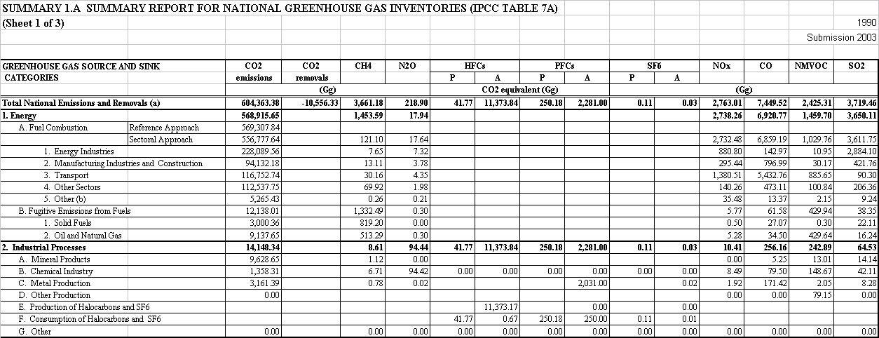

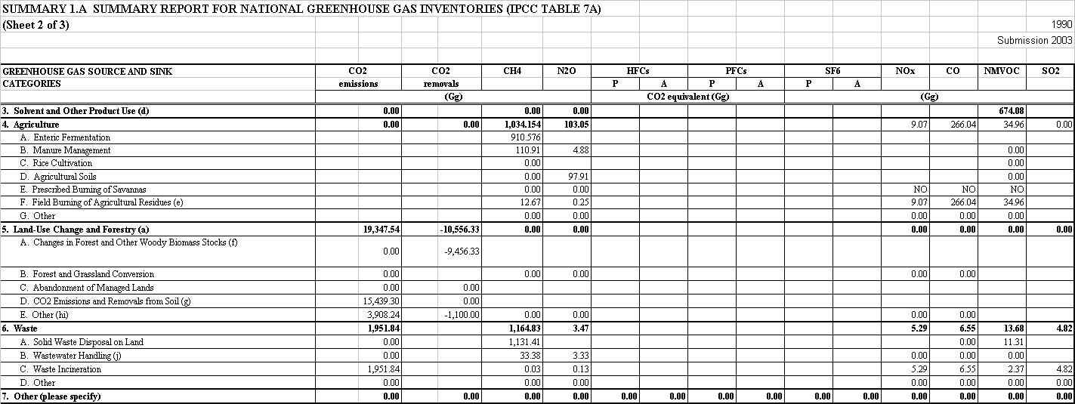

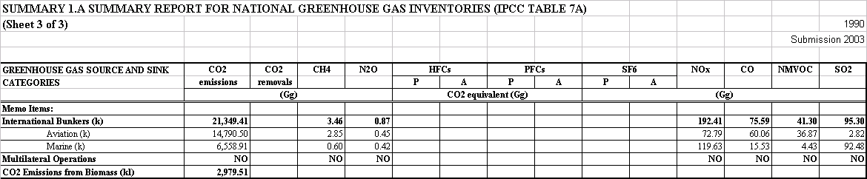

SECTORAL TABLES 2001

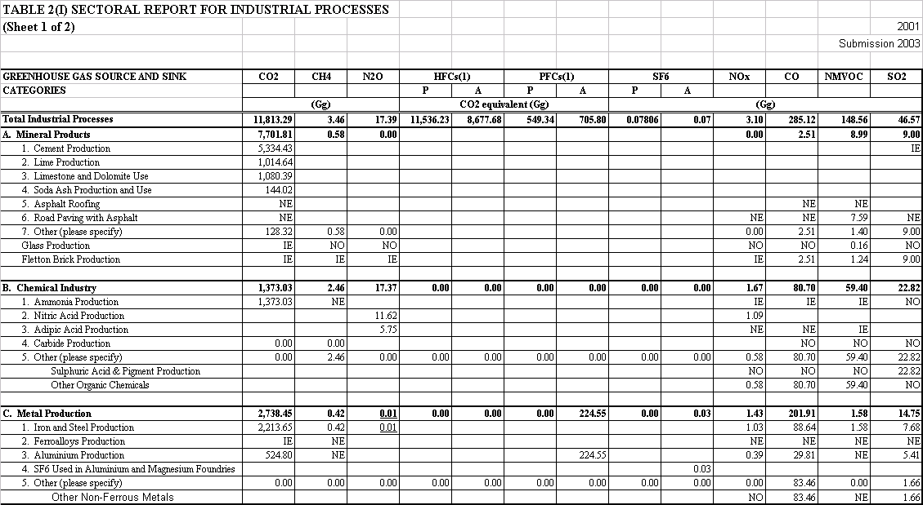

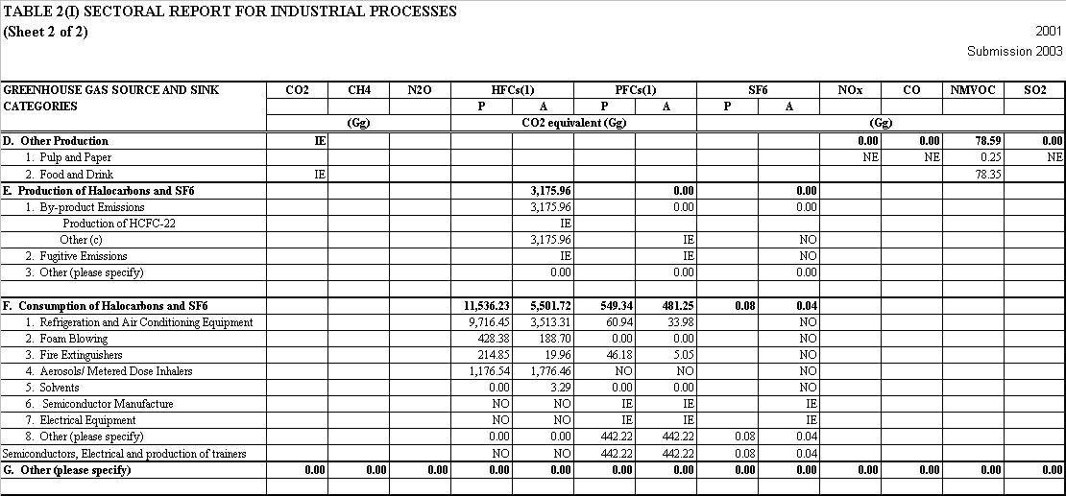

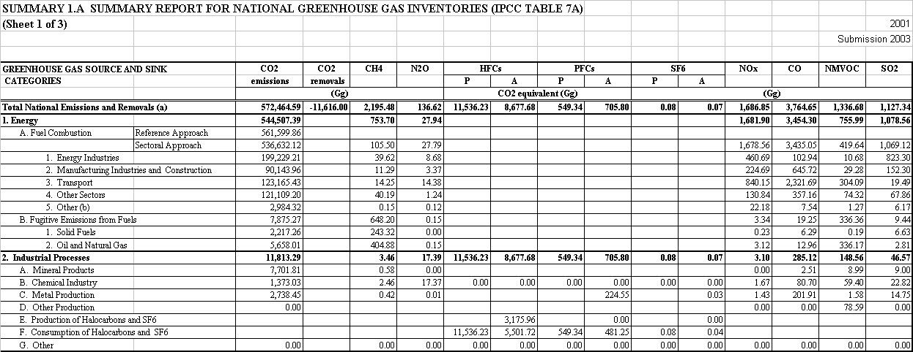

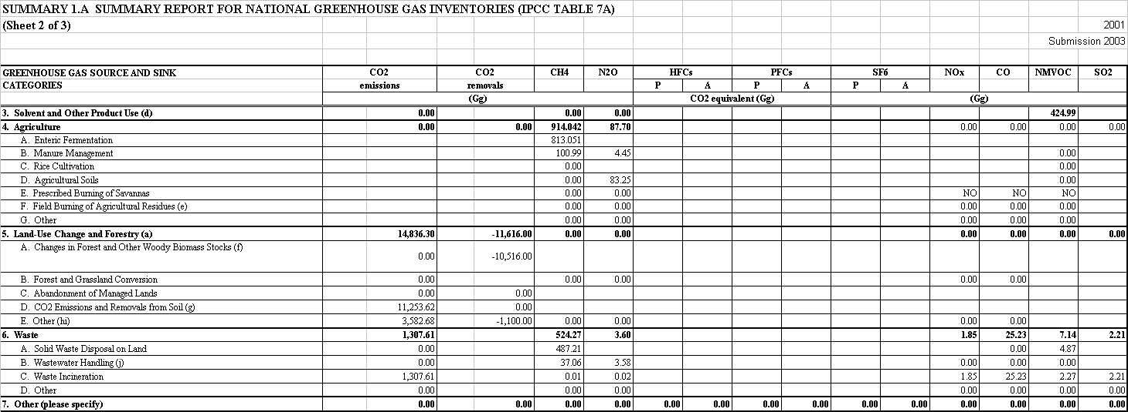

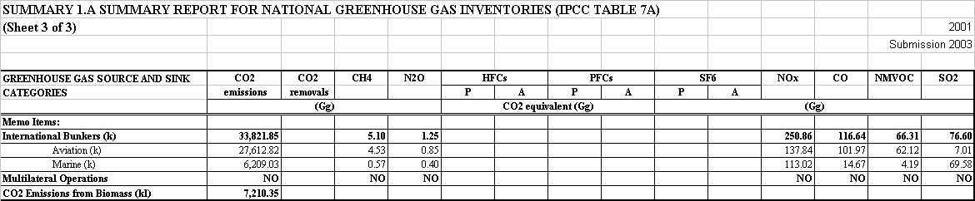

Footnotes for IPCC Sectoral Tables

a Net flux may be estimated as the sum of emissions and removals.
b Naval vessels and military aircraft.
c Emissions arise from refrigeration, electronics applications, electrical insulation, foams, aerosols, training shoes and solvent cleaning.
d The CO₂ equivalent of solvent NMVOC (excluding 3C) is 1641 Gg in 1990 and 1035 Gg in 2001
e Field burning ceased in 1994.
f 5A Removals are sum of removals to forest biomass, forest litter and forest soil.
g 5D Emissions are sum of emissions from soils and removals to soils due to land use change (not forestry), Set Aside
and liming of agricultural land.
h 5E Emissions are sum of emissions from soils due to upland drainage, lowland drainage and peat extraction
i 5E Removals are increases in crop biomass.
j Emissions from own wastewater treatment by industry are not estimated.
k Emissions are for information only and are not totalled.
l Emissions arise from wood, straw, biogases and poultry litter combustion for energy production.

NE Not estimated
NO Not occurring
IE Included elsewhere

The UK has elected to use 1995 as the base year for emissions of fluorinated compounds in accordance with Article 3.8 of the Kyoto protocol.
 Emissions from fuel combustion are defined as IPCC category 1A and refer to the combustion of fuels for energy production.
 One Gg equals one thousand tonnes.
 Electricity generated by Major Power Producers, DTI (2002)
☞ Electricity supplied (gross) by Major Power Producers, DTI (2002) • Plant loads, demand and efficiency, Table 5.9, DTI (2002)
AEAT (2002) Atmospheric Emissions From Small Carcass Incinerators. A report for the Department for Environment, Food and Rural Affairs. DEFRA contract DEFRA/WA0806. AEAT report number AEAT/ENV/R/0920. AEA Technology Environment, Culham Science Centre, Abingdon, Oxfordshire, OX14 3ED
The UK Greenhouse Gas Inventory is submitted to the United Nations Framework Convention on Climate Change in the form of the Common Reporting Format, or "CRF"

