CAFEAir

User Guide

CONTENTS
CONTENTS 1
INTRODUCTION 2
OPENING THE DATABASE 2
SEARCH DATA 3
Pollution Search 3
Location Search 5
Measure Search 5
Search Results 6
VIEW DATA 7
Authority and Measure Records 7
Detailed Assessments 8
VIEW CATEGORY CODES 8
EDIT DATA 8
Authority and Measure Records 8

INTRODUCTION
The CAFEAir database contains information on measures implemented by various authorities to prevent or reduce short-term pollution peaks or to reduce localised pollution ‘hot-spots’. This data is held within a Microsoft Access 2000 format database with forms and reports available for searching and viewing the records.
The database and its associated MS Word documents must all be placed in the same folder.
The remainder of this document describes how to view and search the database.

OPENING THE DATABASE
Either start Microsoft Access, select File – Open from the menu bar, and then navigate to CAFEAir.mdb. Or double click on CAFEAir.mdb from within Windows Explorer. You will then be presented with the CAFEAir Startup Form.

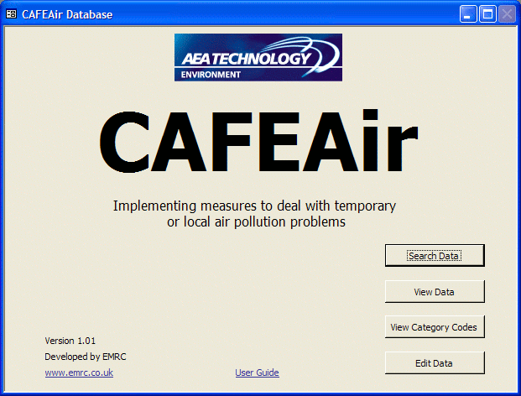

Clicking on the ‘User Guide’ hyperlink will allow you to view this document in Word (providing you have Word installed and associated with .DOC files).
Clicking on the ‘Search Data’ button will enable you to specify criteria and search the database for matching authority and measure details. There is also the option to print a report of the results.
Clicking on the ‘View Data’ button lets you view all the authority and measure records in the database. From here you can also view the case studies.
Clicking on the ‘View Category Codes’ enables you to view and print information on all the Standards, Sector and Typology Codes defined in the database. These reports contain additional descriptive information which is not included on other forms or reports due to lack of space.
Clicking on the ‘Edit Data’ button lets you edit all the authority and measure records in the database. This feature is password protected.
The following sections describe searching and viewing records in the database.

SEARCH DATA
The search options provide ways of searching for authorities and measures. The pollution and location searches find matching authorities and all the measures associated with them. While the measure search finds only matching measures, but will also display information about the associated authority.

Pollution Search
On selecting the ‘Pollution Search’ you will be presented with a form to enable you to enter your search criteria. This allows you to search for authorities with an air quality problem due to a particular pollutant. You may also refine your search by including either the season in which the problem occurs, or the sector(s) which contribute to the problem and their level of contribution.
First you should select the pollutant you are interested in from the drop-down list at the top of the form (Step 1). You also have the option to search for authorities either with pollution peaks during a particular season or from a particular contributing sector (Step 2).
If you select ‘Seasons in which problem occurs’ then you can specify the seasons of interest (Step 3A). The sector options in Step 3B will not be available to you. If you select more than one season then the search will return authorities affected by the selected pollutant in any one (or more) of the specified seasons. If, for example, you are interested in winter pollution peaks for all pollutants then clear the pollutant box (Step 1) and only select ‘Winter Peak Episodes’ in Step 3A. Finally, when you have set your criteria, click the ‘Search’ button (Step 4).
If you select ‘Sectors which contribute to the problem’ then you can specify the sectors of interest (Step 3B). The season options in Step 3A will not be available to you. You can select the level of contribution that you are interested in, in a similar manner to the season selection described above.
To select the sectors of interest, use the four list boxes towards the bottom of the form. These list boxes show the available codes, with a brief description of each code. For a complete list of sector codes use the ‘View Category Codes’ button on the main CAFEAir form.
Clicking on an item in the ‘Sector’ list box will select it and update the ‘SubSector’ list box with the subsectors associated with the selected sector. More than one sector may be selected, and clicking on a selected sector will deselect it. Continue by selecting the required subsector(s), subsubsector(s) and fuel. The ‘Selected Sectors’ box at the bottom of the screen shows all the codes that will be included in the search. It is for information only and does not allow codes to be selected from it.
The screen shot below shows the following search criteria :-
- Pollutant is O₃
- Problem area is contributing sectors
- Contribution level is dominant
- Sector code is M (Mobile)
- SubSector code is R (Road)
- SubSubSector code is N (Non Public Transport HDV)
- Fuel codes are A (All), D (Diesel) and N (Non-diesel)

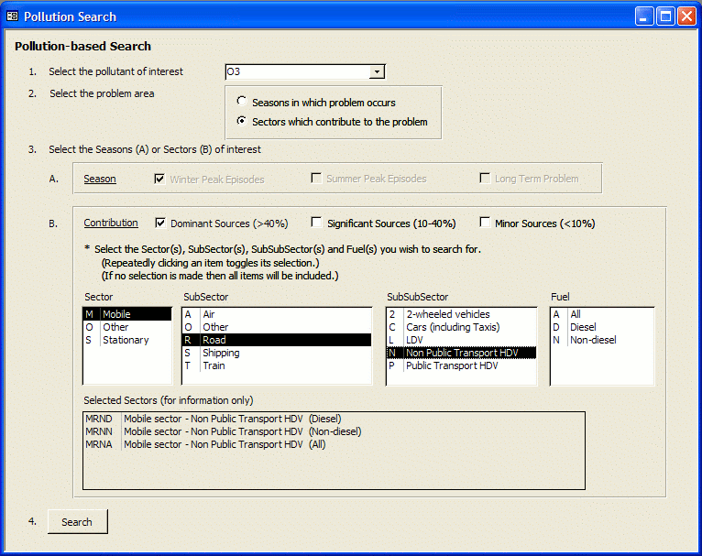

Thus the sectors which will be included in the search are MRNA, MRND and MRNN. If no items are selected in a particular list box then all codes in that list box (and consequently also any list boxes to its right) will be included in the search. So if, for example, you were interested in the pollution contributed of all Mobile-Road sectors then you would only need to select the Sector code ‘M’ (Mobile) and the SubSector code ‘R’ (Road). Leaving the SubSubSector unspecified would result in all the associated SubSubSector and Fuel codes being included in the search, the ‘Selected Sectors’ box would list all the codes included in the search. Finally, when you have set your criteria, click the ‘Search’ button (Step 4).

Location Search
On selecting the ‘Location Search’ you will be presented with a form to allow you to enter your search criteria. This allows you to search for authorities of a certain type or in a certain location.

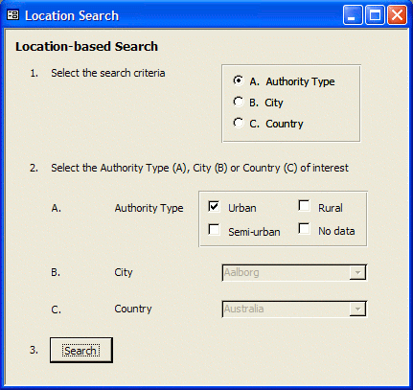

First select the type of search criteria, ‘Authority Type’, ‘City’ or ‘Country’ (Step 1). Your selection here will determine which part of Step 2 is available to you. If you selected ‘A. Authority Type’ then use the check boxes in Step 2A to specify the type(s) of authority you wish to search for. If you selected ‘B. City’ then use the drop down list box in Step 2B to select the city of interest. If you selected ‘C. Country’ then use the drop down list box in Step 2C to select the country of interest. Finally, when you have set your criteria, click the ‘Search’ button (Step 3).

Measure Search
On selecting the ‘Measure Search’ you will be presented with a form to allow you to enter your search criteria. This allows you to search for measures of a certain type or that influence a certain sector.
First select the type of search criteria, ‘Type of measure’ or ‘Sectors influenced by measure’ (Step 1). Your selection here will determine which part of Step 2 is available to you. If you selected ‘Type of measure’ then use the check boxes in Step 2A to specify the type(s) of measure you wish to search for. If you selected ‘Sectors influenced by measure’ then use the ‘Sector’, ‘SubSector’, ‘SubSubSector’ and ‘Fuel’ list boxes in Step 2B to specify the sector(s) of interest, in a similar manner to that described for the Pollution Search above.

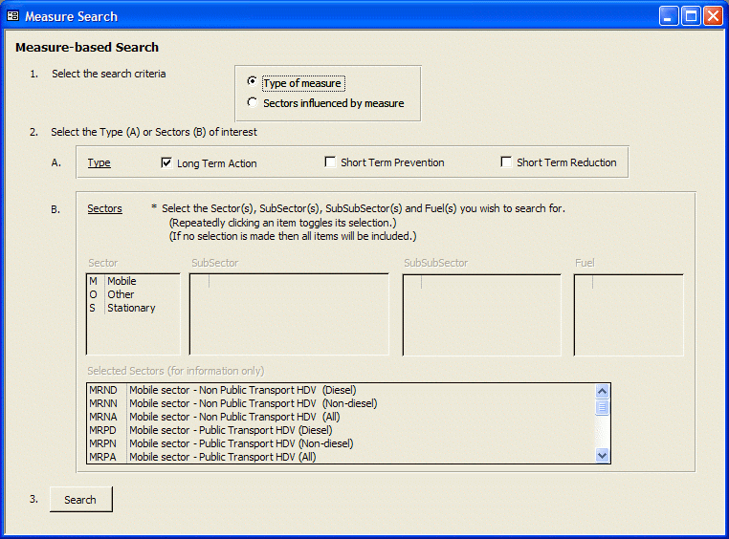

Finally, when you have set your criteria, click the ‘Search’ button (Step 3).

Search Results
When selecting your search criteria the options presented to you are derived from the complete set of valid options and codes defined in the database, so it is possible that there may not be a match within the authority or measure records. In which case a message box will be displayed to inform you that no matching records were found.
However, should one or more records matching your specified criteria be found a form similar to the one below will be used to display the search results.

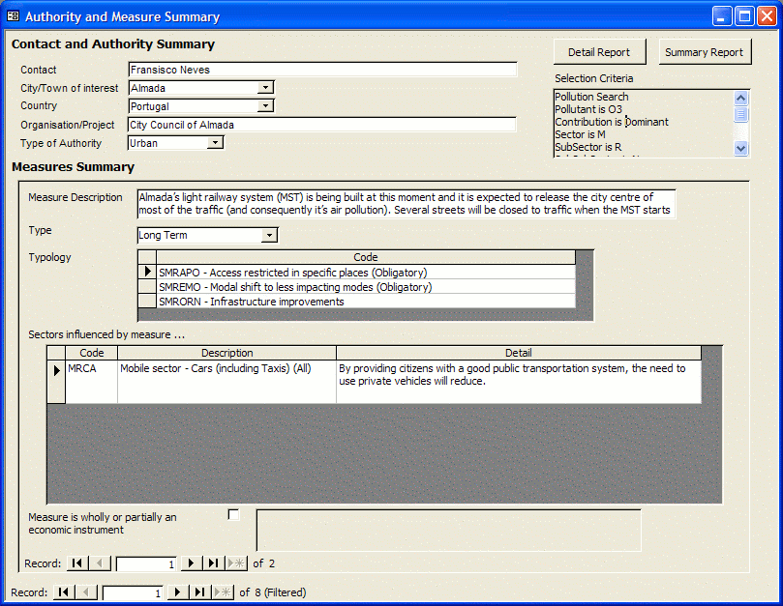

This form shows a sub-set of authority and measure data, but allows you to step through (using the navigation buttons at the bottom of the form) the authority and/or measure records that matched the search criteria. The number to the right of the navigation buttons show how many records were retrieved, and ‘(Filtered)’ is displayed if this is a subset of records.
Authority searches, i.e. pollution and location searches, will display all measures associated with each selected authority. While measure searches will only display those measures that match the search criteria, although information on the authority that each measure is associated with will also be shown.
The box labelled ‘Selection Criteria’, at the top right of the form, contains information on the type of search performed and the selection criteria that were specified. The two buttons above this box allow you to produce reports of the search results, and the selection criteria are also included in these reports.
Clicking the ‘Summary Report’ button produces a report containing the same set of information that is shown on the form. While clicking the ‘Detailed Report’ button produces a report that contains all the fields associated with the authority and measure records selected.
The reports are initially previewed on the screen, but may be printed by selecting File – Print from the Access menu bar.

VIEW DATA
The view data options allow you to view all the data associated with the authority and measure records in the database, or the detailed assessment documents.

Authority and Measure Records
Clicking the ‘Contact Details’ button displays a form showing the contact details and state of work for each authority. Clicking the ‘Air Quality Details’ button displays a form showing information on the air quality problems of each authority. Clicking the ‘Measure Details’ button displays a form showing all the data associated with each measure in the database.
You can use the navigation buttons at the bottom of the forms to step through the records. The number to the right of the navigation buttons shows the number of records available. You may also use the standard Access filter and sort facilities (under Records on the menu bar), or Find (under Edit on the menu bar), to quickly locate individual records.

Detailed Assessments
Clicking the ‘View Assessments’ button displays a list of hyperlinks to the detailed assessments available. They are held as Word documents, so you must have Word installed and associated with .DOC files. Clicking on a hyperlink will then open the associated assessment in Word.

VIEW CATEGORY CODES
In order to try and reduce the complexity of the database forms and reports some data has had to be encoded. The ‘View Category Codes’ options allow you to view and print the structure and full descriptions of these shorthand codes. Each option previews a report to the screen. The report may be printed by selecting File – Print from the main menu bar.
Clicking the ‘View Standards’ button displays a report showing the pollutant, standard short hand (used on forms and reports), standard description and standard criteria for each air quality standard defined in the database.
Clicking the ‘View Sector Codes’ button displays a report describing the set of valid sectors (and their codes) that are defined in the database.
Clicking the ‘View Typology Codes’ button displays a report describing the set of valid typology codes that are defined in the database.

EDIT DATA
The edit data options allow you to edit the data associated with the authority and measure records in the database, using similar forms to those that allow you to simply view the data. But access to this feature is password protected and you should request a password from the supplier of this database if you wish to edit its contents.

Authority and Measure Records
Clicking the ‘Contact Details’ button displays a form showing the contact details and state of work for each authority. Clicking the ‘Air Quality Details’ button displays a form showing information on the air quality problems of each authority. Clicking the ‘Measure Details’ button displays a form showing all the data associated with each measure in the database.
These forms allow you to add and delete records as well as amend those that are already there. You can use the navigation buttons at the bottom of the forms to step through the records. The number to the right of the navigation buttons shows the number of records available. You may also use the standard Access filter and sort facilities (under Records on the menu bar), or Find (under Edit on the menu bar), to quickly locate individual records.

