Development of a GIS method to assess exposure of households to roadside NO₂
A report produced for Department of Environment, Transport and the Regions, The National Assembly for Wales, The Scottish Executive and the Department of Environment for Northern Ireland

Katie King, Tony Bush and John Stedman
November 1999

Development of a GIS method to assess exposure of households to roadside NO₂
A report produced for Department of Environment, Transport and the Regions, The National Assembly for Wales, The Scottish Executive and the Department of Environment for Northern Ireland

Katie King, Tony Bush and John Stedman
November 1999

Title | Development of a GIS method to assess exposure of households to Roadside NO₂
Customer | Department of Environment, Transport and the Regions, The National Assembly for Wales, The Scottish Executive and the Department of Environment for Northern Ireland
Customer reference
Confidentiality, copyright and reproduction
File reference
Report number
Report status | Draft
AEA Technology
E5 Culham
Abingdon
Oxfordshire
OX14 3ED

Telephone 01235 463715
Facsimile 01235 463574
AEA Technology is the trading name of AEA Technology plc
AEA Technology is certificated to BS EN ISO9001:(1994)

 | Name | Signature | Date
Author | Katie King  Tony Bush  John Stedman
Reviewed by | John Stedman
Approved by | Garry Hayman

Executive Summary
The Government and devolved administrations have recently published a consultation document entitled ‘The Air Quality Strategy for England, Scotland, Wales and Northern Ireland’. The air quality modelling work undertaken for this report indicated that policies currently in place or to take effect before 2005 will lead to the NO₂ annual average objective of 40 μgm⁻³ being achieved at all background locations, except inner London, and at most roadside locations by 2005. However, the national modelling identified a number of major urban road links where concentrations at the roadside may exceed the objective.
A pilot study has already been undertaken to estimate the number of households likely to be exposed to exceedances of the NO₂ objective. This considered 102 road links, including a case study of the North Circular Road in London, and involved visits to each road and the use of a postcode to determine numbers of residential addresses. The site visits found that 23 road links have houses within 10m of the kerb, with a total estimate of more than 1,200 houses. Using the postcode data, a total of over 2,600 houses were found to exist along these road links, but the data sets were not detailed enough to determine how many of these are within 10 m of the kerb. The current study aims to consider the location of the houses in more detail through the use of more detailed digital map data.
The Geographical Information System (GIS) method developed in this study used a variety of digital map data: OS Landline, OS Oscar, OS Address Point and aerial photographs, linked together within a GIS. A total of 102 links were analysed, finding an estimated number of households in the range of 1,783 to 2,365. The range of estimates is attributed to various sources of uncertainty mainly related to limitations of the OS data and the interpretation of the Address Point database. However, this result is considered to be more accurate than that provided by the pilot survey, because of the much greater level of detail available concerning the nature of the buildings along the individual road links.
The links considered were those with the highest predicted NO₂ concentrations. However, those with lower traffic flows, and hence lower predicted concentrations, are more likely to be residential roads, and therefore may represent higher risks in terms of exposure.

Contents
1 Introduction 1
1.1 Background 1
1.2 sTUDY Objective 2
2 Method 3
2.1 Method Overview 3
2.2 Data requirements and data preparation 3
2.3 Method used to select addresses 6
3 Results 9
3.1 Sources of uncertainty 12
4 Conclusions 13
5 References 14

Appendices
Appendix 1 Detailed results by road link

Introduction

Background
The UK Government and devolved administrations are taking active measures to improve air quality through the Air Quality Strategy for England, Scotland, Wales and Northern Ireland (AQS) (DETR et al 1999a). This Strategy defines Air Quality Standards and Objectives for eight pollutants and identifies their major sources. The AQS gives the following objectives for nitrogen dioxide (NO₂) to be achieved by the end of 2005:
- Annual mean: The annual mean must not exceed 40 μgm⁻³.
- Hourly mean: The hourly mean must not exceed 200 μgm⁻³, not to be exceeded
more than 18 times a year.
In addition the European Union ‘Daughter Directive’ gives the following limit values for NO₂ to be achieved by 1 January 2010:
- Annual mean limit value of 40 μgm⁻³.
- 1-hour limit value of 200 μgm⁻³, not to be exceeded more than 18 times a year.
The annual mean objective and limit value are likely to be the most stringent of the targets, particularly at the roadside.
The Government has recently published a consultation document on the Review of the Air Quality Strategy (DETR et al 1999b). This report sets out proposals for amending the Air Quality Strategy following a review carried out during 1998.
The national modelling of roadside NO₂ concentrations (Stedman et al, 1998), carried out as part of this review, indicated that policies currently in place or to take effect before 2005 will lead to the annual average objective being achieved at all background locations, except inner London, and at most roadside locations by 2005. However, the national modelling identified a number of major urban road links where concentrations at the roadside may exceed the objective.
One of the key uncertainties within the national modelling of NO₂ is the question of public exposure. The approach adopted in the Strategy is to apply the objectives where members of the public are likely to be exposed over the averaging time of the objective. In the case of annual mean, this refers to roadside locations where residential buildings schools or hospitals etc are close to the kerb. The national models used for the review of the Air Quality Strategy simply predicted NO₂ at the roadside and did not consider the location of housing. NO₂ concentrations also decrease significantly with distance from the roadside. If housing is located more than about 10 m from the edge of the road, then NO₂ levels there are likely to be lower than the roadside levels predicted by the model.
A pilot study to assess the number of households adjacent to road links with the highest predicted roadside NO₂ has been undertaken (King et al 1999). This considered 102 road links, including a case study of the North Circular Road in London, and involved visits to each road and the use of a postcode to determine numbers of residential addresses. The site visits found that 23 road links have houses within 10m of the kerb, with a total estimate of more than 1,200 houses. Using the postcode data, a total of over 2,600 houses were found to exist along these road links, but the data sets were not detailed enough to determine how many of these are within 10 m of the kerb. The current study aims to consider the location of the houses in more detail through the use of more detailed digital map data.

sTUDY Objective
The objectives of this study were:
- to develop an accurate Geographical Information System (GIS) based method for estimating numbers of households exposed to exceedances of the annual mean air quality objective for NO₂ at the roadside;
- to quantify the number of households within 10m of kerb on these links;
- to enable similar assessment of exposure to other pollutants using this method.
For this study, only those road links surveyed in the pilot study (King et al 1999) were considered.

Method

Method Overview
This method uses detailed Ordnance Survey (OS) digital map data to determine the exact location of the road links under scrutiny. The widths of the roads were measured and then the buildings within 10m of the kerb were identified. Postal Address Point data were then used to determine the nature of the buildings identified, and the number of residential buildings was estimated. The results have been compared with those obtained in the pilot study (King et al 1999). Aerial photographs have also been used to provide a further check on the results in some locations.
The method was implemented using ArcView GIS software, customised to provide relevant functionality. However, the data preparation, prior to using this new ArcView functionality, was a significant part of the method because of the nature of the digital data in its raw form.

Data requirements and data preparation
Three key data types were required in the development of this method: OS OSCAR, OS Landline and OS Address Point. Aerial photographs have also been used to provide more information about the nature of some of the roads.

OS OSCAR

OS OSCAR data provides an accurate digital map of the whole GB road network, and therefore offers a considerable improvement on the current roadside NO₂ database, which is limited to straight line representations of these links. This straight line representation of the road links was used to compile the 1996 National Atmospheric Emission Inventory and subsequent pollution mapping results (Salway et al 1999). An improved OS Meridian based map of roadlinks, at a resolution appropriate to the national scale mapping, is currently being used to compile the 1997 NAEI.
As with all OS digital maps, the OSCAR data is organised into a series of square tiles covering the whole of Great Britain. In the case of OSCAR data these tiles are 5km across. For each city, the relevant OSCAR tiles were selected and the 'A' roads were extracted, as all of the road links considered within the national modelling for the review of the NAQS are of this type. Figure 1 shows two example OSCAR tiles, one with all the detail and one with just the 'A' roads. The lines in the OSCAR data set actually correspond to the road or carriageway centre lines, and hence for dual carriageways there are two lines.

OS Landline

OS Landline is a very detailed digital map, which, in urban areas, is made up of a series of 500m square tiles. The Landline maps include outlines of every building and of road kerbs. Many other details are also included, such as property boundaries and watercourses. The relevant tiles adjacent to the road links were selected, and the buildings and kerb lines were extracted. Figure 2 shows examples of the Landline tiles.
Figure 1 Two OSCAR tiles

Figure 2 Landline data

OS Address Point

The OS Address Point data consists of a series of points defined by grid references. These points correspond to each postal delivery address location, which are nominally the location of the letter box. The digital files are organised by postcode sector. Sectors covering the links under scrutiny in each city were identified, and those points that fall within the area of interest extracted. Figure 3 shows the Address Points that exist within one of the Landline tiles in Figure 2.

Figure 3 Address Point data

Aerial photographs

Aerial photos have been obtained from the National Remote Sensing Centre. These are available in 1km tiles, which cover a selection of cities in the UK. Photographs have been obtained for a small selection of road links in London, Birmingham and Manchester. The data have primarily been used to provide further contextual information to clarify any uncertainty. Figure 4 shows an example of the aerial photography data with the OSCAR data overlaid.

Figure 4 An example of the aerial photography (London A4088 link 57656)
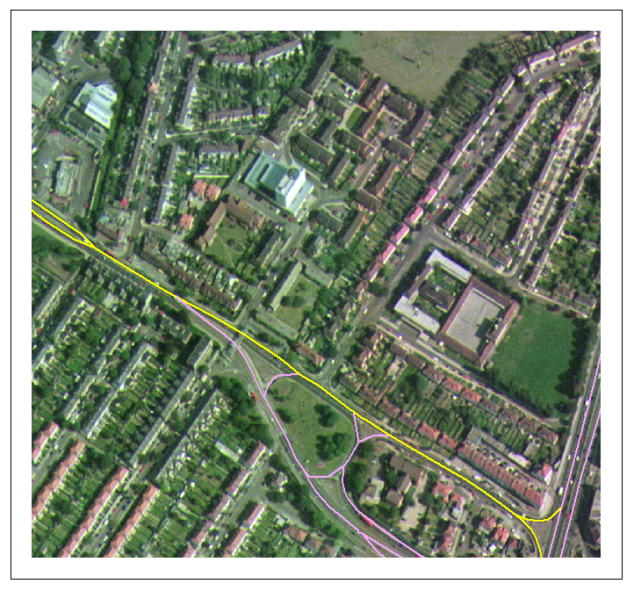

Method used to select addresses
A series of tools were developed using Avenue, the ArcView programming language. These tools provide an element of automation in the processing of the OS data.
The road links studied were those visited as part of the pilot study, as described in King et al (1999). The OS data were prepared separately for each city in this study. Once the data had been prepared, each link could be examined in detail.
Firstly, in order to determine which buildings were within 10m of the kerb, the distance of the kerb from the road centre line was measured manually at a number of points along the road link. This was required because the kerbline data was not in a format that could be used to measure the distance from the buildings directly. The average distance of the road centre to the kerb was often 3 to 6 metres and therefore the distance used to test for exposure was 13 to 16m from the road centre line. If large variations in road width existed then a maximum and minimum distance were used for the next part of the analysis.
Secondly, all buildings were selected that had a façade within the calculated distance from the road centre line. Figure 5 shows this selection, with buildings within 10m of the kerb coloured yellow.
Figure 5 Selected buildings
Once the buildings had been selected and checked, the Address Point map was queried to select those points that correspond to the selected buildings. Again, the results of this selection were checked manually to ensure that no Address Points were missing or had been included incorrectly. Figure 6 shows the Address Points selected, also in yellow.
Figure 6 Selected address points
The last stage of the process was to identify which of the selected Address Points correspond to residential buildings. This was performed using the assumption that non-residential buildings have some sort of business or organisation name in the Address Point database (in the ‘On’ column in the table below). The residential building count therefore only includes address points that have no name.
Where the road width is variable along the route two selections have been made: at a minimum distance form the road centre and a maximum. This provides a range of possible exposed households. On some roads where lots of residential buildings were found, this range was examined to determine which estimate is most accurate.
Table 1 Address Point data showing residential and non-residential addresses
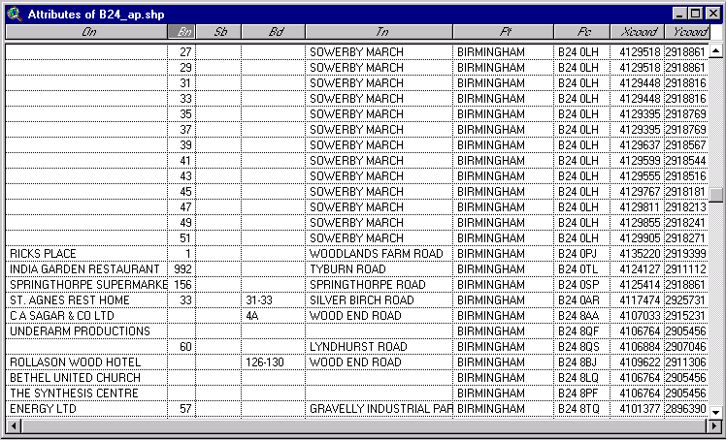

Results
A summary of the results is shown below in Table 2. A comparison is also made with the results of the site visits in the pilot study. Detailed results for each road link are shown in Appendix 1. The figures in Table 2 are estimated numbers of residential buildings, based on the assumption that residential buildings are those address points with no building name. This does however conceal some uncertainty because there may be buildings of non-residential use that also do not have names. This issue is considered further in the next section on sources of uncertainty.
Table 2 Summary of results
City | Number of links analysed | Number of households found in site visits in pilot study | Number of households estimated in this study (range based on varying road width assumptions) |  | Comments
Birmingham | 16 | 59 | 260 | 453 | The current analysis has identified more houses than found in the pilot survey.  A large number of addresses suspected to be non-residential especially on city centre links.
Bristol | 7 | 0 | 17 | 20 | All links are in commercial areas, therefore most addresses likely to be non-residential.
Doncaster | 2 | 0 | 2 | 2 | Good correspondence.
Glasgow | 3 | 0 | 6 | 13 | Good correspondence.
Hull | 3 | 0 | 66 | 76 | Houses identified very near to end of road, may have been missed in the pilot survey. Also houses in adjacent roads are very near this road.
Leeds | 9 | 50+ | 41 | 41 | Good correspondence.
Leicester | 6 | 6 | 54 | 55 | This total includes a block of 24 flats.  The links are all on a city centre ring road identified as commercial land use. Many of the points selected are therefore thought to be non-residential..
Liverpool | 16 | 860+ | 485 | 642 | Roads with large numbers of houses correspond well with previous results.
London (A406) | 18 | 215+ | 373 | 497 | Large numbers of flats included in this total. Also one link were houses were found to be within 10m in this study but not included in pilot.  Otherwise good correspondence.
Manchester | 12 | 95+ | 103 | 152 | The current analysis has identified houses within 10m that were not included in the pilot survey.
Newcastle | 4 | 0 | 344 | 378 | A large block of flats is included
Portsmouth / Fareham | 3 | 6 | 10 | 13 | Good correspondence.
Sheffield | 3 | 0 | 22 | 23 | Possibly non-residential buildings.
TOTAL | 102 | 2000+ | 1783 | 2365

The analysis of the aerial photos provided some additional information. Figure 7 shows the photograph of the centre of Birmingham with the OSCAR data overlaid. Link 57191 is highlighted in yellow. The photo shows that large commercial and industrial buildings dominate the area. In contrast, Figure 8 (link 16365 on Tyburn Road) shows mainly residential buildings with gardens. The south side of the link is commercial.
Figure 7 Bull Ring (link 57191) in Birmingham
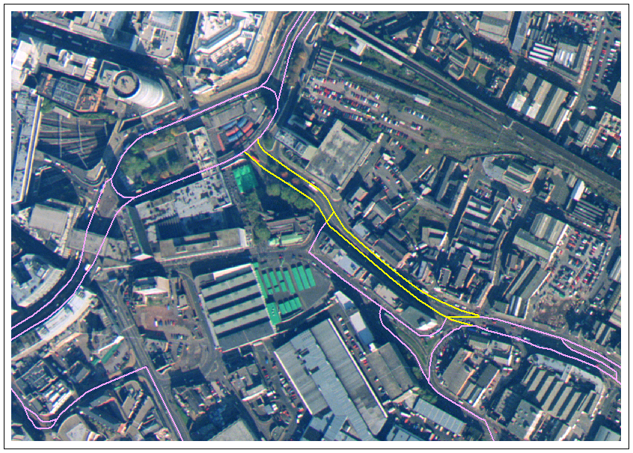
Figure 8 Tyburn Road (link 16365) in Birmingham
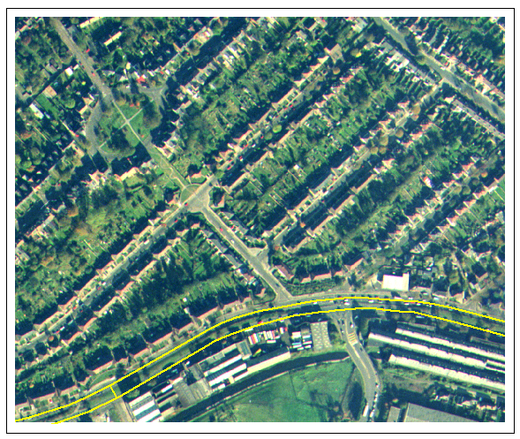

Figure 9 shows the large number of houses close to the North Circular Road on link 37113. Although the picture is not very clear, the variable road and pavement widths can be seen. Figure 10 shows part of link 37809, where no houses were found within 10m of the road in the pilot study, but between 27 and 43 have been found in this study.
Figure 9 London, North Circular Road (link 37113)
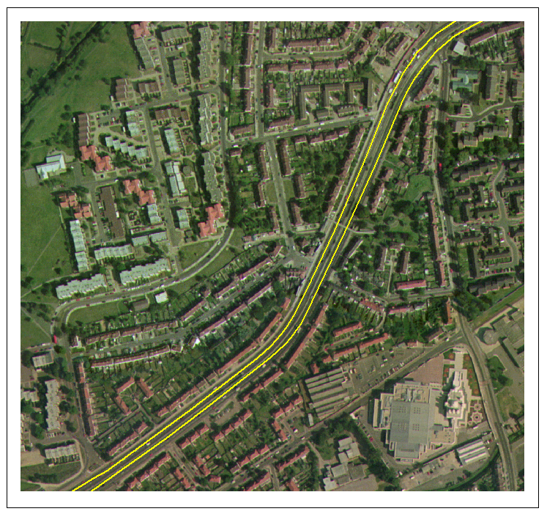
Figure 10 Manchester, A5103 near junction of M63 (link 37809)
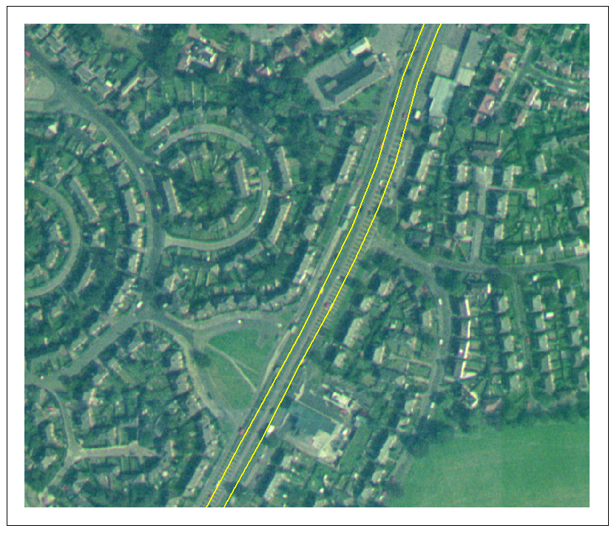

Sources of uncertainty
The description of the method included some discussion of the problems encountered with the digital maps and address point data. These problems may account for some of the disparity between the results of these two studies. Brief explanations of the possible sources of uncertainty in the new method are listed below. Appendix 1 also includes comments on individual road links.

- Selection of buildings within 10m of the kerb:
OS Landline data does not represent buildings as polygons and therefore it is not always possible to select individual buildings within the 10m zone. For example, whole terraces of houses may be selected. As far as possible this was corrected for by visual inspection of the selection in the GIS.
Variations in road width, slip roads and access roads caused problems in the calculation of the distance of the houses from the kerb. A range of values for the road width was used and this provided a range of possible households exposed. The aerial photographs did not provide any additional data that can improve this method. A possible solution would be to make individual measurements from the landline data between each house and to the road. This would clearly be very time consuming.
The OS Landline data provides no vertical distance information. For example the road could be a flyover or underpass and therefore the actual distance of buildings close to the road is greater than is shown on the map. No solution has been implemented for this problem.
- Selection of Address Points within selected buildings:
Because of the nature of the Landline data described above, address points could not be selected on the basis of being 'inside' a building. Therefore all Address Points within a distance of 5m of selected building outlines were selected.
- Residential Address Points:
It was assumed that Address Points without a building name are residential. This assumption may have provided an over-estimate where there are non-residential buildings that are empty or where no name is given in the database. In some cases such errors could be identified and corrected, such as where surrounding buildings were obviously commercial rather than residential, but in others it was not possible to make the distinction.
- Blocks of flats:
Address points with flats or apartments are often represented by a series of points all at the same grid reference. The exposed households are those at ground level and possibly first floor level, but it is not possible to determine how many of the flats are at these levels. In these cases, all addresses are included.
- Inaccuracy in the original survey:
Inaccurate distance measurements in the pilot study may have resulted in uncertainty in the exposures. For example, overestimates of distances would have resulted in buildings not being counted in the pilot.

Conclusions
Compared with the pilot study, the results of this analysis provide a more accurate estimate of the numbers of buildings along the road links with the highest predicted NO₂ concentrations. A large amount of data has been used and although the method developed is partly automated, the results at each stage are checked carefully to ensure that the results are as accurate as possible based on the information available.

The method can be applied to assess exposure at any distance from the road for any pollutant for which concentration data is available. The NO₂ exposure results provided here can also be updated as the NO₂ modelling is improved, which may result in a different set of road links requiring analysis.

In this study, the households exposed to NO₂ have been assumed to be those within 10m of the kerbside. This distance is chosen somewhat arbitrarily, based on the knowledge that NO₂ concentrations decrease from the kerbside towards the buildings, although the rate of this decline is not known. Also the predictive model of air concentrations is only valid for roads where there is a canyon effect caused by buildings close to the roads. It is thought that this model is not reliable where the buildings are greater than 10m from the kerb.

The actual number of residential houses exposed to exceedances of the NO₂ objectives are likely to be considerably higher than stated here, as only 102 links have been considered compared with 761 which were predicted to exceed the NO₂ objective in 2005. The links considered were those with the highest predicted NO₂ concentrations. However, those with lower traffic flows, and hence lower predicted concentrations, are more likely to be residential roads, and therefore may represent higher risks in terms of exposure.

The results of this report may be of use to Local Authorities as a check against locally derived estimates of exposure or as a starting point in the analysis of likely areas requiring action.

References
DETR et al (1999a) The Air Quality Strategy for England, Scotland, Wales and Northern Ireland, Department of the Environment, Transport and the Regions, The Scottish Office, The Welsh Office, Department of the Environment Northern Ireland. The Stationary Office, August 1999.
DETR et al (1999b) Review of the National Air Quality Strategy Department of the Environment, Transport and the Regions, The Scottish Office, The Welsh Office, Department of the Environment Northern Ireland. The Stationary Office, January 1999.
King, K., Stedman, J and Goodwin, R. (1999) Pilot study of exposure of households ro roadside NO_{2,}, AEA Technology Environment, National Environmental Technology Centre, Report AEAT-5624.
Salway, A.G., Eggleston, H.S., Goodwin, J.W.L., Berry, J.E. and Murrels, T.P. (1999) UK Emissions of Air Pollutants 1970-1996. National Atmospheric Emissions Inventory, AEA Technology, National Environmental Technology Centre, Report AEAT-3092.
Stedman JR, Bush T and King K (1998) An empirical model for estimating roadside nitrogen dioxide concentrations in the UK. AEA Technology Environment, National Environmental Technology Centre, Report AEAT-4291.

Appendices
CONTENTS
Appendix 1 | Detailed results by road link

Appendix 1 Details of individual roads links analysed

Road details |  |  |  |  | Pilot survey results |  |  |  | New analysis
Census ID | City | Name of road | Road No. e.g. A40 | Length (m) | Houses within  10 m?  Y/N | Aspect?  Buildings both sides? | Continue survey? Y/N | No. of houses at < 10m | Min distance tested | Max distance tested | Number of residential buildings (min) | Number of residential buildings (max) | Comment
6390 | Birmingham | Kingsbury Road | A38 | 1273 | y | wide road, housing and commercial both sides | y | 20 | 13 | 16 | 13 | 63 | Variable width road/pavements make it difficult to accurately measure houses. 13m is the most accurate
6391 | Birmingham | James Watt Queensway | A4400 | 800 | n | commercial offices, open road | n |  | 13 |  | 31 | 63 | Ring road, few buildings close to main road
7676 | Birmingham | Dartmouth Middleway | A4540 | 419 | n | all commercial, open road | n |  |  |  |  |  | Results combined with 57193
7928 | Birmingham | St Chads Queensway | A4400 | 800 | n | mainly commercial, 1 block flats at ~25m | n |  |  |  |  |  | No houses
16365 | Birmingham | Tyburn Road | A38 | 1742 | y | houses one side, commercial on the other | y | 15 | 13 | 14 | 15 | 66 | Lots of semi detached houses on N side of the road, lots just on or within 10m. Offices and industry opposite.
27736 | Birmingham | Watery Lane Middleway | A4540 | 1558 | n | no housing within 30m | n |  | 15 |  | 2 | 2 | unlikely to be residential - more likely empty or unnamed buildings
36400 | Birmingham | Moor Street Queensway | A4400 | 500 | n | high office blocks | n |  | 15 |  | 0
46398 | Birmingham | Lichfield Road | A5127 | 2731 | n | wide road, mixed low commercial | n |  | 13 | 16 | 19 | 39 | lots of 'residential' buildings but they din't look like houses - large blocks of flats or empoty office / industry buildings?
46399 | Birmingham | Bristol Road | A38 | 847 | n | wide road, mixed commercial | n |  | 13 |  | 33 | 33 | looks like a commercial area but has buildings with no name
47202 | Birmingham | Chester Road | A452 | 1400 | n | wide road, some commercial | n |  |  |  |  |  | no houses
47999 | Birmingham | Bristol Road | A4400 | 650 | n | wide road, small shops, offices above | n |  | 13 |  | 30 | 30 | looks like a commercial area but has buildings with no name
56394 | Birmingham | St Chads Queensway | A38 | 782 | n | wide road, some shops | n |  | 13 | 16 | 4 | 4 | unlikely to be residential - more likely empty or unnamed buildings
56399 | Birmingham | Tyburn Road | A38 | 1201 | y | wide open road, housing one side, commercial on the other | y | 10-15 | 14 | 16 | 57 | 129 | Looks like 14m is the most accurate. Some terraces with all addresses selected may represent an over estimate.
57191 | Birmingham | Bull Ring Digbeth | A41 | 405 | n | built up high shops / offices | n |  | 15 |  | 33 | 33 | looks like a commercial area but has buildings with no name
57193 | Birmingham | Dartmouth Middleway | A4540 | 393 | n | open area, mainly large commercial | n |  | 13 |  | 2 | 2 | commercial area (these results include link 7676)
57194 | Birmingham | Belgrave Middleway | A4540 | 812 | y | open wide road, housing | y | 6 | 13 |  | 21 | 21 | block of flats and a terrace of houses
36409 | Bristol | Bond Street | A4044 | 500 | n | Offices 1 side | n |  | 15 |  | 0
37053 | Bristol | Western Inner Ring Road | A4044 | 1100 | n | offices and shops both sides | n |  | 14 | 17 | 12 | 14 | some flats (above shops?) and possibly some empty offices
48003 | Bristol | Brunel Way | A370 | 500 | n | no buildings close | n |  |  |  | 0 |  | no houses
48459 | Bristol | Temple Gate Bath Bridge | A4 | 347 | n | station / hotel | n |  | 15 | 18 | 0 | 0
56375 | Bristol | Temple Way | A4044 | 706 | n | wide road with offices both sides | n |  | 15 | 18 | 4 | 4
56400 | Bristol | Bond Street | A4044 | 347 | n | high office blocks both sides | n |  | 15 |  | 0
57291 | Bristol | Newfoundland Street | A4032 | 1100 | n | wide open road, shops at one end | n |  | 13 | 17 | 1 | 2
7397 | Doncaster | ? | A638 | 685 | n | commercial | n |  | 17 | 20 | 1 | 1
8747 | Doncaster | ? | A638 | 853 | n | offices and commercial | n |  | 17 | 20 | 1 | 1
16270 | Fareham | A27/A32 | A27/A32 | 780 | n | open | n |  | 15 |  | 0 |  | very few buildings near, no houses
20922 | Glasgow | Stobcross Street | A814 | 700 | n | underneath flyover and high hotels | n |  | 15 | 18 | 4 | 4
40924 | Glasgow | Clydeside Expressway | A814 | 3500 | n | open area, commercial both sides | n |  | 14 | 16 | 0 | 0
50974 | Glasgow | Clyde Tunnel | A739 | 2009 | n | it's a tunnel! | n |  | 14 | 16 | 2 | 9
7913 | Hull | Garrison Road | A63 | 805 | n | wide open road, some commercial | n |  |  |  |  |  | no buildings within 15m of road centre
27932 | Hull | Castle Street | A63 | 658 | y | wide road | y | 6 in 1 block | 14 | 17 | 42 | 52 | a couple of block of terraces. Trinity Court and Fish Street
48331 | Hull | Hessle Road | A63 | 965 | n | wide road and commercial offices | no |  | 13 |  | 24 | 24 | Some houses near slip road (do these count?), and others near main part of road
8554 | Leeds | York Road | A64 | 500 | n | open, offices both sides | n |  |  |  |  | 0
16593 | Leeds | York Road | A64 | 2800 | y | housing and shops both sides | y | 50+ | 16 |  | 38 | 38 | lots of houses just over 10m
18451 | Leeds | West Street | A58 | 476 | n | all offices | n |  |  |  | 0 |  | 3 large buildings, don't look like houses
28003 | Leeds | Wellington Road | A58 | 600 | n | open area | n |  |  |  |  | 0
28005 | Leeds | A643 in Holbeck | A643 | 1200 | n | open area, some commercial | n |  |  |  |  | 0
46633 | Leeds | York Road | A64 | 2800 | n | wide open road, some houses at 20-25m | n |  | 15 |  | 3 | 3
48049 | Leeds | Wellington Road | A58 | 500 | n | no buildings | n |  |  |  |  | 0
48535 | Leeds | West Street | A58 | 300 | n | open road, elevated | n |  |  |  |  | 0
57696 | Leeds | Geldard Street | A58 | 300 | n | open road, commercial both sides | n |  |  |  |  | 0
36502 | Leicester | Burleys Way | A46 | 500 | no | commercial area | n |  | 15 |  | 5 | 5 | one is an Arts Centre, others look like businesses but no names
36524 | Leicester | St Mathews Way | A47 | 585 | n | open, some commercial | no |  | 13 |  | 8 | 8 | 6 look like residential; 2 are 'empty' units; business units that look like houses
48489 | Leicester | Vaughn Way | A46 | 400 | no | commercial area | n |  | 15 |  | 5 | 5 | the 'residentials' look like commercial
48677 | Leicester | Humberstone Rd | A47 | 472 | n | all commercial | no |  | 14 |  | 9 | 9 | mixture of building sizes, looks all commercial
56435 | Leicester | A47 west of ring road | A47 | 430 | y | wide split road | y | 6 flats | 15 | 17 | 25 | 26 | one large block of 24 flats, the other two buildings look too large for residential
56464 | Leicester | Vaughn Way | A46 | 600 | no | commercial area | n |  | 15 |  | 2 | 2 | don't look like residential buildings
7274 | Liverpool | Breaze Hill | A5058 | 690 | y | few houses 1 side | y | 10 | 15 | 17 | 62 | 65 | Buildings with mulitple APs which appear to be residential (flats?)
7862 | Liverpool | Brunswick Street | A580 | 500 | n | wide road | n |  | 16 | 18 | 7 | 16
17657 | Liverpool | Strand Street | A5036 | 621 | n | wide road, commercial | n |  | 17 | 19 | 2 | 26
17661 | Liverpool | Rocky Lane | A5049 | 1347 | y | half domestic, half commercial | y | 300+ | 16 | 18 | 146 | 174
18508 | Liverpool | M62 link | A580 | 372 | y | open road | y | 20 | 17 | 19 | 9 | 9
28563 | Liverpool | Islington | A580 | 214 | N | commercial | n |  | 15 | 17 | 3 | 4
37334 | Liverpool | Queens Drive | A5058 | 751 | y | wide road, housing both sides | y | 300+ | 14 | 16 | 112 | 112
37794 | Liverpool | Erskine Street | A580 | 800 | n | wide open road | n |  | 16 | 18 | 1 | 1
38350 | Liverpool | Lime Street | A5038 | 341 | n | all commercial | n |  | 15 | 17 | 4 | 10
47911 | Liverpool | Near University | A59 | 1300 | n | open road | n |  | 15 | 17 | 19 | 19
47917 | Liverpool | Edge Lane | A5047 | 2085 | y | mainly commercial, wide road | y | 30 | 14 | 16 | 87 | 89 | All APs appear to be residential
47919 | Liverpool | Edge Lane | A5080 | 1105 | y | wide road | y | 200+ | 14 | 16 | 33 | 117 | All APs appear to be residential
48332 | Liverpool | Near University | A59 | 300 | n | open road | n |  | 16 | 18 | 0 | 0
56612 | Liverpool | Near University | A59 | 638 | n | wide open road | n |  | 16 | 18 | 0 | 0
57715 | Liverpool | Liver Street | A5041 | 109 | n | empty road | n |  | 15 | 17 | 0 | 0
58222 | Liverpool | New Islington | A5080 | 227 | n | open road | n |  | 15 | 17 | 0 | 0
6076 | London | North Circular Road | A1 | 500 | n | wide road, some buildings set back | n |  | 15 |  | 2 | 2 | houses at end of terraces on side roads
7055 | London | North Circular Road | A406 | 2100 | y | housing at one end of link, rest is wide dual carriageway | y | 20 | 15 | 16 | 20 | 31 | terrace close to Hanger Lane Juntion
8468 | London | North Circular Road | A406 | 300 | n | flyover, commercial nearby | n |  |  |  | 0 |  | no houses
17018 | London | Gunnersbury Avenue | A406 | 1300 | n | residential, set back from road | n |  | 15 |  | 14 | 14 | a few houses close to junction
17019 | London | North Circular Road | A406 | 1939 | y | commercial and residential, dual carriageway | y | 50 | 15 | 16 | 28 | 68 | various blocks of terraced houses and individual houses
17020 | London | North Circular Road | A406 | 900 | n | some residential set back from road, then underpass | n |  |  |  | 0 |  | no houses
26080 | London | North Circular Road | A1 | 206 | n | open road, one apartment block | n |  | 16 | 17 | 32 | 32 | block of flats and one house
27086 | London | Hanger Lane | A406 | 200 | n | no houses noted in survey, picture shows some close to road | n |  | 18 |  | 9 | 9 | wide road, one block of flats
27087 | London | North Circular Road | A406 | 900 | n | commercial buildings and flyover | n |  |  |  | 0 |  | no houses
37112 | London | Gunnersbury Avenue | A406 | 1100 | y | some houses set back, some close; open road with wide central area | y | 35 |  |  | 0 |  | no houses, must have under-estimated distance in pilot survey
37113 | London | North Circular Road | A406 | 2400 | y | houses close to road, often both sides | y | 100+ | 15 | 18 | 209 | 269 | variable road width, difficult to accurately quantify. Lots of houses close to road
37114 | London | North Circular Road | A406 | 940 | n | open road, few buildings | n |  | 15.2 |  | 16 | 16 | two blocks of flats
38366 | London | Hanger Lane | A406 | 1992 | n | some commercial, some open | n |  | 15 | 16 | 38 | 49 | a few houses at the south end of the link
38601 | London | Hanger Lane Roundabout | A406 | 200 | n | shops set back from large roundabout, | n |  |  |  | 0 |  | no houses
56758 | London | North Circular Road | A406 | 1200 | n | no buildings, underpass | n |  | 15 |  |  |  | no houses
56982 | London | Forty Lane | A4088 | 822 | n | residential, houses set back from road | n |  | 16 | 17 | 5 | 7 | one house has a part near the road, and a couple of other buildings
57056 | London | North Circular Road | A406 | 721 | y | 2 storey houses both sides | y | 10 | 14 | 15 | 33 | 44 | lots of houses close to Northern side of A406, some on oposite side at ends of side roads
57656 | London | Blackbird Hill / Neasdon Lane | A4088 | 1100 | n | commercial and residential, houses at > 10m | n |  | 15 | 16.5 | 112 | 143 | lots of flats (in divided houses?); disparity between findings - likely over-estimate of distance in pilot survey
6161 | Manchester | Broad Street, Pendleton | A6 | 1000 | n | mostly commercial, houses used as offices | n |  | 17 | 25 | 0 | 10
16537 | Manchester | Old Trafford | A34 | 700 | n | mainly low commercial, some houses on side roads close but not <10m |  |  | 16 | 20 | 6 | 8
17675 | Manchester | Princess Road | A5103 | 2169 | n | some houses close according the photos, not quantified in survey | y | ? | 14 | 16 | 0 | 2 | Much shorter road link than that quantified in the pilot study.
26352 | Manchester | Kingsway | A56 | 792 | y | wide road, some with open aspect, some houses close | y | 20 | 16 | 18 | 12 | 14
28684 | Manchester | Chester Rd in Stretford, | A56 | 137 | n | residential type buildings, not quantified | y | >25 | 15 | 20 | 2 | 3 | Variable road and pavement widths make quantification difficult. See photograph.
36578 | Manchester | Chester Rd in Stretford | A56 | 822 | n | wide aspect, low buildings | n |  | 15 | 20 | 33 | 34
36585 | Manchester | Regent Road | A57 | 895 | n | housing set back from road on one side, mostly open aspect on other | n |  | 15 | 20 | 0 | 8
37809 | Manchester | junction of M63 | A5103 | 1400 | n | housing set back from road |  |  | 16 | 18 | 27 | 46
48023 | Manchester | Regent Road, | A57 | 495 | n | commercial and residential, some blocks of flats very close | y | possibly >50 flats | 14 | 20 | 16 | 16
56160 | Manchester | Crescent Chapel | A6 | 748 | n | commercial | n |  | 16 | 20 | 3 | 3
58022 | Manchester | Old Trafford | A56 | 600 | n | open aspect, block of flats set way back, commercial close to road |  |  | 16 | 20 | 0 | 0
58252 | Manchester | Great Ancoats St | A665 | 127 | n | commercial | n |  | 15 | 20 | 4 | 8
6090 | Newcastle | Gateshead Highway | A184 | 450 | n | wide road, offices | no |  | 15 | 17 | 276 | 276
18626 | Newcastle | A1 in Lemmington | A1 | 1500 | n | wide road, no buildings | n |  | 16 | 20 | 2 | 5
47829 | Newcastle | Park Road | A184 | 3069 | n | wide open, some commercial | n |  | 14 | 16 | 34 | 43
58151 | Newcastle | A167 | Tyne Bridge | 800 | n | river | n |  | 16 | 18 | 32 | 54
28437 | Portsmouth | A228 in Hilsen | A228 | 2158 | y | wide road some commercial | y | 6 | 16 | 18 | 10 | 13 | kerb width variable, some semis on one side
47078 | Portsmouth | A3/M27 junction | A3 | 450 | n | open junction | n |  | 15 |  |  |  | no houses, just a car dealer
18722 | Sheffield | Sheaf Street | A61 | 800 | n | open area, some commercial | n |  | 16 | 18 | 6 | 6
47839 | Sheffield | Wicker | A6135 | 304 | n | shops and offices built up | n |  | 15 | 17 | 6 | 7
48076 | Sheffield | Sheaf Street | A61 | 379 | n | built up area, commercial | n |  | 16 | 18 | 10 | 10

